Solution Symbol Resource

Access Points
Symbol Name:
Symbol Picture:
Symbol Source:
Symbol Date: May 2015
Created by: Esri Solutions Team
License: None
Acknowledgement: None required
Notes: None

Act of Nature
Symbol Name: Storm
Symbol Picture:
Symbol Source: The Noun Project
Symbol Date: December 2015
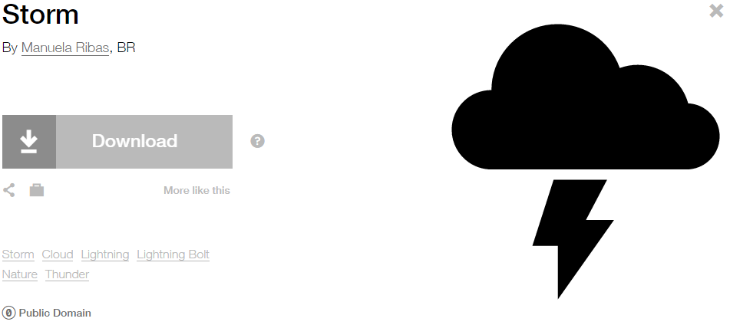
Modified by: Esri Solutions Team
License: Public Domain
Acknowledgement: None required
Notes: None

Address Not Verified
Symbol Name: P
Symbol Picture: 
Symbol Source: Arial Rounded MT Bold font
Symbol Date: May 2016
Modified by: Esri Solutions Team
License: None
Acknowledgement: None required
Notes: None

Address Verified
Symbol Name: A
Symbol Picture: 
Symbol Source: Arial Rounded MT Bold font
Symbol Date: May 2016
Modified by: Esri Solutions Team
License: None
Acknowledgement: None required
Notes: None

Alarm Control Panels - Other
Symbol Name: Alarm
Symbol Picture: 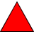
Symbol Source: NAPSG (National Alliance for Public Safety GIS Foundation)
Symbol Date: March 2017
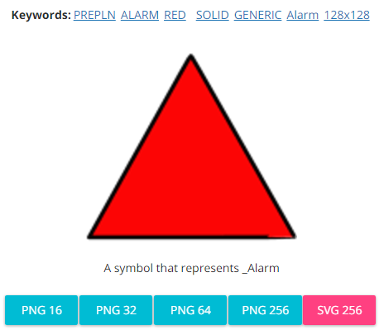
Modified by: Esri Solutions Team
License: None
Acknowledgement: None required
Notes: None

Alternative Entry Point
Symbol Name: P
Symbol Picture: 
Symbol Source: Arial font
Symbol Date: December 2015
Modified by: Esri Solutions Team
License: None
Acknowledgement: None required
Notes: None

Adult Care
Symbol Name: L1 Adult Day Care
Symbol Picture: 
Symbol Source: ERS Homeland Security style file
Symbol Date: March 2015
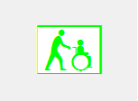
Modified by: Esri Solutions Team
License: None
Acknowledgement: None Required
Notes: None

Agriculture Animal Health Incident
Symbol Name: L1 Animal Feedlots
Symbol Picture: 
Symbol Source: ERS Homeland Security style file
Symbol Date: February 2015
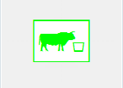
Modified by: Esri Solutions Team
License: None
Acknowledgement: None required
Notes: None

Air Incident
Symbol Name: Air Incident
Symbol Picture: 
Symbol Source: ERS Homeland Security style file
Symbol Date: February 2015

Modified by: Esri Solutions Team
License: None
Acknowledgement: None required
Notes: None

Airplane Crash
Symbol Name: Air Incident
Symbol Picture: 
Symbol Source: ERS Homeland Security style file
Symbol Date: September 2015

Modified by: Esri Solutions Team
License: None
Acknowledgement: None required
Notes: None

Airports
Symbol Name: Airport
Symbol Picture: 
Symbol Source: Forestry style file
Symbol Date: May 2014

Modified by: Esri Solutions Team
License: None
Acknowledgement: None required
Notes: None

Amphibian
Symbol Name: Toad
Symbol Picture: 
Symbol Source: The Noun Project
Symbol Date: March 2015
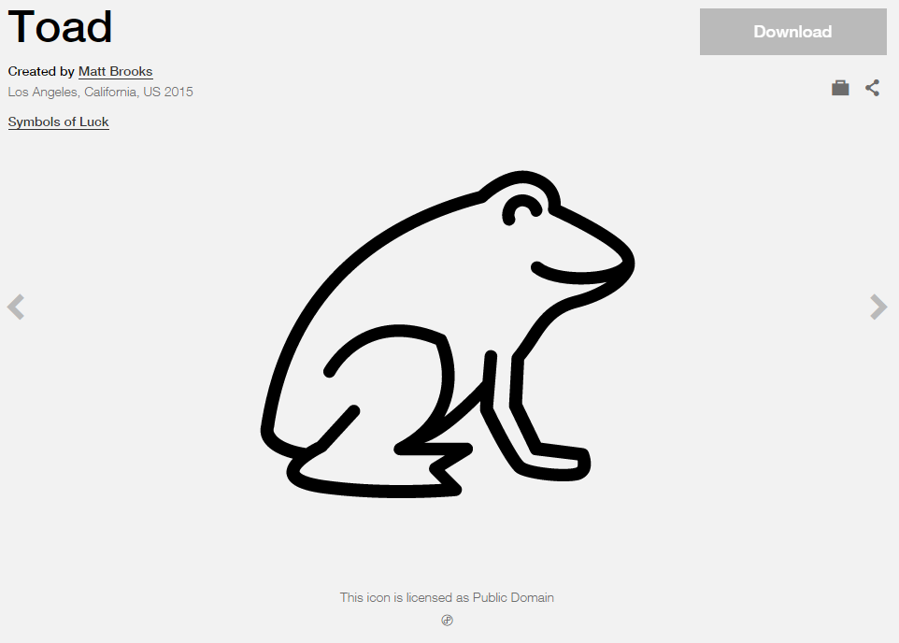
Modified by: Esri Solutions Team
License: Public Domain
Acknowledgement: None required
Notes: None

Animal Disease Outbreak
Symbol Name: Substance Abuse Service
Symbol Picture: 
Symbol Source: The Noun Project
Symbol Date: September 2015
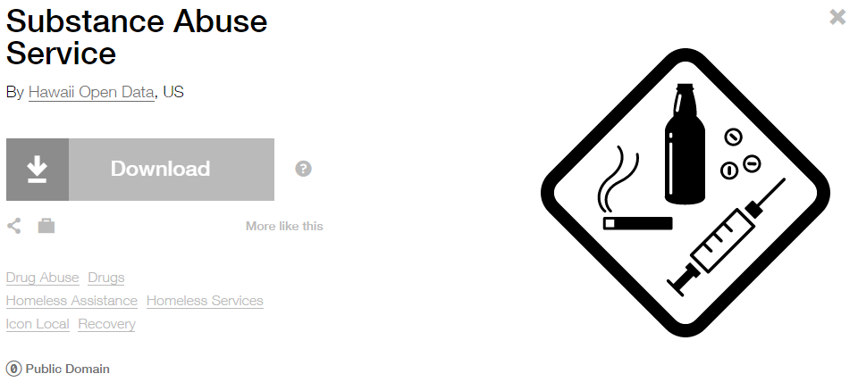
Modified by: Esri Solutions Team
License: Public Domain
Acknowledgement: None required
Notes: None

Animal Feeding Operations Permit
Symbol Name: Horse Area
Symbol Picture: 
Symbol Source: Forestry style file
Symbol Date: August 2014
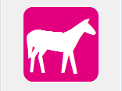
Modified by: Esri Solutions Team
License: None
Acknowledgement: None required
Notes: None

Animal Health Emergency
Symbol Name: Cross 2
Symbol Picture: 
Symbol Source: ESRI Default style file
Symbol Date: July 2015
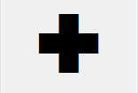
Modified by: Esri Solutions Team
License: None
Acknowledgement: None required
Notes: None

Animal Problem – Completed, In – Progress, Received, and Submitted
Symbol Name:
Symbol Picture: 
Symbol Source:
Symbol Date: March 2016
Created by: Esri Solutions Team
License: None
Acknowledgement: None required
Notes: None

Appliances
Symbol Name:
Symbol Picture: 
Symbol Source:
Symbol Date: March 2015
Created by: Esri Solutions Team
License: None
Acknowledgement: None required
Notes: None

Aquatic Resource Alteration Permit
Symbol Name: Water Recreation
Symbol Picture: 
Symbol Source: Forestry style file
Symbol Date: August 2014

Modified by: Esri Solutions Team
License: None
Acknowledgement: None required
Notes: None

Art Galleries
Symbol Name:
Symbol Picture: 
Symbol Source:
Symbol Date: March 2015
Created by: Esri Solutions Team
License: None
Acknowledgement: None required
Notes: None

Arts and Cultural Centers
Symbol Name: Arts-And-Culture
Symbol Picture: 
Symbol Source: The Noun Project
Symbol Date: February 2015
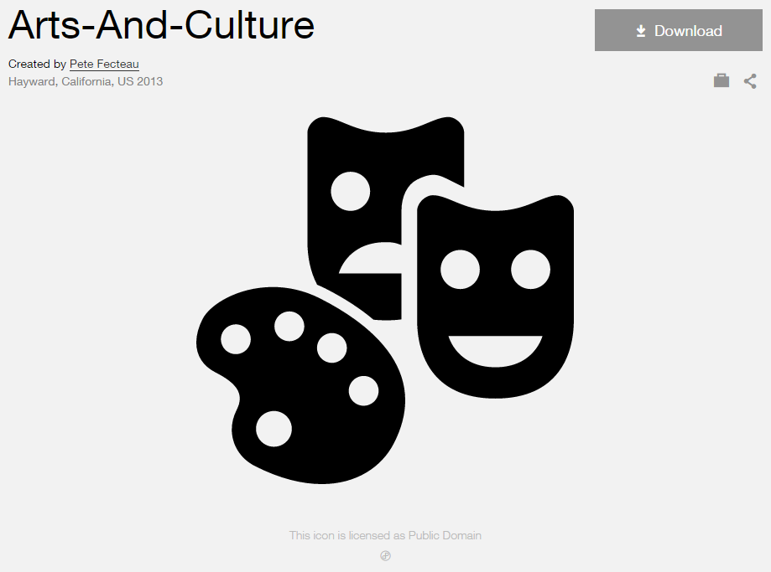
Modified by: Esri Solutions Team
License: Public Domain
Acknowledgement: None required
Notes: None

Assessment Appeal Applicant
Symbol Name: Coordinated Assessment
Symbol Picture: 
Symbol Source: The Noun Project
Symbol Date: October 2015
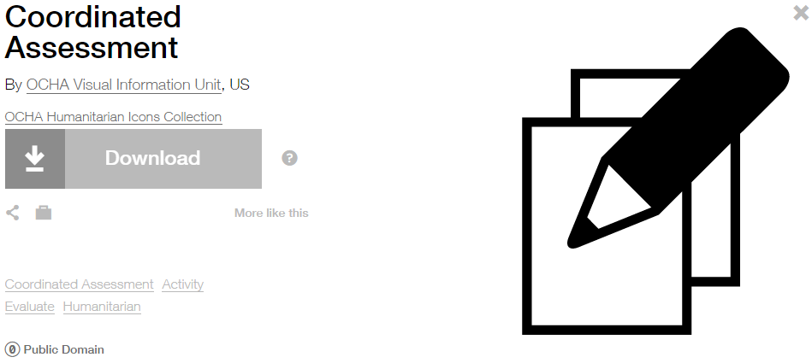
Modified by: Esri Solutions Team
License: Public Domain
Acknowledgement: None required
Notes: None

Asset Misplaced
Symbol Name: Map
Symbol Picture: 
Symbol Source: The Noun Project
Symbol Date: May 2015
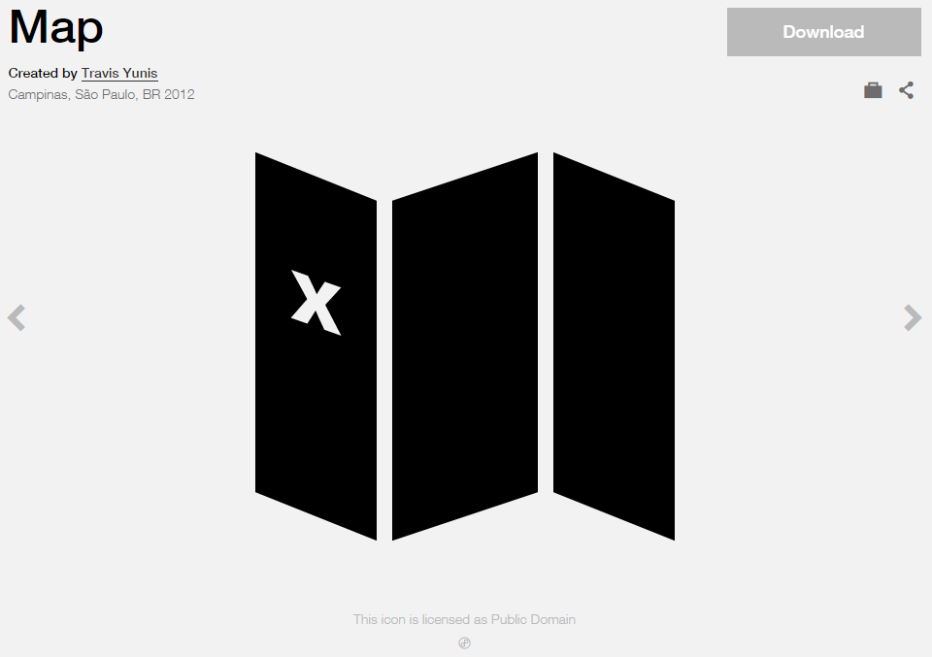
Modified by: Esri Solutions Team
License: Public Domain
Acknowledgement: None required
Notes: None

ATM
Symbol Name: ATM
Symbol Picture: 
Symbol Source: Arial Rounded MT Bold
Symbol Date: August 2015
Modified by: Esri Solutions Team
License: None
Acknowledgement: None required
Notes: None

Attic Access
Symbol Name: Attic Access
Symbol Picture: 
Symbol Source: NAPSG (National Alliance for Public Safety GIS Foundation)
Symbol Date: March 2017
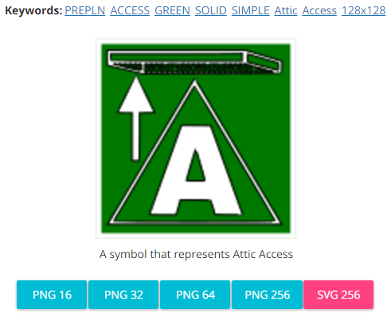
Modified by: Esri Solutions Team
License: None
Acknowledgement: None required
Notes: None

Automated External Defibrillators
Symbol Name: Bolt & Heart
Symbol Picture: 
Symbol Source: Esri style file & The Noun Project
Symbol Date: July 2015
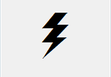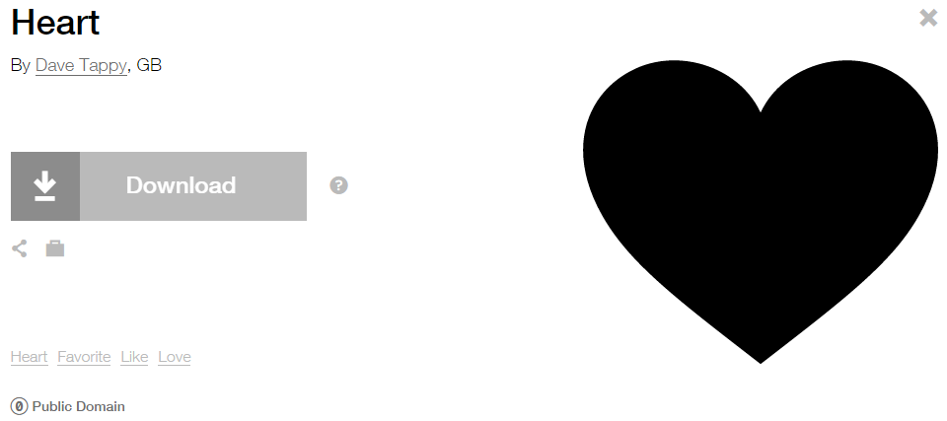
Modified by: Esri Solutions Team
License: Public Domain
Acknowledgement: None required
Notes: None

Avalanche
Symbol Name: Avalanche
Symbol Picture: 
Symbol Source: The Noun Project
Symbol Date: August 2015
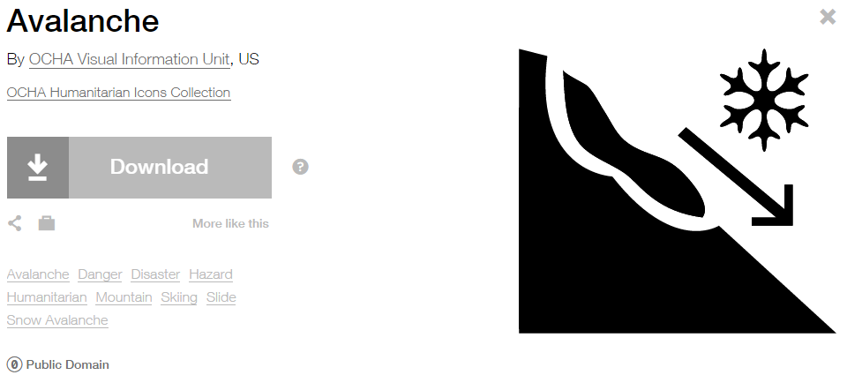
Modified by: Esri Solutions Team
License: Public Domain
Acknowledgement: None required
Notes: None

Barricade
Symbol Name:
Symbol Picture: 
Symbol Source:
Symbol Date: August 2015
Created by: Esri Solutions Team
License: None
Acknowledgement: None required
Notes: None

Basement Access
Symbol Name:
Symbol Picture: 
Symbol Source:
Symbol Date: March 2017
Modified by: Esri Solutions Team
License: None
Acknowledgement: None required
Notes: None

Biological Attack
Symbol Name: L1 Biological Sensor
Symbol Picture: 
Symbol Source: ERS Homeland Security
Symbol Date: October 2015

Modified by: Esri Solutions Team
License: None
Acknowledgement: None required
Notes: None

Bioscience Employers
Symbol Name:
Symbol Picture: 
Symbol Source:
Symbol Date: March 2015
Created by: Esri Solutions Team
License: None
Acknowledgement: None required
Notes: None

Bioretention Basin
Symbol Name: BB
Symbol Picture: 
Symbol Source: Arial Rounded MT Bold
Symbol Date: March 2015
Modified by: Esri Solutions Team
License: None
Acknowledgement: None required
Notes: None

Biosolids Permit
Symbol Name: Unicode 50
Symbol Picture: 
Symbol Source: ESRI Enviro Hazard Sites font
Symbol Date: September 2014
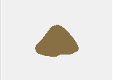
Modified by: Esri Solutions Team
License: None
Acknowledgement: None required
Notes: None

Bioswale
Symbol Name: B
Symbol Picture: 
Symbol Source: Arial Rounded MT Bold Font
Symbol Date: March 2015
Modified by: Esri Solutions Team
License: None
Acknowledgement: None required
Notes: None

Bird
Symbol Name: Bird Infestation
Symbol Picture: 
Symbol Source: Esri ERS Homeland Security style file
Symbol Date: March 2015

Modified by: Esri Solutions Team
License: None
Acknowledgement: None required
Notes: None

BMP Maintenance Violation
Symbol Name: BMP
Symbol Picture: 
Symbol Source: Arial Rounded MT Bold Font
Symbol Date: March 2015
Modified by: Esri Solutions Team
License: None
Acknowledgement: None required
Notes: None

Birth Service
Symbol Name: Baby
Symbol Picture: 
Symbol Source: The Noun Project
Symbol Date: March 2015
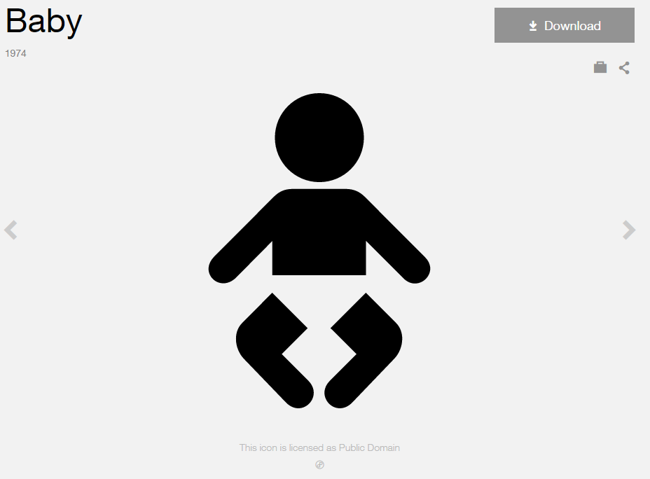
Modified by: Esri Solutions Team
License: Public Domain
Acknowledgement: None Required
Notes: None

Bleacher
Symbol Name: Waiting Room, Lounge
Symbol Picture: 
Symbol Source: Public Signs style file
Symbol Date: August 2015
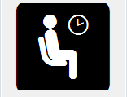
Modified by: Esri Solutions Team
License: None
Acknowledgement: None required
Notes: None

Blight Problem – Completed, In – Progress, Received, and Submitted
Symbol Name: Graffiti Removal
Symbol Picture: 
Symbol Source: The Noun Project
Symbol Date: April 2016
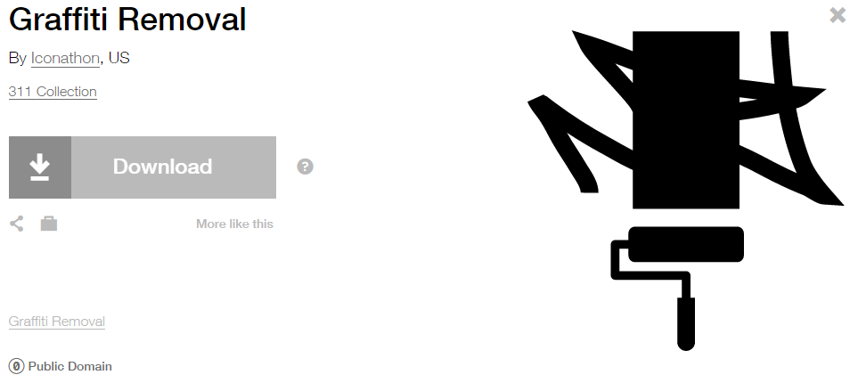
Modified by: Esri Solutions Team
License: Public Domain
Acknowledgement: None required
Notes: None

Boat Launch
Symbol Name: Boat Launch
Symbol Picture: 
Symbol Source: Forestry style file
Symbol Date: May 2014

Modified by: Esri Solutions Team
License: None
Acknowledgement: None required
Notes: None

Brickwork
Symbol Name:
Symbol Picture:
Symbol Source:
Symbol Date: May 2015
Created by: Esri Solutions Team
License: None
Acknowledgement: None required
Notes: None

Bridges
Symbol Name: Highway
Symbol Picture: 
Symbol Source: The Noun Project
Symbol Date: July 2015
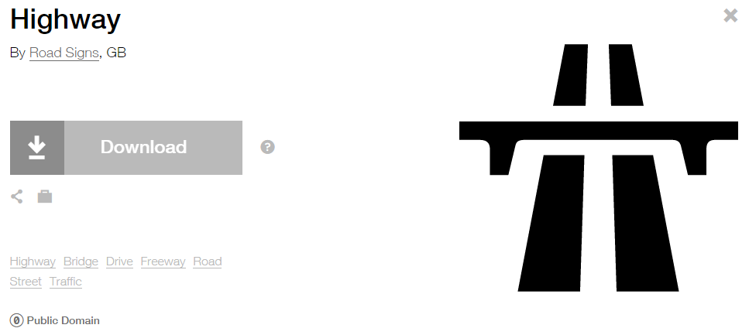
Modified by: Esri Solutions Team
License: Public Domain
Acknowledgement: None required
Notes: None

Broken
Symbol Name:
Symbol Picture:
Symbol Source:
Symbol Date: May 2015
Created by: Esri Solutions Team
License: None
Acknowledgement: None required
Notes: None

Building Access - Other
Symbol Name:
Symbol Picture: 
Symbol Source:
Symbol Date: March 2017
Modified by: Esri Solutions Team
License: None
Acknowledgement: None required
Notes: None

Building Problem – Completed, In – Progress, Received, and Submitted
Symbol Name: Building 3
Symbol Picture: 
Symbol Source: Civic style file
Symbol Date: March 2015
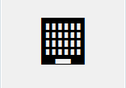
Modified by: Esri Solutions Team
License: None
Acknowledgement: None required
Notes: None

Business Location
Symbol Name: Building 3
Symbol Picture: 
Symbol Source: Civic style file
Symbol Date: April 2015
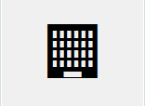
Modified by: Esri Solutions Team
License: None
Acknowledgement: None required
Notes: None

Chemical Attack
Symbol Name: Chemical Weapon
Symbol Picture: 
Symbol Source: The Noun Project
Symbol Date: October 2015
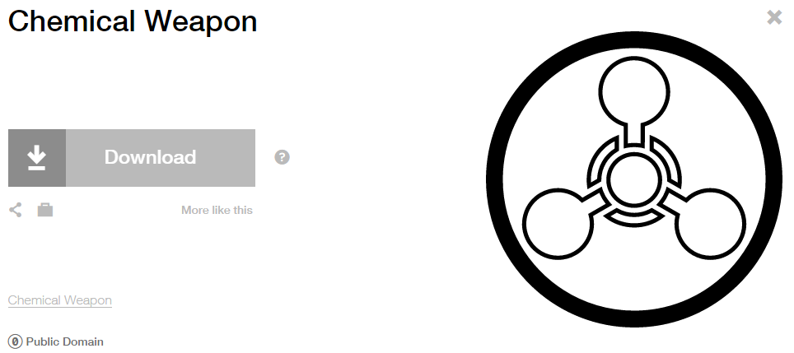
Modified by: Esri Solutions Team
License: Public Domain
Acknowledgement: None required
Notes: None

Chikungunya
Symbol Name: !
Symbol Picture: 
Symbol Source: Arial Rounded MT Bold
Symbol Date: December 2016
Modified by: Esri Solutions Team
License: None
Acknowledgement: None required
Notes: None

Call Cancelled Incident
Symbol Name: Phone 1
Symbol Picture:
Symbol Source: Civic style file
Symbol Date: November 2015
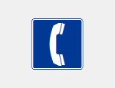
Modified by: Esri Solutions Team
License: None
Acknowledgement: None required
Notes: None

Camera
Symbol Name:
Symbol Picture: 
Symbol Source:
Symbol Date: December 2015
Created by: Esri Solutions Team
License: None
Acknowledgement: None required
Notes: None

Catch Basins - Adopted
Symbol Name:
Symbol Picture: 
Symbol Source:
Symbol Date: May 2016
Created by: Esri Solutions Team
License: None
Acknowledgement: None required
Notes: None

Catch Basins – Adopted By You
Symbol Name:
Symbol Picture: 
Symbol Source:
Symbol Date: May 2016
Created by: Esri Solutions Team
License: None
Acknowledgement: None required
Notes: None
Catch Basins - Available
Symbol Name:
Symbol Picture: 
Symbol Source:
Symbol Date: May 2016
Created by: Esri Solutions Team
License: None
Acknowledgement: None required
Notes: None

Catch Basins – Nearest Orphan
Symbol Name:
Symbol Picture: 
Symbol Source:
Symbol Date: May 2016
Created by: Esri Solutions Team
License: None
Acknowledgement: None required
Notes: None

Children’s Activities
Symbol Name: Slow Children at Play
Symbol Picture: 
Symbol Source: Transportation style file
Symbol Date: February 2015
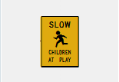
Modified by: Esri Solutions Team
License: None
Acknowledgement: None required
Notes: None

Churches
Symbol Name: Church
Symbol Picture: 
Symbol Source: Civic style file
Symbol Date: January 2015
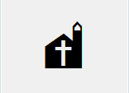
Modified by: Esri Solutions Team
License: None
Acknowledgement: None required
Notes: None

Civil Disturbance Incident
Symbol Name: Civil Disturbance
Symbol Picture: 
Symbol Source: ERS Homeland Security style file
Symbol Date: February 2015
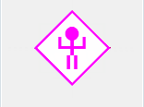
Modified by: Esri Solutions Team
License: None
Acknowledgement: None required
Notes: None

Coastal Erosion
Symbol Name: Coastal
Symbol Picture: 
Symbol Source: The Noun Project
Symbol Date: October 2015
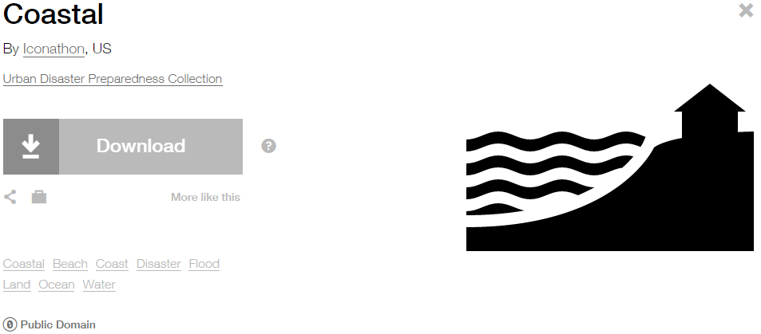
Modified by: Esri Solutions Team
License: Public Domain
Acknowledgement: None required
Notes: None

Clinics
Symbol Name: Cross 2
Symbol Picture: 
Symbol Source: ESRI style file
Symbol Date: May 2014
Modified by: Esri Solutions Team
License: None
Acknowledgement: None required
Notes: None

Collapse
Symbol Name:
Symbol Picture:
Symbol Source:
Symbol Date: May 2015
Created by: Esri Solutions Team
License: None
Acknowledgement: None required
Notes: None

College/University
Symbol Name: L1 College University
Symbol Picture: 
Symbol Source: ESRI ERS Homeland Security style file
Symbol Date: January 2015

Modified by: Esri Solutions Team
License: None
Acknowledgement: None required
Notes: None

Command Post
Symbol Name: Command Post Plain
Symbol Picture: 
Symbol Source: NAPSG (National Alliance for Public Safety GIS Foundation)
Symbol Date: February 2017
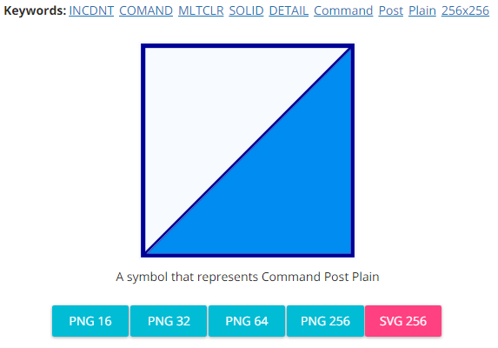
Modified by: Esri Solutions Team
License: None
Acknowledgement: None required
Notes: None

Community Center
Symbol Name: Leadership
Symbol Picture: 
Symbol Source: The Noun Project
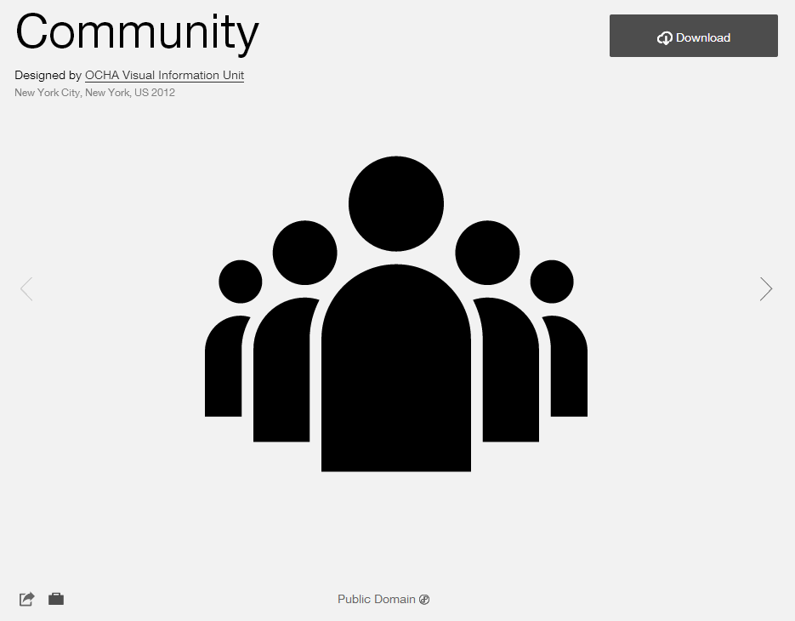
Symbol Date: February 2015
Modified by: Esri Solutions Team
License: Public Domain
Acknowledgement: None required
Notes: None

Community Event – Approved, Denied, More Information Required, Other, Proposed, Submitted, Under Review
Symbol Name:
Symbol Picture: 
Symbol Source: Arial Rounded MT Bold
Symbol Date: June 2015
Modified by: Esri Solutions Team
License: None
Acknowledgement: None required
Notes: None

Compressed Natural Gas Shut Off
Symbol Name: CNG Main_With Line
Symbol Picture: 
Symbol Source: NAPSG (National Alliance for Public Safety GIS Foundation)
Symbol Date: March 2017
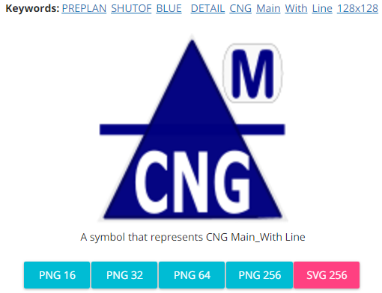
Modified by: Esri Solutions Team
License: None
Acknowledgement: None required
Notes: None

Construction/Demolition
Symbol Name: Construction
Symbol Picture: 
Symbol Source: The Noun Project
Symbol Date: March 2015
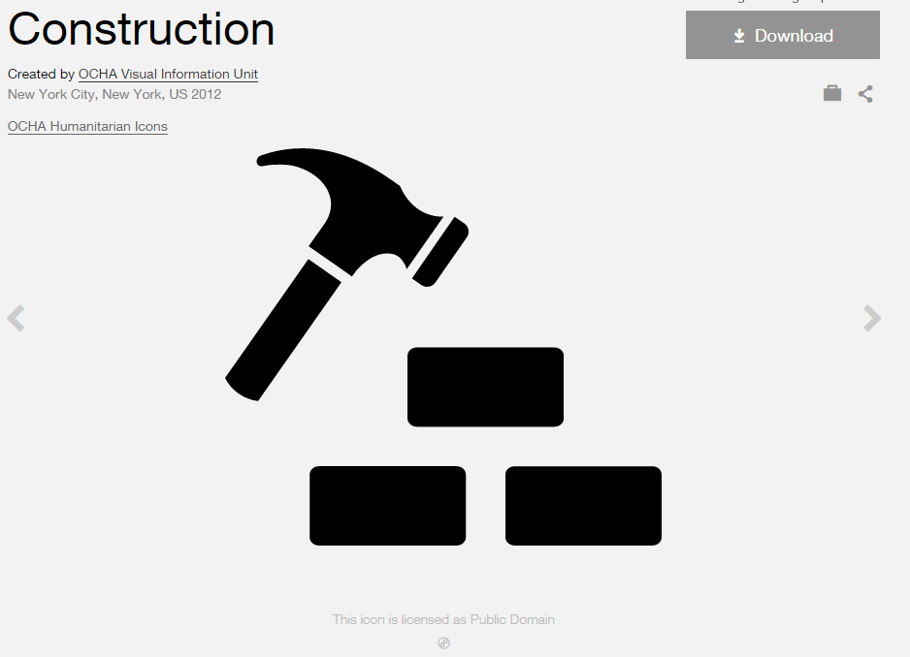
Modified by: Esri Solutions Team
License: Public Domain
Acknowledgement: None required
Notes: None

Construction Permit
Symbol Name: Construction
Symbol Picture: 
Symbol Source: The Noun Project
Symbol Date: March 2015
Modified by: Esri Solutions Team
License: Public Domain
Acknowledgement: None required
Notes: None

Cooling Center
Symbol Name: Unicode 160
Symbol Picture: 
Symbol Source: ESRI US MUTCD 3 font
Symbol Date: February 2015
Modified by: Esri Solutions Team
License: None
Acknowledgement: None required
Notes: None

Coral
Symbol Name: Coral
Symbol Picture: 
Symbol Source: Environmental style file
Symbol Date: May 2016
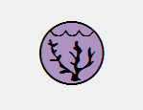
Modified by: Esri Solutions Team
License: None
Acknowledgement: None required
Notes: None

Corporate Headquarters
Symbol Name: Building 4
Symbol Picture: 
Symbol Source: Civic style file
Symbol Date: January 2015
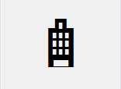
Modified by: Esri Solutions Team
License: None
Acknowledgement: None required
Notes: None

Crab
Symbol Name: Crab
Symbol Picture: 
Symbol Source: Environmental style file
Symbol Date: May 2016

Modified by: Esri Solutions Team
License: None
Acknowledgement: None required
Notes: None

Crack
Symbol Name:
Symbol Picture:
Symbol Source:
Symbol Date: May 2015
Created by: Esri Solutions Team
License: None
Acknowledgement: None required
Notes: None

Criminal Activity Incident
Symbol Name: Criminal Activity
Symbol Picture: 
Symbol Source: ERS Homeland Security style file
Symbol Date: February 2015
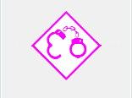
Modified by: Esri Solutions Team
License: None
Acknowledgement: None required
Notes: None

Curb Ramps
Symbol Name: Walk 1
Symbol Picture: 
Symbol Source: Transportation style file
Symbol Date: July 2015
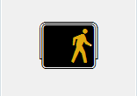
Modified by: Esri Solutions Team
License: None
Acknowledgement: None required
Notes: None

Customer Contacted
Symbol Name:
Symbol Picture: 
Symbol Source:
Symbol Date: May 2015
Created by: Esri Solutions Team
License: None
Acknowledgement: None required
Notes: None

Customer Interested
Symbol Name:
Symbol Picture: 
Symbol Source:
Symbol Date: May 2015
Created by: Esri Solutions Team
License: None
Acknowledgement: None required
Notes: None

Customer Not Contacted
Symbol Name:
Symbol Picture: 
Symbol Source:
Symbol Date: May 2015
Created by: Esri Solutions Team
License: None
Acknowledgement: None required
Notes: None

Customer Not Interested
Symbol Name:
Symbol Picture: 
Symbol Source:
Symbol Date: May 2015
Created by: Esri Solutions Team
License: None
Acknowledgement: None required
Notes: None

Cyber Incident
Symbol Name: Monitor
Symbol Picture: 
Symbol Source: The Noun Project
Symbol Date: October 2015
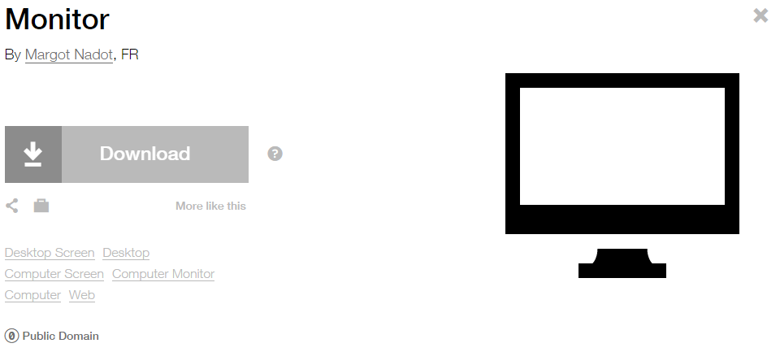
Modified by: Esri Solutions Team
License: Public Domain
Acknowledgement: None required
Notes: None

Damage Assessment - Commercial Buildings – Affected
Symbol Name: Building 3
Symbol Picture: 
Symbol Source: Civic style file
Symbol Date: March 2015
Modified by: Esri Solutions Team
License: None
Acknowledgement: None required
Notes: None

Damage Assessment - Commercial Buildings – Destroyed
Symbol Name: Building 3
Symbol Picture: 
Symbol Source: Civic style file
Symbol Date: March 2015
Modified by: Esri Solutions Team
License: None
Acknowledgement: None required
Notes: None

Damage Assessment - Commercial Buildings – Inaccessible
Symbol Name: Building 3
Symbol Picture: 
Symbol Source: Civic style file
Symbol Date: March 2015
Modified by: Esri Solutions Team
License: None
Acknowledgement: None required
Notes: None

Damage Assessment - Commercial Buildings – Major
Symbol Name: Building 3
Symbol Picture: 
Symbol Source: Civic style file
Symbol Date: March 2015
Modified by: Esri Solutions Team
License: None
Acknowledgement: None required
Notes: None

Damage Assessment - Commercial Buildings – Minor
Symbol Name: Building 3
Symbol Picture: 
Symbol Source: Civic style file
Symbol Date: March 2015
Modified by: Esri Solutions Team
License: None
Acknowledgement: None required
Notes: None

Damage Locations - High
Symbol Name: Light Bulb
Symbol Picture: 
Symbol Source: The Noun Project
Symbol Date: April 2015
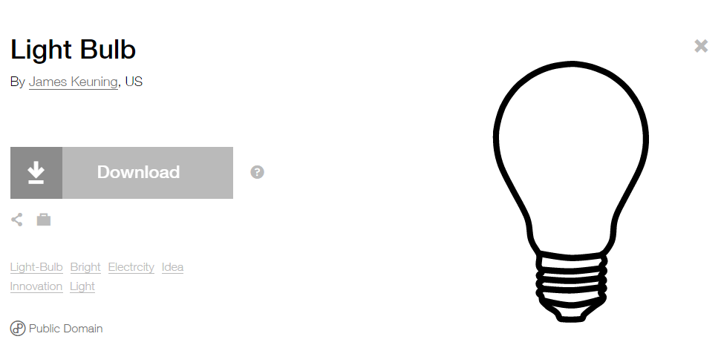
Modified by: Esri Solutions Team
License: Public Domain
Acknowledgement: None required
Notes: None

Damage Locations - Low
Symbol Name: Light Bulb
Symbol Picture: 
Symbol Source: The Noun Project
Symbol Date: April 2015
Modified by: Esri Solutions Team
License: Public Domain
Acknowledgement: None required
Notes: None

Damage Locations - Medium
Symbol Name: Light Bulb
Symbol Picture: 
Symbol Source: The Noun Project
Symbol Date: April 2015
Modified by: Esri Solutions Team
License: Public Domain
Acknowledgement: None required
Notes: None

Damage Locations - No Damage
Symbol Name: Light Bulb
Symbol Picture: 
Symbol Source: The Noun Project
Symbol Date: April 2015
Modified by: Esri Solutions Team
License: Public Domain
Acknowledgement: None required
Notes: None

Damage Locations – Other/Unknown
Symbol Name: Light Bulb
Symbol Picture: 
Symbol Source: The Noun Project
Symbol Date: April 2015
Modified by: Esri Solutions Team
License: Public Domain
Acknowledgement: None required
Notes: None

Damage Locations - Urgent
Symbol Name: Light Bulb
Symbol Picture: 
Symbol Source: The Noun Project
Symbol Date: April 2015
Modified by: Esri Solutions Team
License: Public Domain
Acknowledgement: None required
Notes: None

Damage Locations - High
Symbol Name: Gas
Symbol Picture: 
Symbol Source: The Noun Project
Symbol Date: April 2015
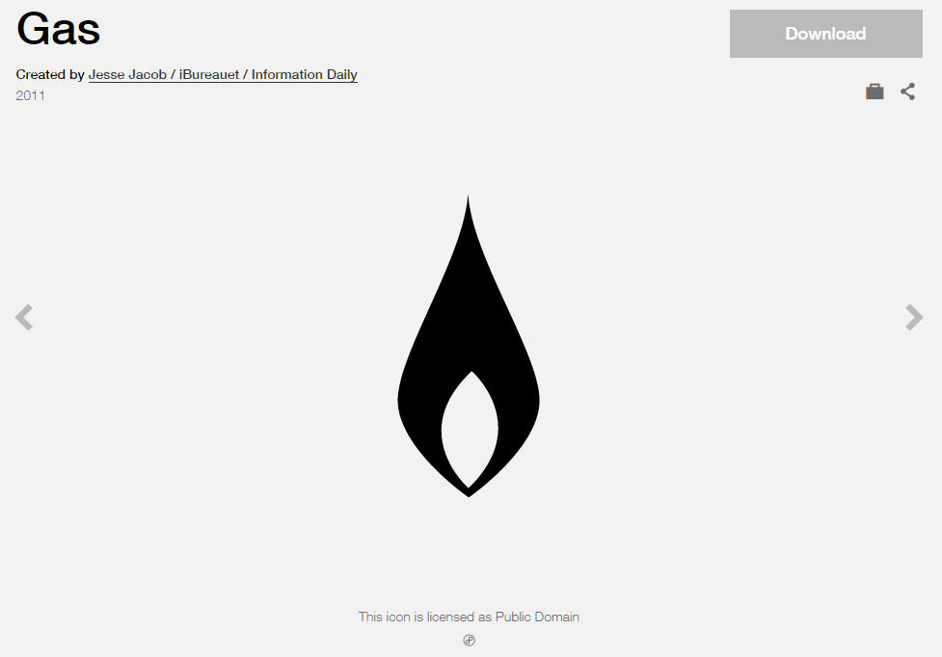
Modified by: Esri Solutions Team
License: Public Domain
Acknowledgement: None required
Notes: None

Damage Locations - Low
Symbol Name: Gas
Symbol Picture: 
Symbol Source: The Noun Project
Symbol Date: April 2015
Modified by: Esri Solutions Team
License: Public Domain
Acknowledgement: None required
Notes: None

Damage Locations - Medium
Symbol Name: Gas
Symbol Picture: 
Symbol Source: The Noun Project
Symbol Date: April 2015
Modified by: Esri Solutions Team
License: Public Domain
Acknowledgement: None required
Notes: None

Damage Locations – No Damage
Symbol Name: Gas
Symbol Picture: 
Symbol Source: The Noun Project
Symbol Date: April 2015
Modified by: Esri Solutions Team
License: Public Domain
Acknowledgement: None required
Notes: None

Damage Locations - No Damage
Symbol Name: Gas
Symbol Picture:
Symbol Source: The Noun Project
Symbol Date: April 2015
Modified by: Esri Solutions Team
License: Public Domain
Acknowledgement: None required
Notes: None

Damage Locations - Other/Unknown
Symbol Name: Gas
Symbol Picture: 
Symbol Source: The Noun Project
Symbol Date: April 2015
Modified by: Esri Solutions Team
License: Public Domain
Acknowledgement: None required
Notes: None

Damage Locations - Urgent
Symbol Name: Gas
Symbol Picture: 
Symbol Source: The Noun Project
Symbol Date: April 2015
Modified by: Esri Solutions Team
License: Public Domain
Acknowledgement: None required
Notes: None

Damage Assessment - Residential Buildings – Affected
Symbol Name: House 2
Symbol Picture: 
Symbol Source: Business style file
Symbol Date: March 2015
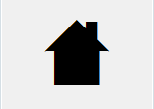
Modified by: Esri Solutions Team
License: None
Acknowledgement: None required
Notes: None

Damage Assessment - Residential Buildings – Destroyed
Symbol Name: House 2
Symbol Picture: 
Symbol Source: Business style file
Symbol Date: March 2015
Modified by: Esri Solutions Team
License: None
Acknowledgement: None required
Notes: None

Damage Assessment - Residential Buildings – Inaccessible
Symbol Name: House 2
Symbol Picture: 
Symbol Source: Business style file
Symbol Date: March 2015
Modified by: Esri Solutions Team
License: None
Acknowledgement: None required
Notes: None

Damage Assessment - Residential Buildings – Major
Symbol Name: House 2
Symbol Picture: 
Symbol Source: Business style file
Symbol Date: March 2015
Modified by: Esri Solutions Team
License: None
Acknowledgement: None required
Notes: None

Damage Assessment - Residential Buildings – Minor
Symbol Name: House 2
Symbol Picture: 
Symbol Source: Business style file
Symbol Date: March 2015
Modified by: Esri Solutions Team
License: None
Acknowledgement: None required
Notes: None

Damage Assessment - Public Facilities - CAT-A-Debris-Removal
Symbol Name: A
Symbol Picture: 
Symbol Source: Arial Rounded MT Bold Font
Symbol Date: March 2015
Modified by: Esri Solutions Team
License: None
Acknowledgement: None required
Notes: None

Damage Assessment - Public Facilities - CAT-B-Protective-Measures
Symbol Name: B
Symbol Picture: 
Symbol Source: Arial Rounded MT Bold
Symbol Date: March 2015
Modified by: Esri Solutions Team
License: None
Acknowledgement: None required
Notes: None

Damage Assessment - Public Facilities - CAT-C-Roads-and-Bridges
Symbol Name: C
Symbol Picture: 
Symbol Source: Arial Rounded MT Bold
Symbol Date: March 2015
Modified by: Esri Solutions Team
License: None
Acknowledgement: None required
Notes: None

Damage Assessment - Public Facilities - CAT-D-Water-Control-Facilities
Symbol Name: D
Symbol Picture: 
Symbol Source: Arial Rounded MT Bold
Symbol Date: March 2015
Modified by: Esri Solutions Team
License: None
Acknowledgement: None required
Notes: None

Damage Assessment - Public Facilities - CAT-E-Public-Buildings
Symbol Name: E
Symbol Picture: 
Symbol Source: Arial Rounded MT Bold
Symbol Date: March 2015
Modified by: Esri Solutions Team
License: None
Acknowledgement: None required
Notes: None

Damage Assessment - Public Facilities - CAT-F-Public-Utilities
Symbol Name: F
Symbol Picture: 
Symbol Source: Arial Rounded MT Bold
Symbol Date: March 2015
Modified by: Esri Solutions Team
License: None
Acknowledgement: None required
Notes: None

Damage Assessment - Public Facilities - CAT-G-Parks-Other
Symbol Name: G
Symbol Picture: 
Symbol Source: Arial Rounded MT Bold
Symbol Date: March 2015
Modified by: Esri Solutions Team
License: None
Acknowledgement: None required
Notes: None

Debris Mixed
Symbol Name:
Symbol Picture: 
Symbol Source: ESRI Enviro Hazard Sites Unicode 50
Symbol Date: March 2015
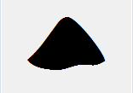
Modified by: Esri Solutions Team
License: None
Acknowledgement: None required
Notes: None

Dangerous Animal
Symbol Name:
Symbol Picture: 
Symbol Source:
Symbol Date: June 2015
Created by: Esri Solutions Team
License: None
Acknowledgement: None required
Notes: None

Debris Other
Symbol Name:
Symbol Picture: 
Symbol Source: ESRI Enviro Hazard Sites Unicode 50
Symbol Date: May 2014
Modified by: Esri Solutions Team
License: None
Acknowledgement: None required
Notes: None

Dam Failure
Symbol Name: Dam
Symbol Picture: 
Symbol Source: Forestry style file
Symbol Date: September 2015
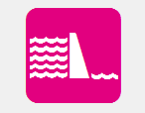
Modified by: Esri Solutions Team
License: None
Acknowledgement: None required
Notes: None

Deformed
Symbol Name:
Symbol Picture:
Symbol Source:
Symbol Date: May 2015
Created by: Esri Solutions Team
License: None
Acknowledgement: None required
Notes: None

Dengue
Symbol Name: !
Symbol Picture: 
Symbol Source: Arial Rounded MT Bold
Symbol Date: December 2016
Modified by: Esri Solutions Team
License: None
Acknowledgement: None required
Notes: None

Department of Public Works
Symbol Name: L3 Traffic Control Point
Symbol Picture: 
Symbol Source: ERS Traffic Control Point
Symbol Date: March 2015
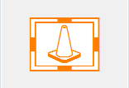
Modified by: Esri Solutions Team
License: None
Acknowledgement: None required
Notes: None

Deposits
Symbol Name:
Symbol Picture:
Symbol Source:
Symbol Date: May 2015
Created by: Esri Solutions Team
License: None
Acknowledgement: None required
Notes: None

Dialysis
Symbol Name: Kidney
Symbol Picture: 
Symbol Source: The Noun Project
Symbol Date: March 2015
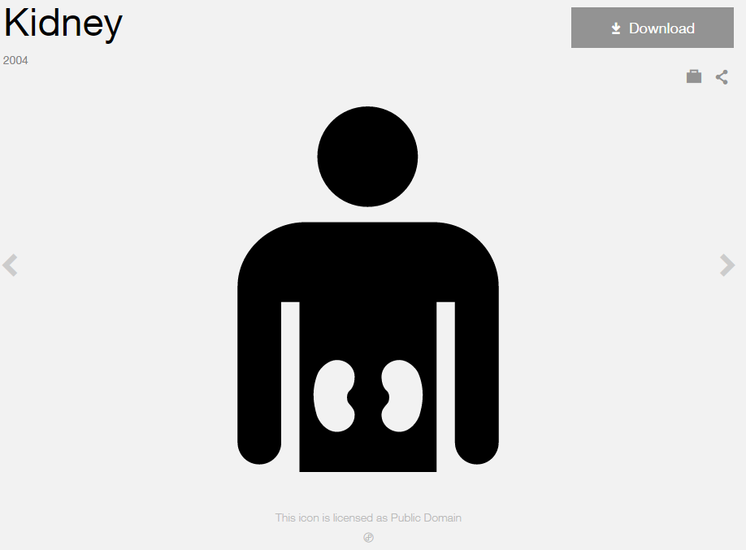
Modified by: Esri Solutions Team
License: Public Domain
Acknowledgement: None Required
Notes: None

Disaster Recovery Center
Symbol Name: Community
Symbol Picture: 
Symbol Source: The Noun Project
Symbol Date: February 2015
Modified by: Esri Solutions Team
License: Public Domain
Acknowledgement: None required
Notes: None

Discharge Point
Symbol Name: Discharge Point
Symbol Picture: 
Symbol Source: Water Wastewater style file
Symbol Date: April 2015
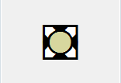
Modified by: Esri Solutions Team
License: None
Acknowledgement: None required
Notes: None

Dissatisfied Customer
Symbol Name:
Symbol Picture: 
Symbol Source:
Symbol Date: June 2015
Created by: Esri Solutions Team
License: None
Acknowledgement: None required
Notes: None

Drinking Fountain
Symbol Name: Drinking Fountain
Symbol Picture: 
Symbol Source: Public Signs style file
Symbol Date: August 2015

Modified by: Esri Solutions Team
License: None
Acknowledgement: None required
Notes: None

Ditch and Channel Stabilization Violation
Symbol Name: DCS
Symbol Picture: 
Symbol Source: Arial Rounded MT Bold Font
Symbol Date: March 2015
Modified by: Esri Solutions Team
License: None
Acknowledgement: None required
Notes: None

Door
Symbol Name: Close The Door
Symbol Picture: 
Symbol Source: The Noun Project
Symbol Date: February 2017
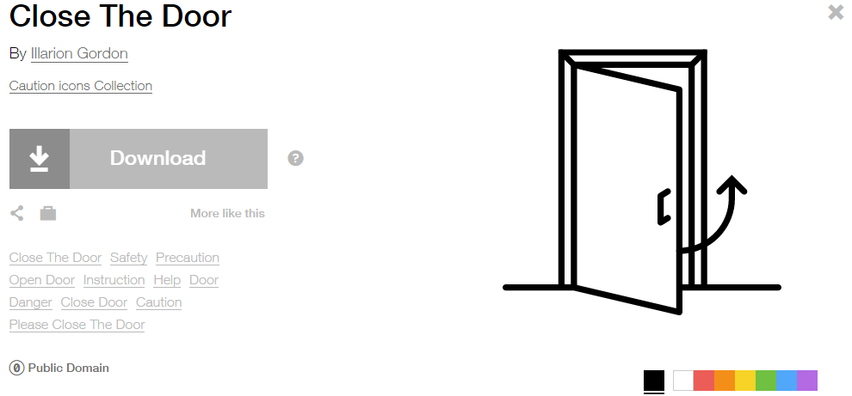
Modified by: Esri Solutions Team
License: Public Domain
Acknowledgement: None required
Notes: None

Drainage Management Violation
Symbol Name: DM
Symbol Picture: 
Symbol Source: Arial Rounded MT Bold Font
Symbol Date: March 2015
Modified by: Esri Solutions Team
License: None
Acknowledgement: None required
Notes: None

Drought
Symbol Name: Drought
Symbol Picture: 
Symbol Source: The Noun Project
Symbol Date: September 2015
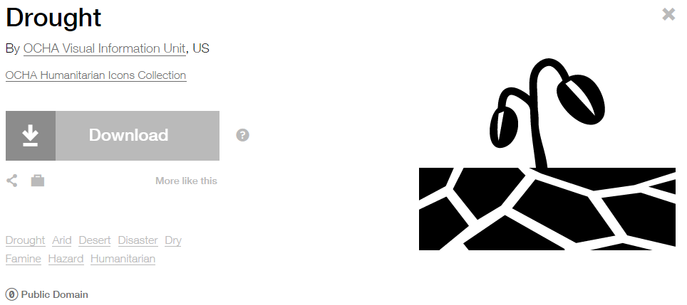
Modified by: Esri Solutions Team
License: Public Domain
Acknowledgement: None required
Notes: None

Earthquake
Symbol Name: Earthquake
Symbol Picture: 
Symbol Source: The Noun Project
Symbol Date: September 2015
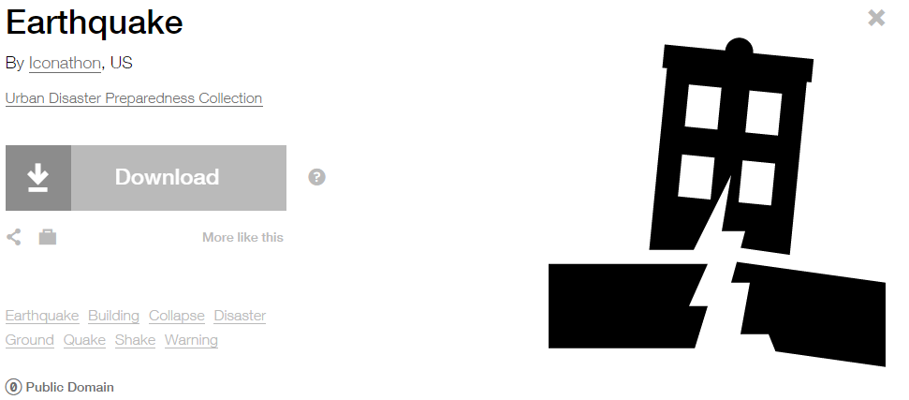
Modified by: Esri Solutions Team
License: Public Domain
Acknowledgement: None required
Notes: None

Electrical Shut Off
Symbol Name: Electrical Inverter Shutoff
Symbol Picture: 
Symbol Source: NAPSG (National Alliance for Public Safety GIS Foundation) – NAPSG_PrePlan.style file
Symbol Date: March 2017

Modified by: Esri Solutions Team
License: None
Acknowledgement: None required
Notes: None

Elevator
Symbol Name: Elevator
Symbol Picture: 
Symbol Source: Public Signs style file
Symbol Date: March 2017
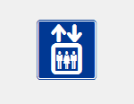
Modified by: Esri Solutions Team
License: None
Acknowledgement: None required
Notes: None

Erosion Protection Violation
Symbol Name: EP
Symbol Picture: 
Symbol Source: Arial Rounded MT Bold Font
Symbol Date: March 2015
Modified by: Esri Solutions Team
License: None
Acknowledgement: None required
Notes: None

Emergency Assistance
Symbol Name: Protection
Symbol Picture: 
Symbol Source: The Noun Project
Symbol Date: July 2015
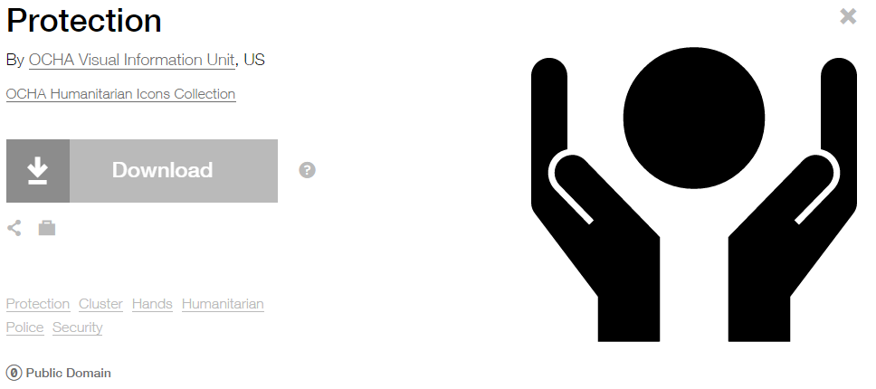
Modified by: Esri Solutions Team
License: Public Domain
Acknowledgement: None required
Notes: None

Emergency Clothing Distribution Center
Symbol Name: Clothes
Symbol Picture: 
Symbol Source: The Noun Project
Symbol Date: July 2015
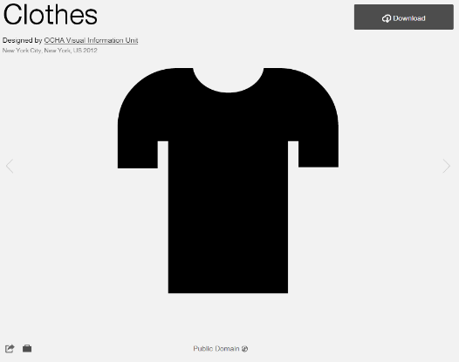
Modified by: Esri Solutions Team
License: Public Domain
Acknowledgement: None required
Notes: None

Emergency Medical Services
Symbol Name: Emergency Medical Services
Symbol Picture: 
Symbol Source: Transportation style file
Symbol Date: July 2015
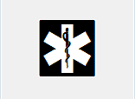
Modified by: Esri Solutions Team
License: None
Acknowledgement: None required
Notes: None

Encephalitis - (Eastern-Equine)
Symbol Name: !
Symbol Picture: 
Symbol Source: Arial Rounded MT Bold
Symbol Date: December 2016
Modified by: Esri Solutions Team
License: None
Acknowledgement: None required
Notes: None

Encephalitis - (Japanese)
Symbol Name: !
Symbol Picture: 
Symbol Source: Arial Rounded MT Bold
Symbol Date: December 2016
Modified by: Esri Solutions Team
License: None
Acknowledgement: None required
Notes: None

Encephalitis - (La-Crosse)
Symbol Name: !
Symbol Picture: 
Symbol Source: Arial Rounded MT Bold
Symbol Date: December 2016
Modified by: Esri Solutions Team
License: None
Acknowledgement: None required
Notes: None

Encephalitis - (Saint-Louis)
Symbol Name: !
Symbol Picture: 
Symbol Source: Arial Rounded MT Bold
Symbol Date: December 2016
Modified by: Esri Solutions Team
License: None
Acknowledgement: None required
Notes: None

Encephalitis - (Venezuelan-Equine)
Symbol Name: !
Symbol Picture: 
Symbol Source: Arial Rounded MT Bold
Symbol Date: December 2016
Modified by: Esri Solutions Team
License: None
Acknowledgement: None required
Notes: None

Encephalitis - (Western-Equine)
Symbol Name: !
Symbol Picture: 
Symbol Source: Arial Rounded MT Bold
Symbol Date: December 2016
Modified by: Esri Solutions Team
License: None
Acknowledgement: None required
Notes: None

Epidemic
Symbol Name: Epidemic
Symbol Picture: 
Symbol Source: The Noun Project
Symbol Date: September 2015
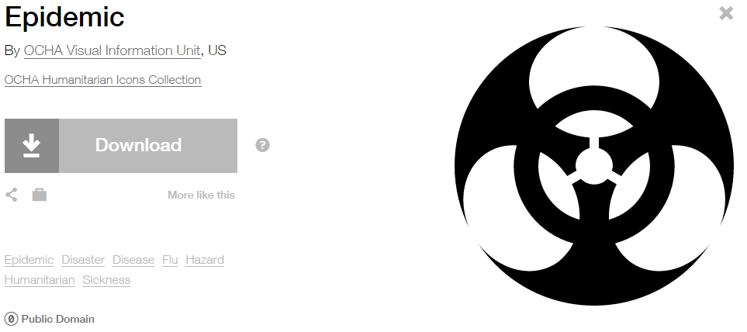
Modified by: Esri Solutions Team
License: Public Domain
Acknowledgement: None required
Notes: None

Erosion Protection Violation
Symbol Name: EP
Symbol Picture:
Symbol Source: Arial Rounded MT Bold Font
Symbol Date: March 2015
Modified by: Esri Solutions Team
License: None
Acknowledgement: None required
Notes: None

Escalator
Symbol Name: Escalator
Symbol Picture: 
Symbol Source: Public Signs style file
Symbol Date: March 2017
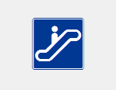
Modified by: Esri Solutions Team
License: None
Acknowledgement: None required
Notes: None

Event
Symbol Name: 1
Symbol Picture: 
Symbol Source: Arial Rounded MT Bold
Symbol Date: June 2015
Modified by: Esri Solutions Team
License: None
Acknowledgement: None required
Notes: None

Event Calendar
Symbol Name: 1
Symbol Picture: 
Symbol Source: Arial Rounded MT Bold
Symbol Date: June 2015
Modified by: Esri Solutions Team
License: None
Acknowledgement: None required
Notes: None

Event Plan Notes
Symbol Name:
Symbol Picture: 
Symbol Source:
Symbol Date: August 2015
Created by: Esri Solutions Team
License: None
Acknowledgement: None required
Notes: None

Event Sign
Symbol Name:
Symbol Picture: 
Symbol Source:
Symbol Date: August 2015
Created by: Esri Solutions Team
License: None
Acknowledgement: None required
Notes: None

Explosive Attack
Symbol Name: Conflict
Symbol Picture: 
Symbol Source: The Noun Project
Symbol Date: October 2015
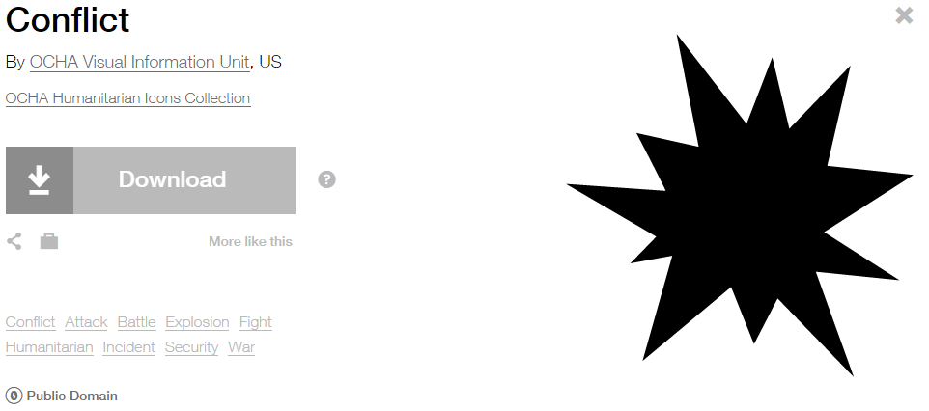
Modified by: Esri Solutions Team
License: Public Domain
Acknowledgement: None required
Notes: None

Extreme Heat
Symbol Name: Unicode 113
Symbol Picture: 
Symbol Source: ESRI Enviro Hazard Analysis
Symbol Date: October 2015

Modified by: Esri Solutions Team
License: Public Domain
Acknowledgement: None required
Notes: None

Failure of equipment or heat source
Symbol Name: Cog
Symbol Picture:
Symbol Source: The Noun Project
Symbol Date: December 2015
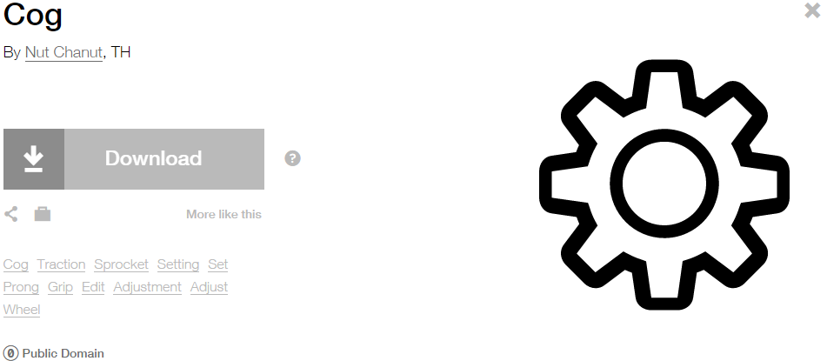
Modified by: Esri Solutions Team
License: Public Domain
Acknowledgement: None required
Notes: None

False Alarm Incident
Symbol Name: Phone 1
Symbol Picture:
Symbol Source: Civic style file
Symbol Date: November 2015
Modified by: Esri Solutions Team
License: None
Acknowledgement: None required
Notes: None

Filariasis
Symbol Name: !
Symbol Picture: 
Symbol Source: Arial Rounded MT Bold
Symbol Date: December 2016
Created by: Esri Solutions Team
License: None
Acknowledgement: None required
Notes: None

Field Interviews
Symbol Name:
Symbol Picture: 
Symbol Source:
Symbol Date: July 2015
Created by: The Solutions Team
License: None
Acknowledgement: None required
Notes: None

Fire Alarm Control Panel
Symbol Name: Alarm Control Panel FAC
Symbol Picture: 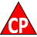
Symbol Source: NAPSG (National Alliance for Public Safety GIS Foundation)
Symbol Date: March 2017
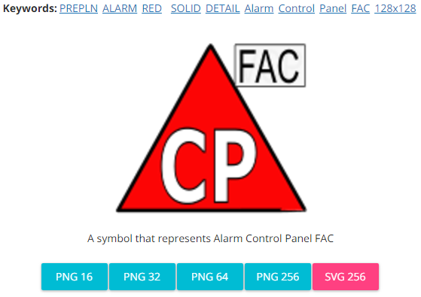
Modified by: The Solutions Team
License: None
Acknowledgement: None required
Notes: None

Fire Alarm Reset Panel
Symbol Name: Reset Panel
Symbol Picture: 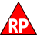
Symbol Source: NAPSG (National Alliance for Public Safety GIS Foundation)
Symbol Date: March 2017
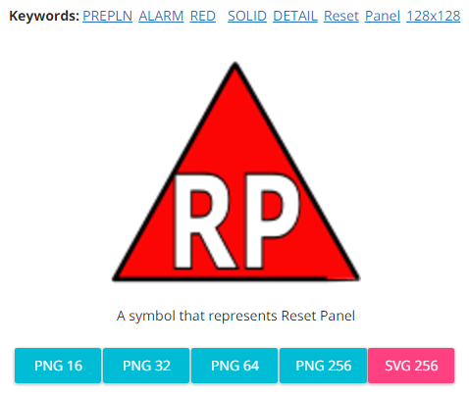
Modified by: The Solutions Team
License: None
Acknowledgement: None required
Notes: None

Fire and Hazardous Materials
Symbol Name: Fire Incident
Symbol Picture: 
Symbol Source: ERS Homeland Security style file
Symbol Date: July 2015

Modified by: Esri Solutions Team
License: None
Acknowledgement: None required
Notes: None

Fire Annunciator
Symbol Name: Alarm Communications Annunciator Panel
Symbol Picture: 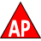
Symbol Source: NAPSG (National Alliance for Public Safety GIS Foundation)
Symbol Date: March 2017
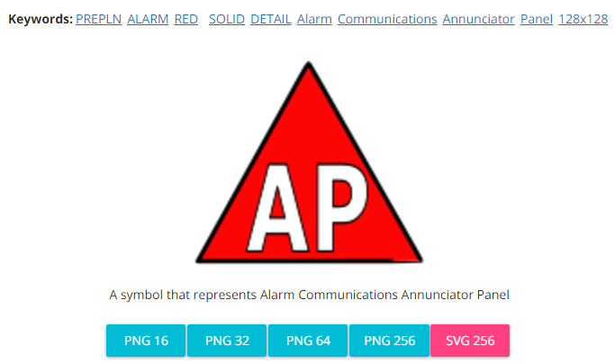
Modified by: The Solutions Team
License: None
Acknowledgement: None required
Notes: None

Fire Department Connection
Symbol Name: Fire Department Connection FDC1
Symbol Picture: 
Symbol Source: NAPSG (National Alliance for Public Safety GIS Foundation)
Symbol Date: March 2017
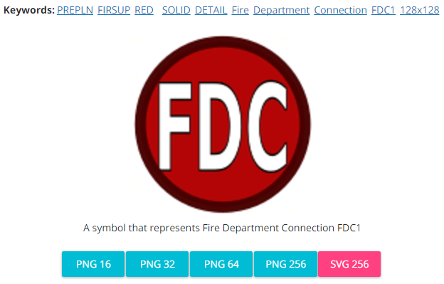
Modified by: The Solutions Team
License: None
Acknowledgement: None required
Notes: None

Fire Escape
Symbol Name: Use Stairs 1
Symbol Picture: 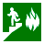
Symbol Source: Hazmat style file
Symbol Date: March 2017
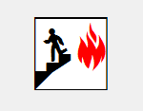
Modified by: The Solutions Team
License: None
Acknowledgement: None required
Notes: None

Fire Extinguisher
Symbol Name: Fire Extinguisher
Symbol Picture: 
Symbol Source: Public Signs style file
Symbol Date: August 2015
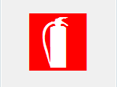
Modified by: Esri Solutions Team
License: None
Acknowledgement: None required
Notes: None

Fire Incident
Symbol Name: Fire Incident
Symbol Picture: 
Symbol Source: ERS Homeland Security style file
Symbol Date: February 2015
Modified by: Esri Solutions Team
License: None
Acknowledgement: None required
Notes: None

Fire Safety Survey - Inspected
Symbol Name:
Symbol Picture: 
Symbol Source:
Symbol Date: April 2014
Created by: Esri Solutions Team
License: None
Acknowledgement: None required
Notes: None

Fire Safety Survey – Not Inspected
Symbol Name:
Symbol Picture: 
Symbol Source:
Symbol Date: April 2014
Created by: Esri Solutions Team
License: None
Acknowledgement: None required
Notes: None

Fire Stations
Symbol Name: Fire Rescue 2
Symbol Picture: 
Symbol Source: Hazmat style file
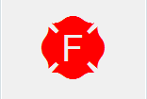
Symbol Date: February 2015
Modified by: Esri Solutions Team
License: None
Acknowledgement: None required
Notes: None

Fire Suppression Systems - Other
Symbol Name:
Symbol Picture: 
Symbol Source:
Symbol Date: March 2017
Created by: Esri Solutions Team
License: None
Acknowledgement: None required
Notes: None

Fireworks Launch Site
Symbol Name: Unicode 81
Symbol Picture: 
Symbol Source: Esri Crime Analysis font
Symbol Date: August 2015
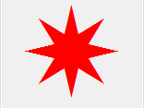
Modified by: Esri Solutions Team
License: None
Acknowledgement: None required
Notes: None

First Aid
Symbol Name:
Symbol Picture:
Symbol Source:
Symbol Date: August 2015
Created by: Esri Solutions Team
License: None
Acknowledgement: None required
Notes: None

First Aid Station
Symbol Name:
Symbol Picture: 
Symbol Source:
Symbol Date: July 2015
Created by: Esri Solutions Team
License: None
Acknowledgement: None required
Notes: None

Fishing Site
Symbol Name: Fishing Area
Symbol Picture: 
Symbol Source: Forestry style file
Symbol Date: May 2014

Modified by: Esri Solutions Team
License: None
Acknowledgement: None Required
Notes: None

Flood
Symbol Name: House 2 and Water Recreation
Symbol Picture: 
Symbol Source: Business style file and Forestry style file
Symbol Date: June 2015
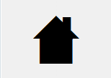
Modified by: Esri Solutions Team
License: None
Acknowledgement: None required
Notes: None

Flooding
Symbol Name: Highway
Symbol Picture: 
Symbol Source: The Noun Project
Symbol Date: June 2015
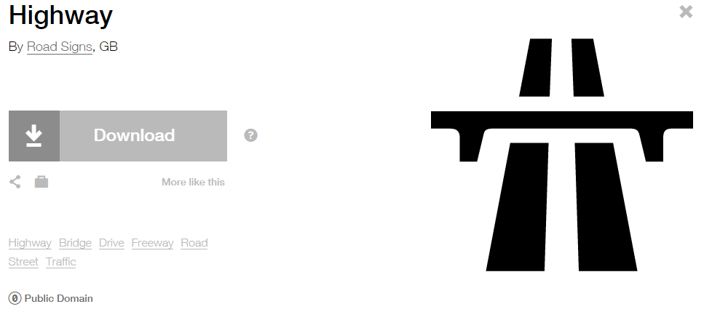
Modified by: Esri Solutions Team
License: Public Domain
Acknowledgement: None required
Notes: None

Fog
Symbol Name: Fog
Symbol Picture: 
Symbol Source: Weather style file
Symbol Date: January 2016
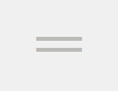
Modified by: Esri Solutions Team
License: None
Acknowledgement: None required
Notes: None

Food Concessions
Symbol Name: Fast Food
Symbol Picture: 
Symbol Source: The Noun Project
Symbol Date: August 2015
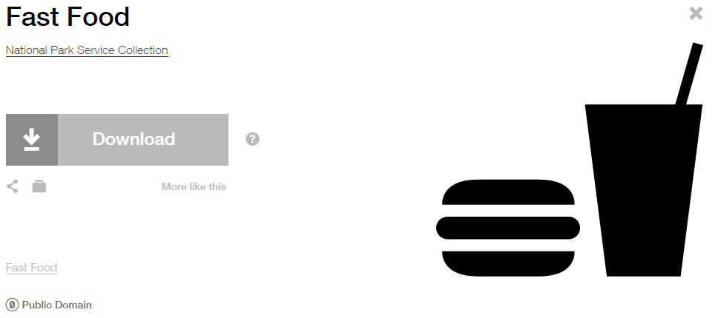
Modified by: Esri Solutions Team
License: Public Domain
Acknowledgement: None required
Notes: None

Food Distribution Center
Symbol Name: Food Warehouse
Symbol Picture: 
Symbol Source: The Noun Project
Symbol Date: July 2015
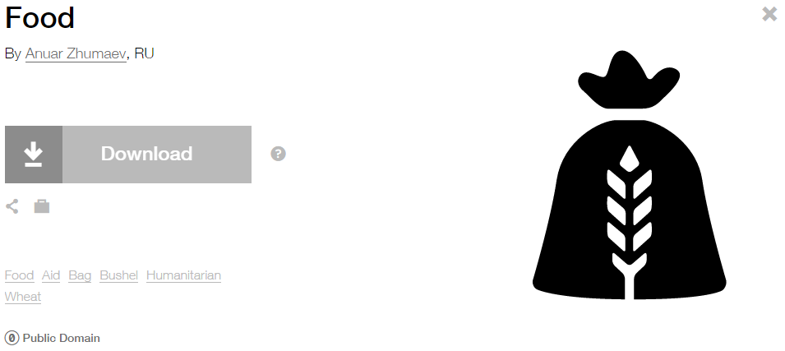
Modified by: Esri Solutions Team
License: Public Domain
Acknowledgement: None required
Notes: None

Food Preparation Equipment
Symbol Name: Kettle
Symbol Picture: 
Symbol Source: The Noun Project
Symbol Date: August 2015

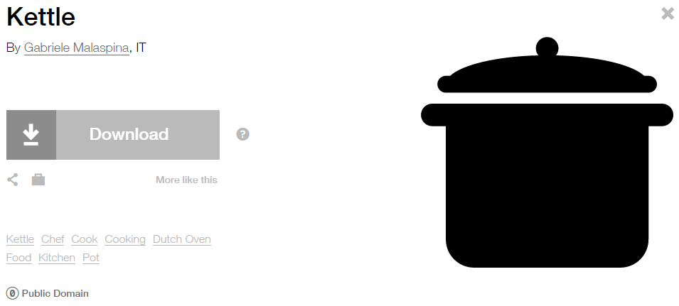
Modified by: Esri Solutions Team
License: Public Domain
Acknowledgement: None required
Notes: None

Foreclosure
Symbol Name: House 2
Symbol Picture: 
Symbol Source: Business style file
Symbol Date: February 2017
Modified by: Esri Solutions Team
License: None
Acknowledgement: None Required
Notes: None

For Sale
Symbol Name: House 2
Symbol Picture: 
Symbol Source: Business style file
Symbol Date: February 2017
Modified by: Esri Solutions Team
License: None
Acknowledgement: None Required
Notes: None

Form Completed and Attached
Symbol Name: Paper-Clip
Symbol Picture: 
Symbol Source: The Noun Project
Symbol Date: May 2015
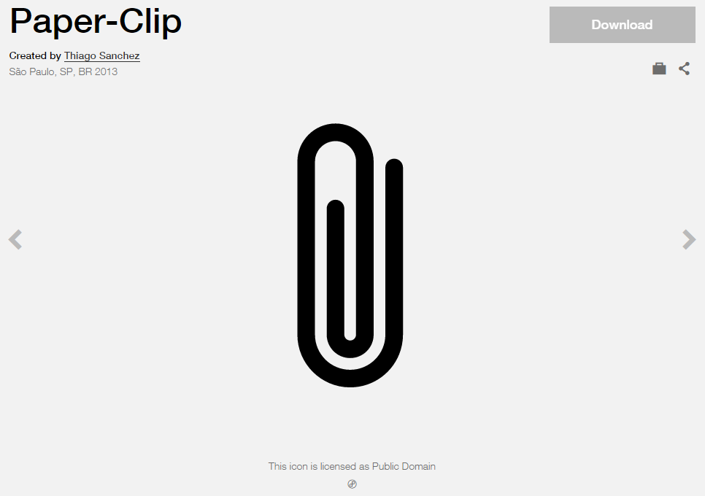
Modified by: Esri Solutions Team
License: Public Domain
Acknowledgement: None required
Notes: None

Form Received by Office
Symbol Name: Mail
Symbol Picture: 
Symbol Source: The Noun Project
Symbol Date: May 2015
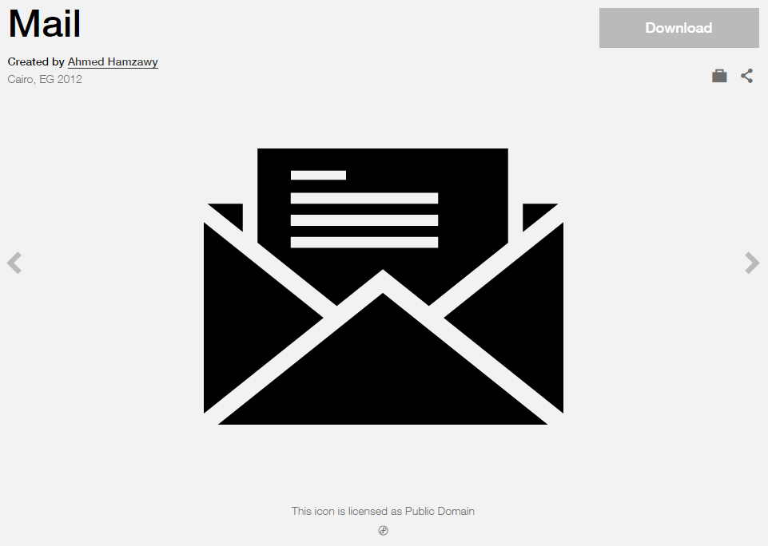
Modified by: Esri Solutions Team
License: Public Domain
Acknowledgement: None required
Notes: None

Form Recorded by Office
Symbol Name: Write
Symbol Picture: 
Symbol Source: The Noun Project
Symbol Date: May 2015
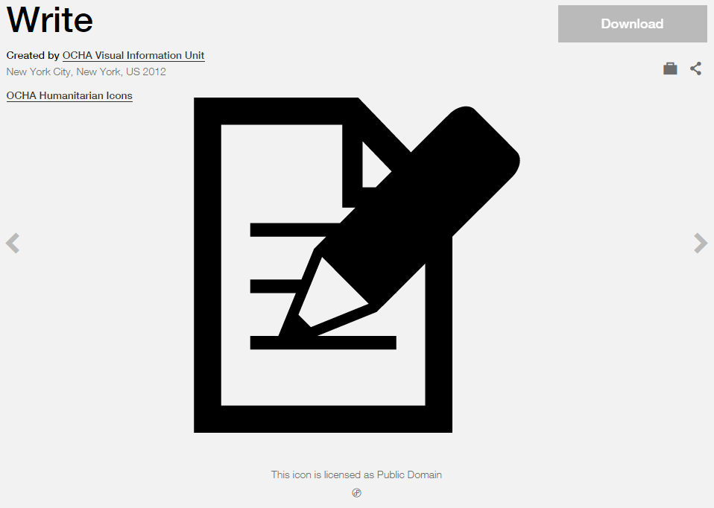
Modified by: Esri Solutions Team
License: Public Domain
Acknowledgement: None required
Notes: None

Fracture
Symbol Name:
Symbol Picture:
Symbol Source:
Symbol Date: May 2015
Created by: Esri Solutions Team
License: None
Acknowledgement: None required
Notes: None

Fortification
Symbol Name:
Symbol Picture:
Symbol Source:
Symbol Date: August 2015
Created by: Esri Solutions Team
License: None
Acknowledgement: None required
Notes: None

Gas Shut Off
Symbol Name: Gas Shutoff – Natural Main
Symbol Picture: 
Symbol Source: NAPSG (National Alliance for Public Safety GIS Foundation) – NAPSG_Preplans.style file
Symbol Date: March 2017

Modified by: Esri Solutions Team
License: None
Acknowledgement: None required
Notes: None

Gate
Symbol Name:
Symbol Picture: 
Symbol Source:
Symbol Date: August 2015
Created by: Esri Solutions Team
License: None
Acknowledgement: None required
Notes: None

Generator
Symbol Name: Power
Symbol Picture: 
Symbol Source: The Noun Project
Symbol Date: August 2015
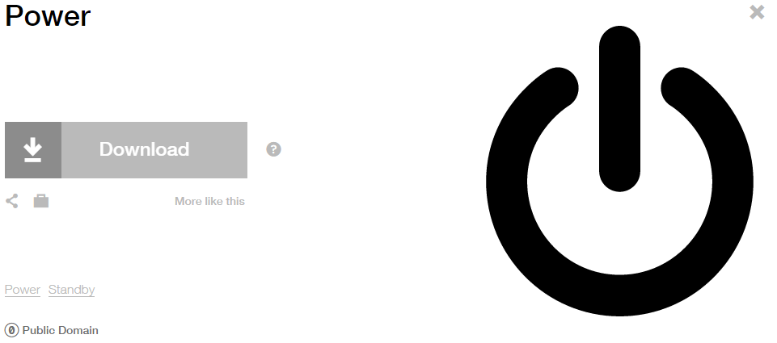
Modified by: Esri Solutions Team
License: Public Domain
Acknowledgement: None required
Notes: None

Geologic Incident
Symbol Name: Rock Collecting
Symbol Picture: 
Symbol Source: Forestry style file
Symbol Date: February 2015

Modified by: Esri Solutions Team
License: None
Acknowledgement: None required
Notes: None

Green Landscaping
Symbol Name: GL
Symbol Picture: 
Symbol Source: Arial Rounded MT Bold Font
Symbol Date: March 2015
Modified by: Esri Solutions Team
License: None
Acknowledgement: None required
Notes: None

Green Roof
Symbol Name: GR
Symbol Picture: 
Symbol Source: Arial Rounded MT Bold Font
Symbol Date: March 2015
Modified by: Esri Solutions Team
License: None
Acknowledgement: None required
Notes: None

Grout Test and Seal
Symbol Name:
Symbol Picture:
Symbol Source:
Symbol Date: May 2015
Created by: Esri Solutions Team
License: None
Acknowledgement: None required
Notes: None

Guest Services
Symbol Name: Ticket Purchase 2
Symbol Picture: 
Symbol Source: Public Signs style file
Symbol Date: August 2015

Modified by: Esri Solutions Team
License: None
Acknowledgement: None required
Notes: None

Habilitation Facility
Symbol Name: Charity
Symbol Picture: 
Symbol Source: The Noun Project
Symbol Date: March 2015
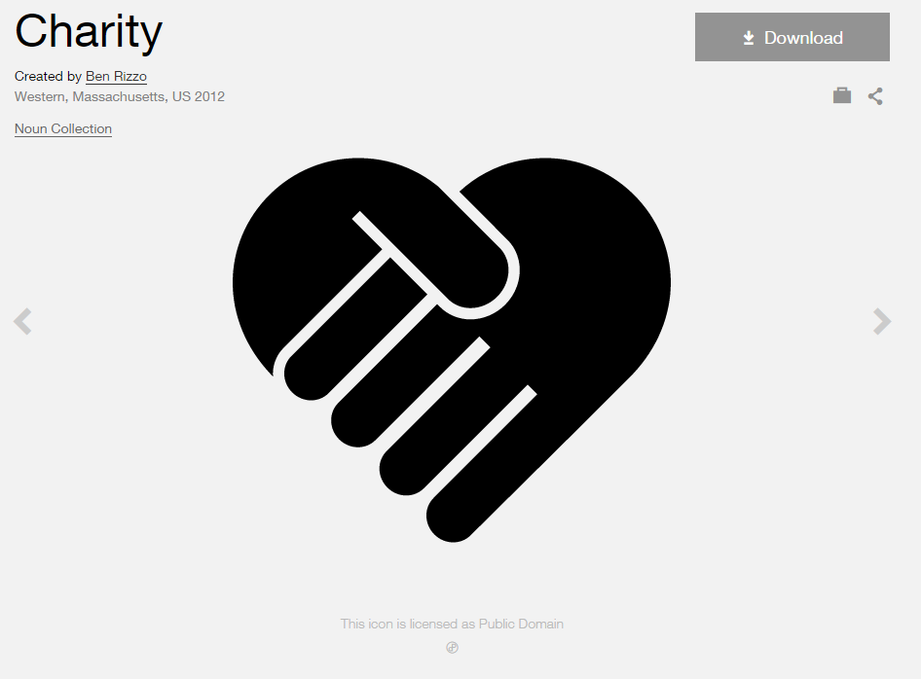
Modified by: Esri Solutions Team
License: Public Domain
Acknowledgement: None Required
Notes: None

Hail
Symbol Name:
Symbol Picture: 
Symbol Source:
Symbol Date: January 2016
Created by: Esri Solutions Team
License: None
Acknowledgement: None required
Notes: None

Handicap Access
Symbol Name: Handicapped 1
Symbol Picture: 
Symbol Source: ESRI style file
Symbol Date: August 2015
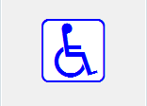
Modified by: Esri Solutions Team
License: None
Acknowledgement: None required
Notes: None

Hazardous
Symbol Name: Hazardous
Symbol Picture: 
Symbol Source: Environmental style file
Symbol Date: June 2015
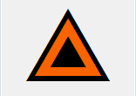
Modified by: Esri Solutions Team
License: None
Acknowledgement: None required
Notes: None

Hazardous Condition Incident
Symbol Name: !
Symbol Picture:
Symbol Source: Arial Rounded MT Bold
Symbol Date: July 2015
Modified by: Esri Solutions Team
License: None
Acknowledgement: None required
Notes: None

Hazardous Materials
Symbol Name: NFPA Diamond
Symbol Picture: 
Symbol Source: Hazmat style file
Symbol Date: March 2017
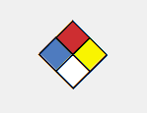
Modified by: Esri Solutions Team
License: None
Acknowledgement: None required
Notes: None

Hazardous Materials Release
Symbol Name: Hazardous Material
Symbol Picture: 
Symbol Source: ERS Homeland Security style file
Symbol Date: February 2015
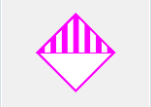
Modified by: Esri Solutions Team
License: None
Acknowledgement: None required
Notes: None

Hose Connections
Symbol Name: Fire Hose Connection Hose Connection
Symbol Picture: 
Symbol Source: NAPSG (National Alliance for Public Safety GIS Foundation)
Symbol Date: March 2017
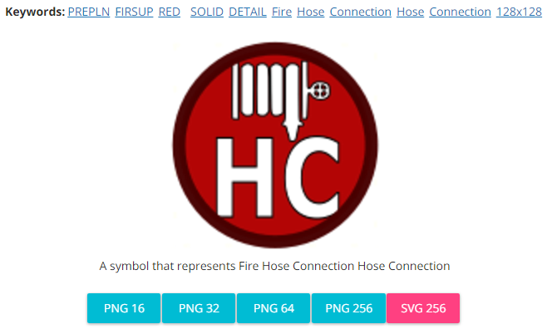
Modified by: Esri Solutions Team
License: None
Acknowledgement: None required
Notes: None

Golf Courses
Symbol Name: Golf Course 1
Symbol Picture: 
Symbol Source: Civic style file
Symbol Date: January 2015
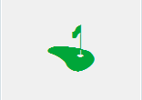
Modified by: Esri Solutions Team
License: None
Acknowledgement: None required
Notes: None

Hazardous Facilities
Symbol Name: Hazardous Material Incident
Symbol Picture: 
Symbol Source: ERS Homeland Security style file
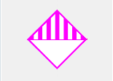
Symbol Date: February 2015
Modified by: Esri Solutions Team
License: None
Acknowledgement: None required
Notes: None

Hazardous Material Incident
Symbol Name: Hazardous Material Incident
Symbol Picture: 
Symbol Source: ERS Homeland Security style file
Symbol Date: February 2015
Modified by: Esri Solutions Team
License: None
Acknowledgement: None required
Notes: None

Hazardous Waste
Symbol Name: Hazardous Material
Symbol Picture:
Symbol Source: ERS Homeland Security style file
Symbol Date: February 2015
Modified by: Esri Solutions Team
License: None
Acknowledgement: None required
Notes: None

Hazards - Other
Symbol Name: Hazardous
Symbol Picture: 
Symbol Source: Environmental style file
Symbol Date: June 2015
Modified by: Esri Solutions Team
License: None
Acknowledgement: None required
Notes: None

Hazmat
Symbol Name: Fire Incident
Symbol Picture: 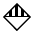
Symbol Source: ERS Homeland Security style file
Symbol Date: July 2015
Modified by: Esri Solutions Team
License: None
Acknowledgement: None required
Notes: None

Healthcare Facilities
Symbol Name: Cross 2
Symbol Picture: 
Symbol Source: ESRI style file
Symbol Date: May 2014
Modified by: Esri Solutions Team
License: None
Acknowledgement: None required
Notes: None

Health Problem – Completed, In – Progress, Received, and Submitted
Symbol Name: First Aid Kit
Symbol Picture: 
Symbol Source: The Noun Project
Symbol Date: April 2016
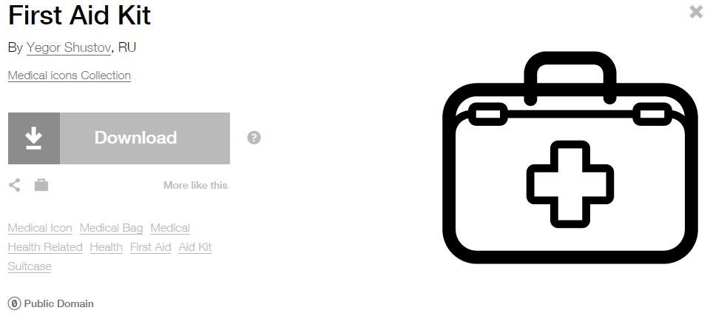
Modified by: Esri Solutions Team
License: Public Domain
Acknowledgement: None required
Notes: None

Hearing
Symbol Name: Hear
Symbol Picture: 
Symbol Source: The Noun Project
Symbol Date: March 2015
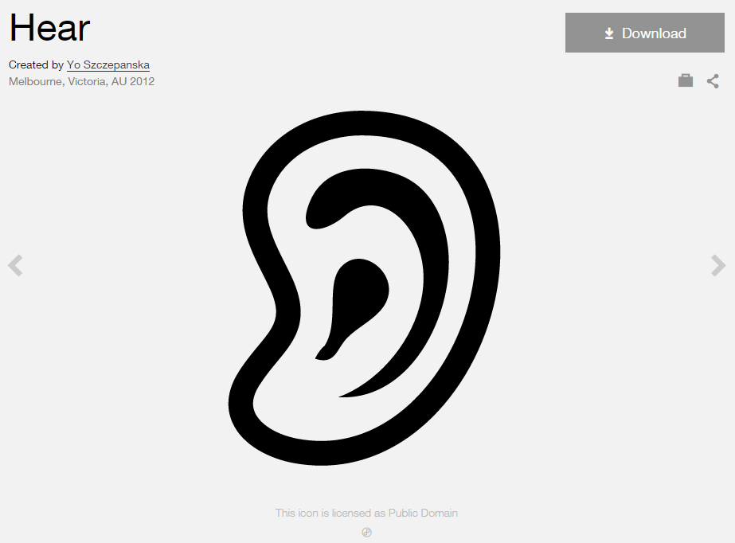
Modified by: Esri Solutions Team
License: Public Domain
Acknowledgement: None Required
Notes: None

Heater - Cooler
Symbol Name: Unicode 160 & Unicode 113
Symbol Picture: 
Symbol Source: ESRI US MUTCD 3 font & ESRI Enviro Hazard Analysis
Symbol Date: August 2015
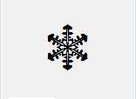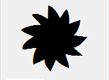
Modified by: Esri Solutions Team
License: None
Acknowledgement: None required
Notes: None

Hole
Symbol Name:
Symbol Picture:
Symbol Source:
Symbol Date: May 2015
Created by: Esri Solutions Team
License: None
Acknowledgement: None required
Notes: None

Home Health, Residential Care
Symbol Name: House 2
Symbol Picture: 
Symbol Source: Business style file
Symbol Date: March 2015
Modified by: Esri Solutions Team
License: None
Acknowledgement: None Required
Notes: None

Hospice
Symbol Name: Bunk-Bed
Symbol Picture: 
Symbol Source: The Noun Project
Symbol Date: March 2015
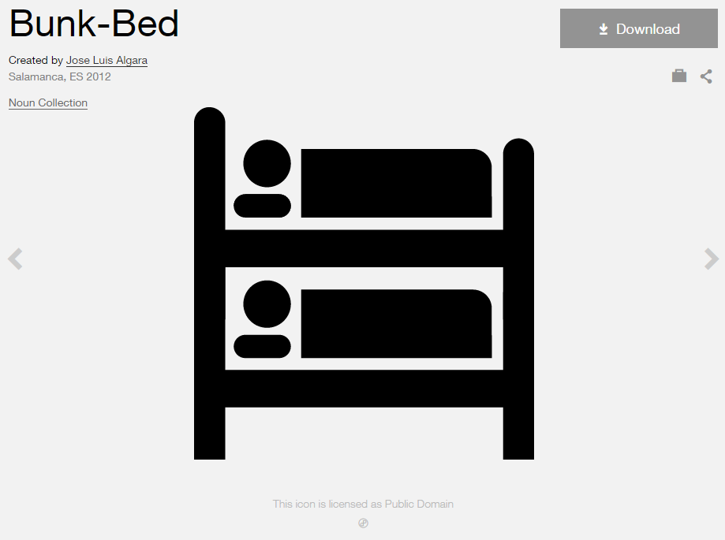
Modified by: Esri Solutions Team
License: Public Domain
Acknowledgement: None Required
Notes: None

Hospital
Symbol Name: Hospital
Symbol Picture: 
Symbol Source: Business style file
Symbol Date: January 2015
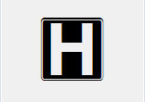
Modified by: Esri Solutions Team
License: None
Acknowledgement: None required
Notes: None

Hurricane
Symbol Name: Hurricane
Symbol Picture: 
Symbol Source: Weather style file
Symbol Date: September 2015

Modified by: Esri Solutions Team
License: None
Acknowledgement: None required
Notes: None

Hydrant - Adopted
Symbol Name: Fire Hydrant 1
Symbol Picture: 
Symbol Source: Hazmat style file
Symbol Date: March 2015
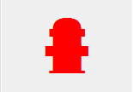
Modified by: Esri Solutions Team
License: None
Acknowledgement: None required
Notes: None

Hydrant – Adopted By You
Symbol Name: Fire Hydrant 1
Symbol Picture: 
Symbol Source: Hazmat style file
Symbol Date: March 2015
Modified by: Esri Solutions Team
License: None
Acknowledgement: None required
Notes: None
Hydrant – Available
Symbol Name: Fire Hydrant 1
Symbol Picture:
Symbol Source: Hazmat style file
Symbol Date: March 2015
Modified by: Esri Solutions Team
License: None
Acknowledgement: None required
Notes: None

Hydrant - Inoperable
Symbol Name: Fire Hydrant 1
Symbol Picture: 
Symbol Source: Hazmat style file
Symbol Date: March 2015
Modified by: Esri Solutions Team
License: None
Acknowledgement: None required
Notes: None

Hydrant - Operable
Symbol Name: Fire Hydrant 1
Symbol Picture: 
Symbol Source: Hazmat style file
Symbol Date: March 2015
Modified by: Esri Solutions Team
License: None
Acknowledgement: None required
Notes: None

Hydrant – Out of Order
Symbol Name: Fire Hydrant 1
Symbol Picture: 
Symbol Source: Hazmat style file
Symbol Date: March 2015
Modified by: Esri Solutions Team
License: None
Acknowledgement: None required
Notes: None

Hydrant – Unclear
Symbol Name: Fire Hydrant 1
Symbol Picture: 
Symbol Source: Hazmat style file
Symbol Date: March 2015
Modified by: Esri Solutions Team
License: None
Acknowledgement: None required
Notes: None

Hydro-Meteorological Incident
Symbol Name:
Symbol Picture: 
Symbol Source:
Symbol Date: February 2015
Created by: Esri Solutions Team
License: None
Acknowledgement: None required
Notes: None

Hydrostatic Permit
Symbol Name: Droplet, Water
Symbol Picture: 
Symbol Source: Environmental style file
Symbol Date: September 2014
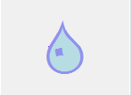
Modified by: Esri Solutions Team
License: None
Acknowledgement: None required
Notes: None

Ice Snow Problem – Completed, In – Progress, Received, and Submitted
Symbol Name: Snow
Symbol Picture: 
Symbol Source: The Noun Project
Symbol Date: January 2016
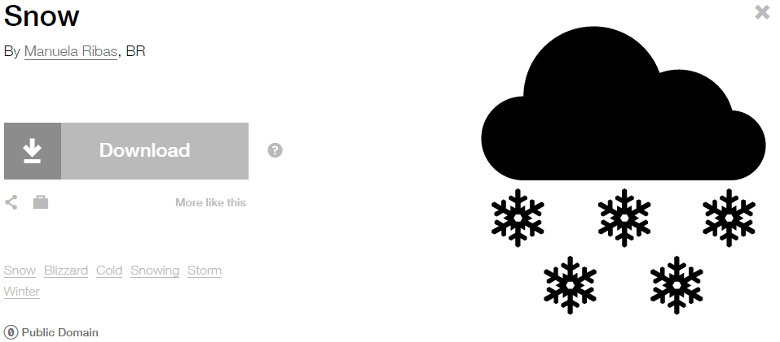
Modified by: Esri Solutions Team
License: Public Domain
Acknowledgement: None required
Notes: None

Incident
Symbol Name: !
Symbol Picture: 
Symbol Source: Arial Rounded MT Bold
Symbol Date: May 2015
Modified by: Esri Solutions Team
License: None
Acknowledgement: None required
Notes: None

Incident Command Post
Symbol Name: Incident Command Post
Symbol Picture: 
Symbol Source: Forestry style file
Symbol Date: July 2015

Modified by: Esri Solutions Team
License: None
Acknowledgement: None required
Notes: None

Incident Management
Symbol Name: !
Symbol Picture: 
Symbol Source: Arial Rounded MT Bold
Symbol Date: July 2015
Modified by: Esri Solutions Team
License: None
Acknowledgement: None required
Notes: None

Incorrect Attribute
Symbol Name: Map
Symbol Picture: 
Symbol Source: The Noun Project
Symbol Date: May 2015
Modified by: Esri Solutions Team
License: Public Domain
Acknowledgement: None required
Notes: None

Incubators
Symbol Name: Business-Incubator
Symbol Picture: 
Symbol Source: The Noun Project
Symbol Date: March 2015
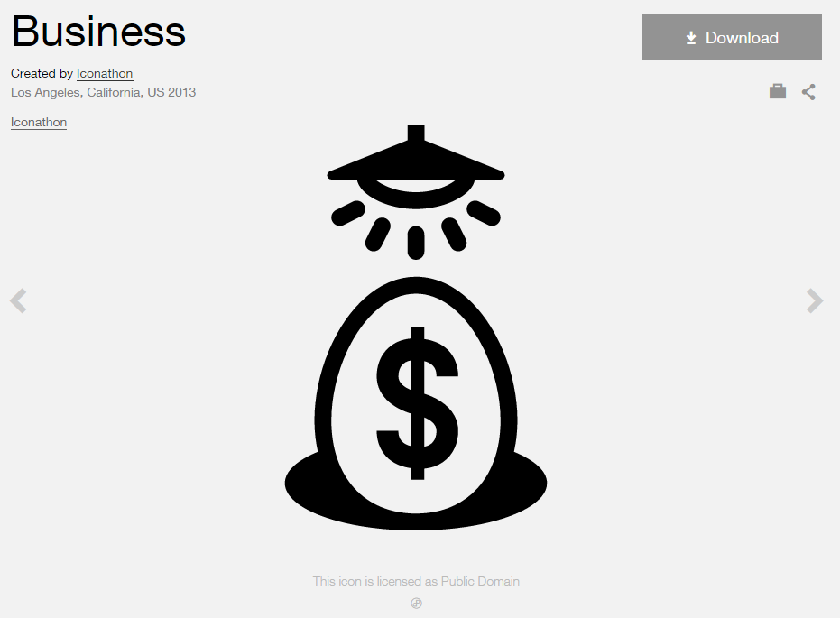
Modified by: Esri Solutions Team
License: Public Domain
Acknowledgement: None required
Notes: None

Individual Permit
Symbol Name:
Symbol Picture: 
Symbol Source:
Symbol Date: September 2014
Created by: Esri Solutions Team
License: None
Acknowledgement: None required
Notes: None

Infestation Incident
Symbol Name: Ant
Symbol Picture: 
Symbol Source: The Noun Project
Symbol Date: March 2015
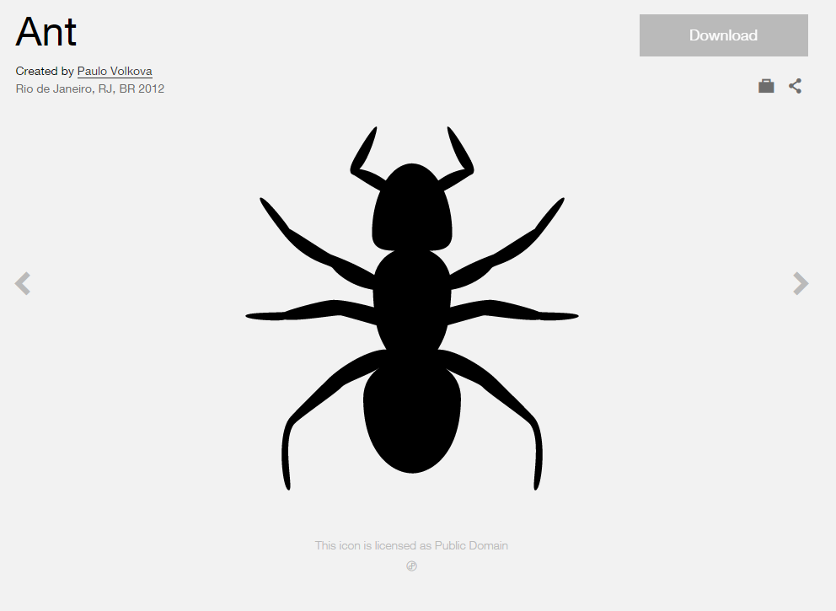
Modified by: Esri Solutions Team
License: Public Domain
Acknowledgement: None required
Notes: None

Infiltration
Symbol Name:
Symbol Picture:
Symbol Source:
Symbol Date: May 2015
Created by: Esri Solutions Team
License: None
Acknowledgement: None required
Notes: None

Information
Symbol Name: i
Symbol Picture: 
Symbol Source: Arial Rounded MT Bold
Symbol Date: April 2014
Modified by: Esri Solutions Team
License: None
Acknowledgement: None Required
Notes: None

Information Center
Symbol Name: Information
Symbol Picture: 
Symbol Source: The Noun Project
Symbol Date: February 2016
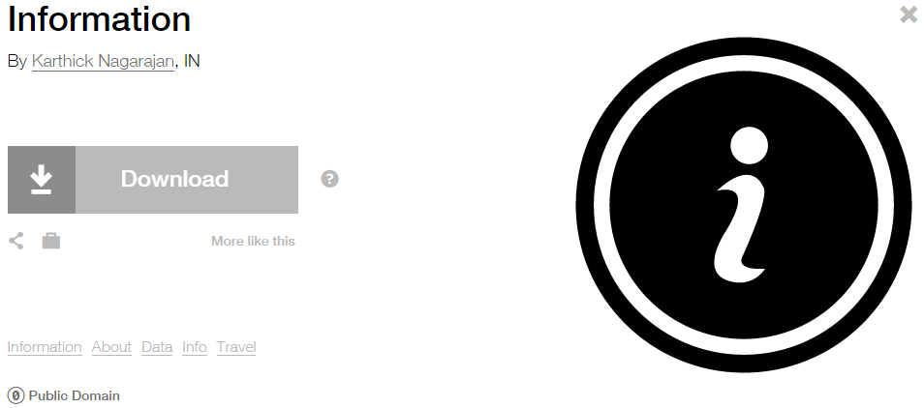
Modified by: Esri Solutions Team
License: Public Domain
Acknowledgement: None required
Notes: None

Information Kiosk
Symbol Name: Information
Symbol Picture:
Symbol Source: The Noun Project
Symbol Date: February 2016
Modified by: Esri Solutions Team
License: Public Domain
Acknowledgement: None required
Notes: None

Inlet Protection Violation
Symbol Name: IP
Symbol Picture: 
Symbol Source: Arial Rounded MT Bold Font
Symbol Date: March 2015
Modified by: Esri Solutions Team
License: None
Acknowledgement: None required
Notes: None

Inlets
Symbol Name:
Symbol Picture: 
Symbol Source:
Symbol Date: April 2015
Created by: Esri Solutions Team
License: None
Acknowledgement: None required
Notes: None

Intentional
Symbol Name: Match
Symbol Picture:
Symbol Source: The Noun Project
Symbol Date: December 2015
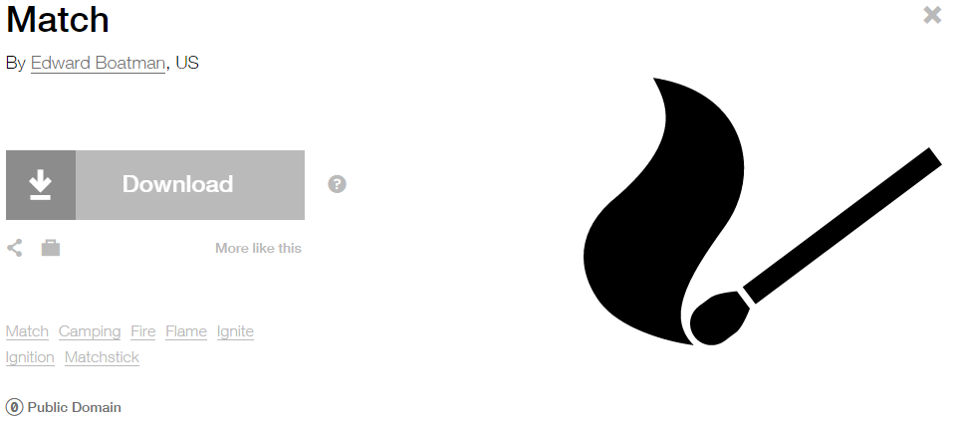
Modified by: Esri Solutions Team
License: Public Domain
Acknowledgement: None required
Notes: None

Interbasin Water Transfer
Symbol Name: Water Recreation
Symbol Picture: 
Symbol Source: Forestry style file
Symbol Date: September 2014

Modified by: Esri Solutions Team
License: None
Acknowledgement: None required
Notes: None

Intruding Sealing Material
Symbol Name:
Symbol Picture:
Symbol Source:
Symbol Date: May 2015
Created by: Esri Solutions Team
License: None
Acknowledgement: None required
Notes: None

Joint
Symbol Name:
Symbol Picture:
Symbol Source:
Symbol Date: May 2015
Created by: Esri Solutions Team
License: None
Acknowledgement: None required
Notes: None

Joint Use Survey - Assigned
Symbol Name:
Symbol Picture: 
Symbol Source:
Symbol Date: April 2015
Created by: Esri Solutions Team
License: None
Acknowledgement: None required
Notes: None

Joint Use Survey - Completed
Symbol Name:
Symbol Picture: 
Symbol Source:
Symbol Date: April 2015
Created by: Esri Solutions Team
License: None
Acknowledgement: None required
Notes: None

Joint Use Survey – Not On Map
Symbol Name:
Symbol Picture: 
Symbol Source:
Symbol Date: April 2015
Created by: Esri Solutions Team
License: None
Acknowledgement: None required
Notes: None

Joint Use Survey – Pole Not Found
Symbol Name:
Symbol Picture: 
Symbol Source:
Symbol Date: April 2015
Created by: Esri Solutions Team
License: None
Acknowledgement: None required
Notes: None

Joint Use Survey – Unassigned
Symbol Name: ?
Symbol Picture: 
Symbol Source: Arial Rounded MT Bold
Symbol Date: April 2015
Modifed by: Esri Solutions Team
License: None
Acknowledgement: None required
Notes: None

Landslide
Symbol Name: Landslide
Symbol Picture: 
Symbol Source: The Noun Project
Symbol Date: September 2015
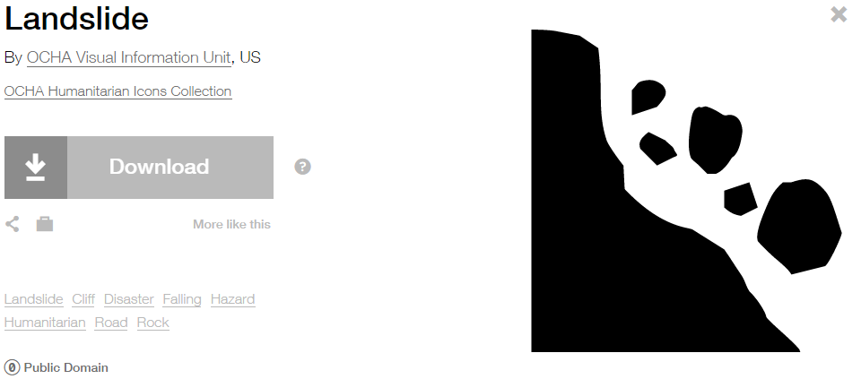
Modified by: Esri Solutions Team
License: Public Domain
Acknowledgement: None required
Notes: None

Land Use Code Violation Closed
Symbol Name: X
Symbol Picture: 
Symbol Source: Myriad Pro – Semi bold font
Symbol Date: March 2015
Modified by: Esri Solutions Team
License: None
Acknowledgement: None required
Notes: None

Land Use Code Violation Open
Symbol Name: Check 1
Symbol Picture: 
Symbol Source: ESRI style file
Symbol Date: March 2015

Modified by: Esri Solutions Team
License: None
Acknowledgement: None required
Notes: None

Large mammal
Symbol Name: Bear
Symbol Picture: 
Symbol Source: The Noun Project
Symbol Date: March 2015
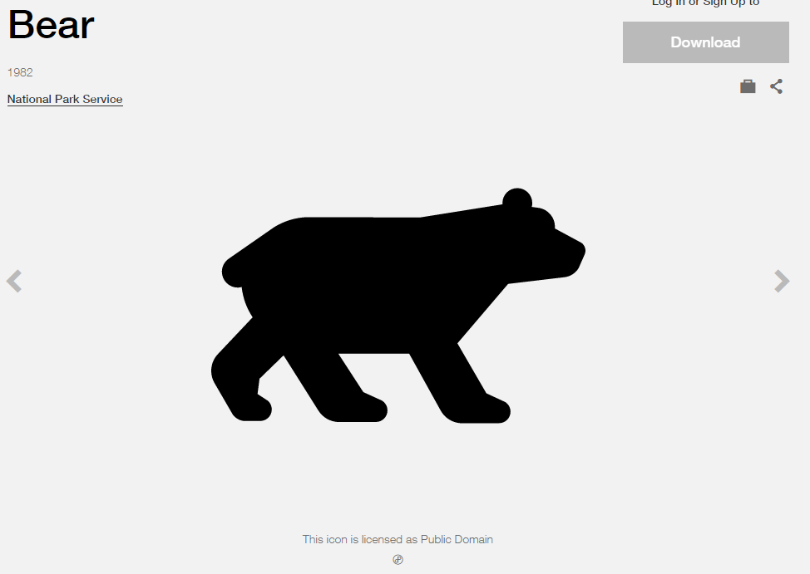
Modified by: Esri Solutions Team
License: Public Domain
Acknowledgement: None required
Notes: None

Laser Light
Symbol Name: Unicode 177
Symbol Picture: 
Symbol Source: ESRI AMFM Water font
Symbol Date: August 2015

Modified by: Esri Solutions Team
License: None
Acknowledgement: None required
Notes: None

Law Enforcement and Security
Symbol Name: Police Badge & L1 Law Enforcement Operations
Symbol Picture: 
Symbol Source: ESRI Crime Analysis & ERS Homeland Security style file
Symbol Date: July 2015


Modified by: Esri Solutions Team
License: None
Acknowledgement: None required
Notes: None

Leak Severity - Cosmetic
Symbol Name: Oil Droplet
Symbol Picture: 
Symbol Source: Petroleum style files
Symbol Date: May 2015
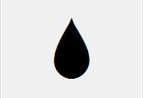
Modified by: Esri Solutions Team
License: None
Acknowledgement: None required
Notes: None

Leak Severity - Critical
Symbol Name: Oil Droplet
Symbol Picture: 
Symbol Source: Petroleum style files
Symbol Date: May 2015
Modified by: Esri Solutions Team
License: None
Acknowledgement: None required
Notes: None

Leak Severity - Major
Symbol Name: Oil Droplet
Symbol Picture: 
Symbol Source: Petroleum style files
Symbol Date: May 2015
Modified by: Esri Solutions Team
License: None
Acknowledgement: None required
Notes: None

Leak Severity - Minor
Symbol Name: Oil Droplet
Symbol Picture: 
Symbol Source: Petroleum style files
Symbol Date: May 2015
Modified by: Esri Solutions Team
License: None
Acknowledgement: None required
Notes: None

Leak Severity - Moderate
Symbol Name: Oil Droplet
Symbol Picture: 
Symbol Source: Petroleum style files
Symbol Date: May 2015
Modified by: Esri Solutions Team
License: None
Acknowledgement: None required
Notes: None

Levee Failure
Symbol Name:
Symbol Picture: 
Symbol Source:
Symbol Date: September 2015
Created by: Esri Solutions Team
License: None
Acknowledgement: None required
Notes: None

Libraries
Symbol Name: Library
Symbol Picture: 
Symbol Source: Civic style file
Symbol Date: January 2015

Modified by: Esri Solutions Team
License: None
Acknowledgement: None required
Notes: None

Lighting Truss
Symbol Name:
Symbol Picture: 
Symbol Source:
Symbol Date: December 2015
Created by: Esri Solutions Team
License: None
Acknowledgement: None required
Notes: None

Lightning
Symbol Name: Storm
Symbol Picture: 
Symbol Source: The Noun Project
Symbol Date: December 2015
Modified by: Esri Solutions Team
License: Public Domain
Acknowledgement: None required
Notes: None

Line
Symbol Name:
Symbol Picture:
Symbol Source:
Symbol Date: May 2015
Created by: Esri Solutions Team
License: None
Acknowledgement: None required
Notes: None
Lining
Symbol Name:
Symbol Picture:
Symbol Source:
Symbol Date: May 2015
Created by: Esri Solutions Team
License: None
Acknowledgement: None required
Notes: None

Liquefied Natural Gas Shut Off
Symbol Name: LNG Main_With Line
Symbol Picture: 
Symbol Source: NAPSG (National Alliance for Public Safety GIS Foundation)
Symbol Date: March 2017
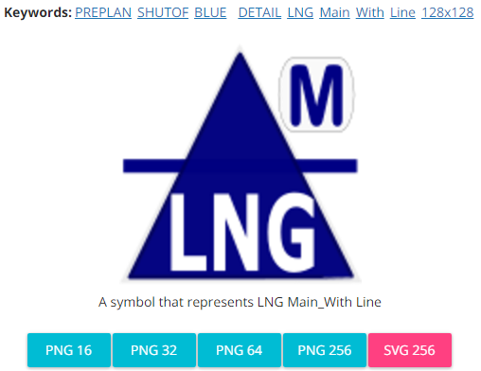
Modified by: Esri Solutions Team
License: None
Acknowledgement: None required
Notes: None

Location Checks - Assigned
Symbol Name: A
Symbol Picture: 
Symbol Source: Arial font
Symbol Date: February 2017
Modified by: Esri Solutions Team
License: None
Acknowledgement: None required
Notes: None

Location Checks – Complete - Evacuated
Symbol Name: E
Symbol Picture: 
Symbol Source: Arial font
Symbol Date: February 2017
Modified by: Esri Solutions Team
License: None
Acknowledgement: None required
Notes: None

Location Checks – Completed - Follow up - Needed
Symbol Name: F
Symbol Picture: 
Symbol Source: Arial font
Symbol Date: February 2017
Modified by: Esri Solutions Team
License: None
Acknowledgement: None required
Notes: None

Location Checks – Completed - No - Information
Symbol Name: N
Symbol Picture: 
Symbol Source: Arial font
Symbol Date: February 2017
Modified by: Esri Solutions Team
License: None
Acknowledgement: None required
Notes: None

Location Checks – Completed – Information - Discovered
Symbol Name: I
Symbol Picture:
Symbol Source: Arial font
Symbol Date: February 2017
Modified by: Esri Solutions Team
License: None
Acknowledgement: None required
Notes: None

Lost - Found
Symbol Name: Lost and Found
Symbol Picture: 
Symbol Source: Public Signs style file
Symbol Date: December 2015

Modified by: Esri Solutions Team
License: None
Acknowledgement: None required
Notes: None

Key Box
Symbol Name: Knox Plain
Symbol Picture: 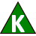
Symbol Source: NAPSG (National Alliance for Public Safety GIS Foundation)
Symbol Date: March 2017
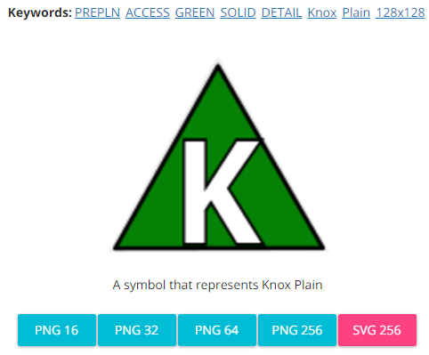
Modified by: Esri Solutions Team
License: None
Acknowledgement: None required
Notes: None

Key Box - Cabinet
Symbol Name: Knox Cabinet
Symbol Picture: 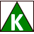
Symbol Source: NAPSG (National Alliance for Public Safety GIS Foundation) – NAPSG_Preplan.style
Symbol Date: March 2017
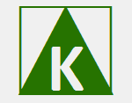
Modified by: Esri Solutions Team
License: None
Acknowledgement: None required
Notes: None

Key Box - Card
Symbol Name: Knox Keycard
Symbol Picture: 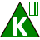
Symbol Source: NAPSG (National Alliance for Public Safety GIS Foundation)
Symbol Date: March 2017
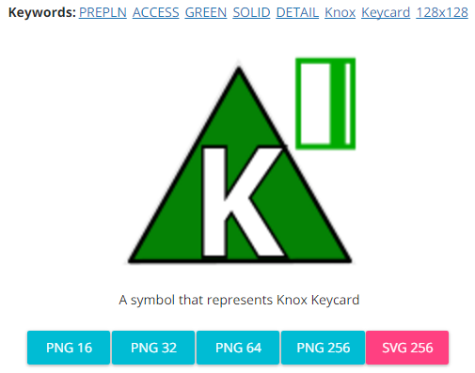
Modified by: Esri Solutions Team
License: None
Acknowledgement: None required
Notes: None

Key Box – Drug Vault
Symbol Name: Knox Drug Vault
Symbol Picture: 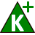
Symbol Source: NAPSG (National Alliance for Public Safety GIS Foundation) – NAPSG_Preplan.style
Symbol Date: March 2017
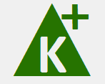
Modified by: Esri Solutions Team
License: None
Acknowledgement: None required
Notes: None

Key Box – Electric Shunt Switch
Symbol Name: Knox KeyShunt
Symbol Picture: 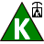
Symbol Source: NAPSG (National Alliance for Public Safety GIS Foundation)
Symbol Date: March 2017
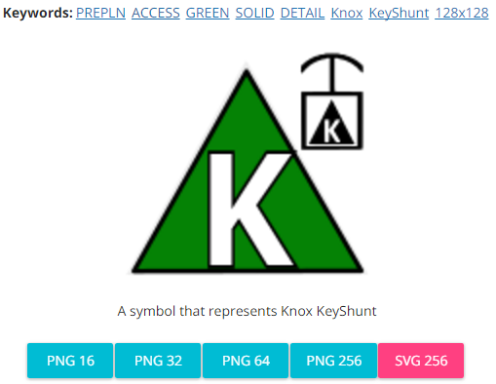
Modified by: Esri Solutions Team
License: None
Acknowledgement: None required
Notes: None

Key Box – Other
Symbol Name:
Symbol Picture: 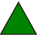
Symbol Source:
Symbol Date: March 2017
Modified by: Esri Solutions Team
License: None
Acknowledgement: None required
Notes: None

Key Box – Residential
Symbol Name: Knox Residential
Symbol Picture: 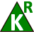
Symbol Source: NAPSG (National Alliance for Public Safety GIS Foundation)
Symbol Date: March 2017
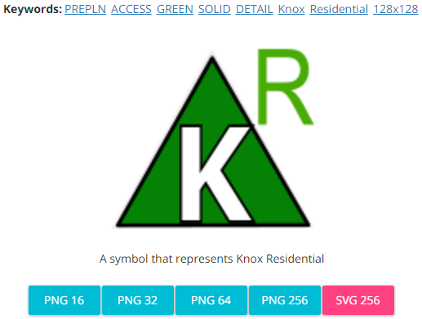
Modified by: Esri Solutions Team
License: None
Acknowledgement: None required
Notes: None

Key Box – Vault
Symbol Name: Knox Vault
Symbol Picture: 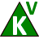
Symbol Source: NAPSG (National Alliance for Public Safety GIS Foundation) – NAPSG_Preplan.style
Symbol Date: March 2017
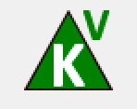
Modified by: Esri Solutions Team
License: None
Acknowledgement: None required
Notes: None

Malaria
Symbol Name: !
Symbol Picture: 
Symbol Source: Arial Rounded MT Bold
Symbol Date: December 2016
Modified by: Esri Solutions Team
License: None
Acknowledgement: None required
Notes: None

Manhole
Symbol Name: Manhole
Symbol Picture: 
Symbol Source: Water Wastewater style file
Symbol Date: April 2015

Modified by: Esri Solutions Team
License: None
Acknowledgement: None required
Notes: None

Marina
Symbol Name: Ship
Symbol Picture: 
Symbol Source: The Noun Project
Symbol Date: March 2015
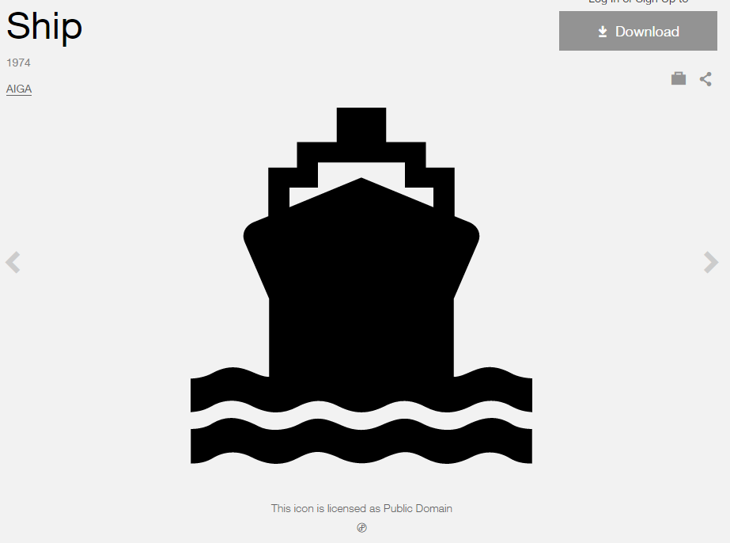
Modified by: Esri Solutions Team
License: Public Domain
Acknowledgement: None required
Notes: None

Marine Incident
Symbol Name: Ship
Symbol Picture: 
Symbol Source: The Noun Project
Symbol Date: March 2015
Modified by: Esri Solutions Team
License: Public Domain
Acknowledgement: None required
Notes: None

Market
Symbol Name: Store
Symbol Picture: 
Symbol Source: The Noun Project
Symbol Date: February 2015
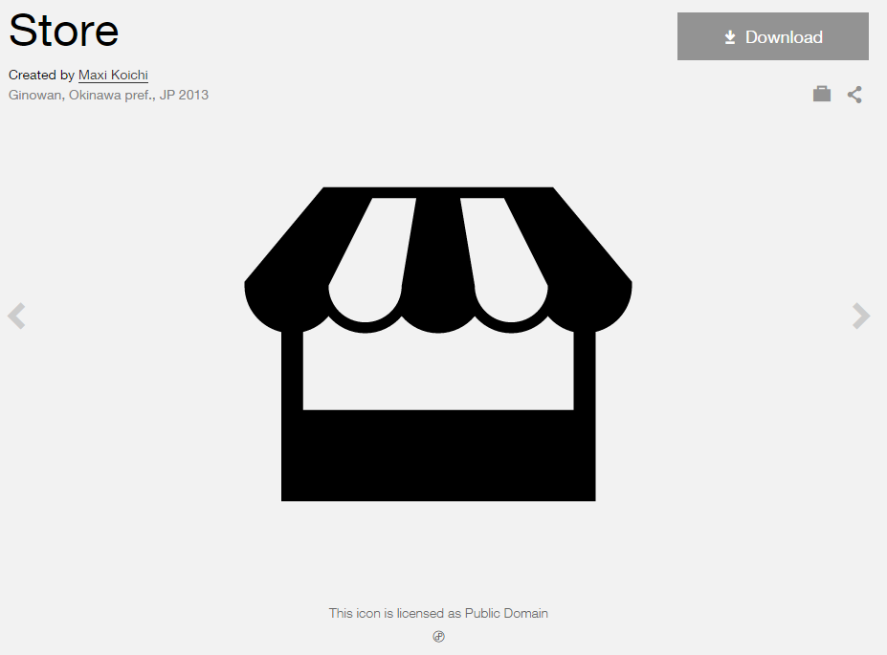
Modified by: Esri Solutions Team
License: Public Domain
Acknowledgement: None required
Notes: None

Mass Transit Stations
Symbol Name: Bus 2
Symbol Picture: 
Symbol Source: Business style file
Symbol Date: March 2015
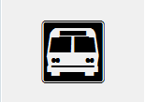
Modified by: Esri Solutions Team
License: None
Acknowledgement: None required
Notes: None

Medical and Public Health
Symbol Name: Men
Symbol Picture: 
Symbol Source: Public Signs style file
Symbol Date: February 2015

Modified by: Esri Solutions Team
License: None
Acknowledgement: None required
Notes: None

Medical Incident
Symbol Name: Emergency Medical Services
Symbol Picture:
Symbol Source: Transportation style file
Symbol Date: July 2015
Modified by: Esri Solutions Team
License: None
Acknowledgement: None required
Notes: None

Medical Vehicle
Symbol Name: Emergency Medical Services
Symbol Picture: 
Symbol Source: Transportation style file
Symbol Date: July 2015
Modified by: Esri Solutions Team
License: None
Acknowledgement: None required
Notes: None

Medivac Site
Symbol Name: MediVac Site
Symbol Picture: 
Symbol Source: GSTOP_2014 style file (Symbol Style set for ArcGIS)
Symbol Date: July 2015

Modified by: Esri Solutions Team
License: None
Acknowledgement: National Wildfire Coordinating Group (NWCG)
Notes: None

Meter Setting
Symbol Name:
Symbol Picture: 
Symbol Source:
Symbol Date: May 2015
Created by: Esri Solutions Team
License: None
Acknowledgement: None required
Notes: None

Materials, Storage, Cleanup Violation
Symbol Name: MST
Symbol Picture: 
Symbol Source: Arial Rounded MT Bold Font
Symbol Date: March 2015
Modified by: Esri Solutions Team
License: None
Acknowledgement: None required
Notes: None

Mine Incident
Symbol Name: Mining/Process
Symbol Picture: 
Symbol Source: Environmental style file
Symbol Date: September 2014
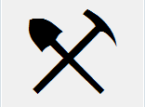
Modified by: Esri Solutions Team
License: None
Acknowledgement: None required
Notes: None

Mining Permit
Symbol Name: Mining/Process
Symbol Picture:
Symbol Source: Environmental style file
Symbol Date: September 2014
Modified by: Esri Solutions Team
License: None
Acknowledgement: None required
Notes: None

Miscellaneous
Symbol Name:
Symbol Picture:
Symbol Source:
Symbol Date: May 2015
Created by: Esri Solutions Team
License: None
Acknowledgement: None required
Notes: None

Missing Asset
Symbol Name: Map
Symbol Picture: 
Symbol Source: The Noun Project
Symbol Date: May 2015
Modified by: Esri Solutions Team
License: Public Domain
Acknowledgement: None required
Notes: None

Mobile Stage
Symbol Name:
Symbol Picture: 
Symbol Source:
Symbol Date: December 2015
Created by: Esri Solutions Team
License: None
Acknowledgement: None required
Notes: None

Mosquito Larvicide Sites
Symbol Name: Mosquito
Symbol Picture: 
Symbol Source: The Noun Project
Symbol Date: March 2016
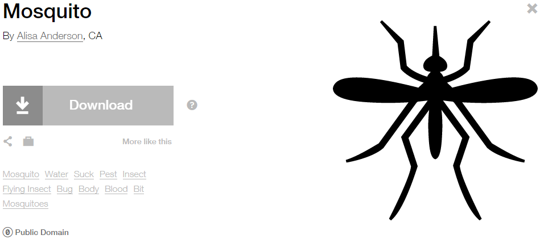
Modified by: Esri Solutions Team
License: Public Domain
Acknowledgement: None required
Notes: None

Mosquito Surveillance Sites
Symbol Name: Mosquito
Symbol Picture: 
Symbol Source: The Noun Project
Symbol Date: March 2016
Modified by: Esri Solutions Team
License: Public Domain
Acknowledgement: None required
Notes: None

Municipal Stormwater Discharge Permit
Symbol Name: Overboard Discharge (right)
Symbol Picture: 
Symbol Source: Environmental style file
Symbol Date: September 2014
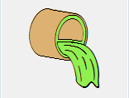
Modified by: Esri Solutions Team
License: None
Acknowledgement: None required
Notes: None

Museums
Symbol Name: Bank 1
Symbol Picture: 
Symbol Source: Business style file
Symbol Date: January 2015

Modified by: Esri Solutions Team
License: None
Acknowledgement: None required
Notes: None

Music Venues
Symbol Name: Music
Symbol Picture: 
Symbol Source: The Noun Project
Symbol Date: February 2015
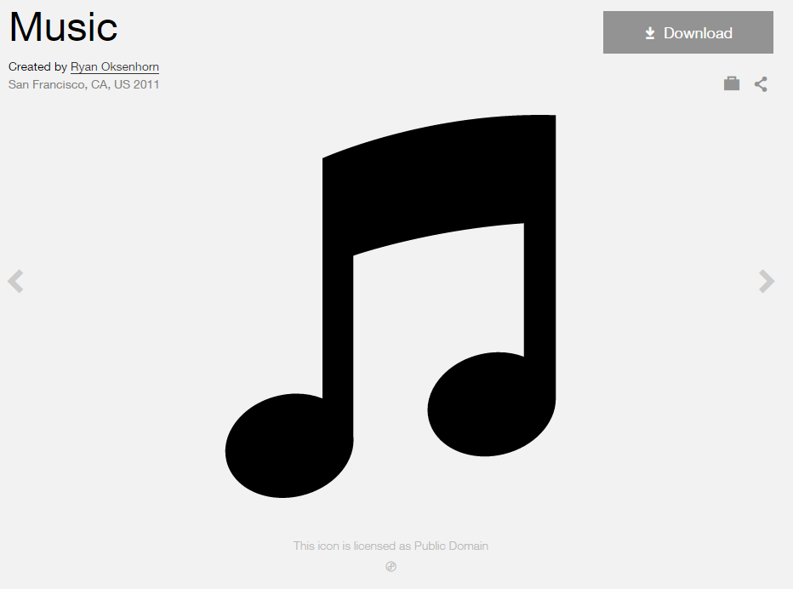
Modified by: Esri Solutions Team
License: Public Domain
Acknowledgement: None required
Notes: None

Natural Disaster Incident
Symbol Name: Storm
Symbol Picture:
Symbol Source: The Noun Project
Symbol Date: December 2015
Modified by: Esri Solutions Team
License: Public Domain
Acknowledgement: None required
Notes: None

Near Repeat
Symbol Name:
Symbol Picture:
Symbol Source:
Symbol Date: June 2016
Created by: Esri Solutions Team
License: None
Acknowledgement: None required
Notes: None

Negotiator
Symbol Name: Speech-Bubble
Symbol Picture: 
Symbol Source: The Noun Project
Symbol Date: February 2017
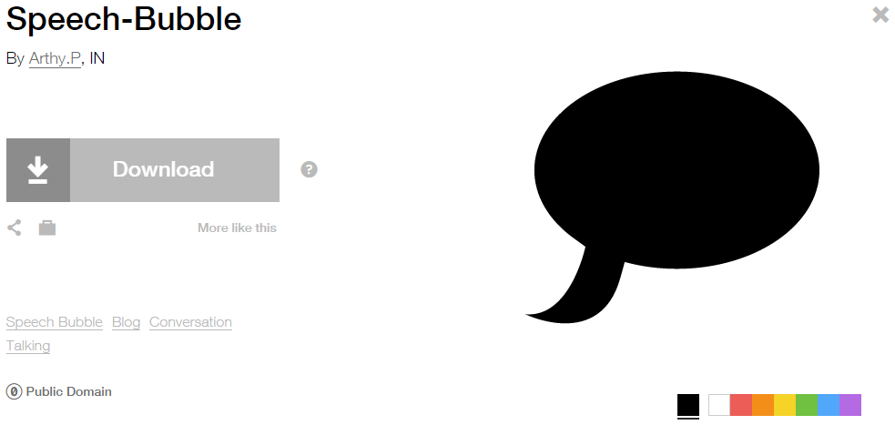
Modified by: Esri Solutions Team
License: Public Domain
Acknowledgement: None required
Notes: None

Neighborhood Police Problem – Completed, In – Progress, Received, and Submitted
Symbol Name: Police Badge
Symbol Picture: 
Symbol Source: ESRI Crime Analysis style file
Symbol Date: July 2015
Modified by: Esri Solutions Team
License: None
Acknowledgement: None required
Notes: None

Observe
Symbol Name: Binoculars
Symbol Picture: 
Symbol Source: The Noun Project
Symbol Date: May 2016
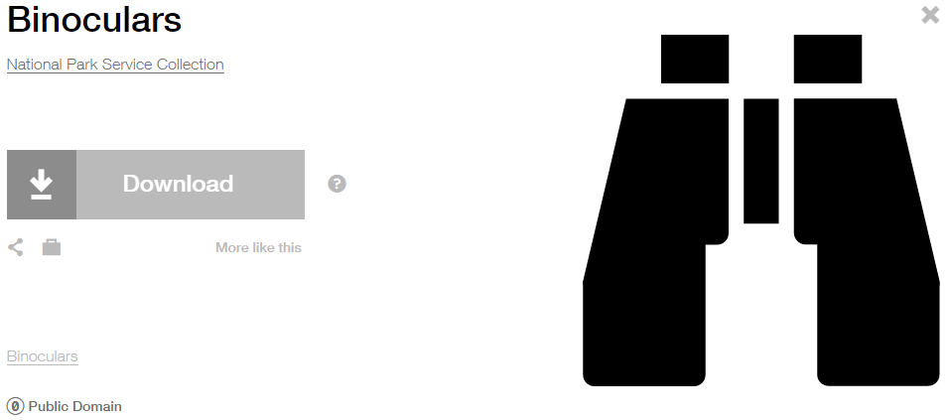
Modified by: Esri Solutions Team
License: Public Domain
Acknowledgement: None required
Notes: None

Obstacle
Symbol Name:
Symbol Picture:
Symbol Source:
Symbol Date: May 2015
Created by: Esri Solutions Team
License: None
Acknowledgement: None required
Notes: None

Occupancies
Symbol Name:
Symbol Picture: 
Symbol Source:
Symbol Date: March 2017
Modified by: Esri Solutions Team
License: None
Acknowledgement: None required
Notes: None

Officer Post
Symbol Name: Police Badge
Symbol Picture: 
Symbol Source: ESRI Crime Analysis style file
Symbol Date: July 2015
Modified by: Esri Solutions Team
License: None
Acknowledgement: None required
Notes: None

On Street Parking
Symbol Name:
Symbol Picture:
Symbol Source:
Symbol Date: July 2015
Created by: Esri Solutions Team
License: None
Acknowledgement: None required
Notes: None

Originator
Symbol Name:
Symbol Picture:
Symbol Source:
Symbol Date: June 2016
Created by: Esri Solutions Team
License: None
Acknowledgement: None required
Notes: None

Other
Symbol Name:
Symbol Picture: 
Symbol Source:
Symbol Date: December 2015
Created by: Esri Solutions Team
License: None
Acknowledgement: None required
Notes: None

Other
Symbol Name:
Symbol Picture:
Symbol Source:
Symbol Date: May 2015
Created by: Esri Solutions Team
License: None
Acknowledgement: None required
Notes: None

Outage - Planned
Symbol Name: Light Bulb
Symbol Picture:
Symbol Source: The Noun Project
Symbol Date: April 2015
Modified by: Esri Solutions Team
License: Public Domain
Acknowledgement: None required
Notes: None

Outage - Unplanned
Symbol Name: Light Bulb
Symbol Picture: 
Symbol Source: The Noun Project
Symbol Date: April 2015
Modified by: Esri Solutions Team
License: Public Domain
Acknowledgement: None required
Notes: None

Outlet Protection Violation
Symbol Name: OP
Symbol Picture: 
Symbol Source: Arial Rounded MT Bold Font
Symbol Date: March 2015
Modified by: Esri Solutions Team
License: None
Acknowledgement: None required
Notes: None

Outpatient
Symbol Name: Outpatient
Symbol Picture: 
Symbol Source: The Noun Project
Symbol Date: March 2015
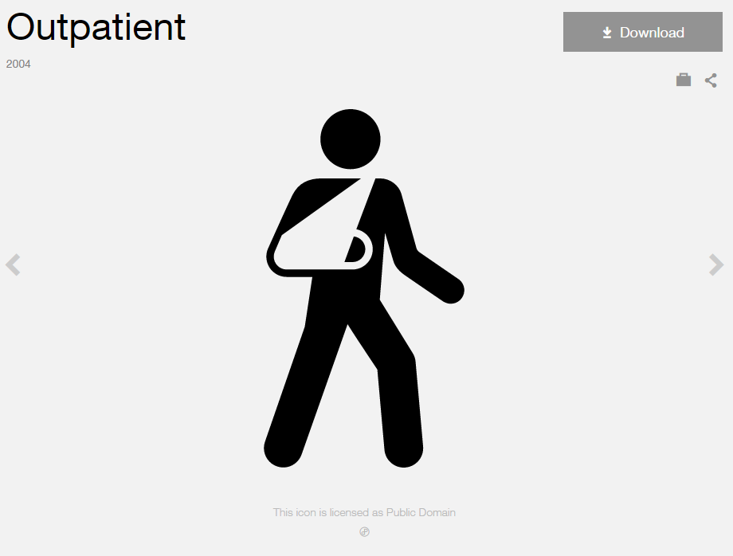
Modified by: Esri Solutions Team
License: Public Domain
Acknowledgement: None Required
Notes: None

Oxygen Shut Off
Symbol Name: Oxygen_With Line
Symbol Picture: 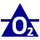
Symbol Source: NAPSG (National Alliance for Public Safety GIS Foundation)
Symbol Date: March 2017
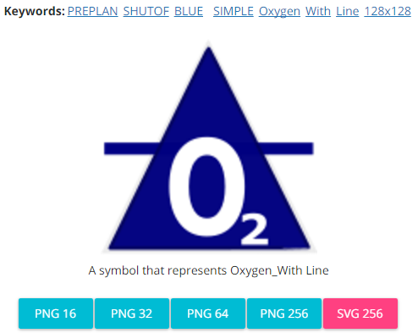
Modified by: Esri Solutions Team
License: None
Acknowledgement: None required
Notes: None

Pandemic
Symbol Name: Mask
Symbol Picture: 
Symbol Source: The Noun Project
Symbol Date: September 2015
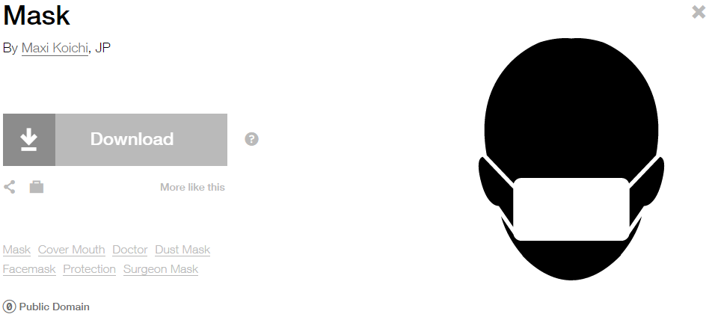
Modified by: Esri Solutions Team
License: Public Domain
Acknowledgement: None required
Notes: None

Park
Symbol Name: National Park
Symbol Picture: 
Symbol Source: Environmental style file
Symbol Date: January 2015
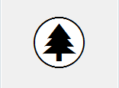
Modified by: Esri Solutions Team
License: None
Acknowledgement: None required
Notes: None

Park Mowing Program – In Progress
Symbol Name: National Park
Symbol Picture: 
Symbol Source: Environmental style file
Symbol Date: May 2014
Modified by: Esri Solutions Team
License: None
Acknowledgement: None required
Notes: None

Park Mowing Program – Inspected
Symbol Name: National Park
Symbol Picture: 
Symbol Source: Environmental style file
Symbol Date: May 2014
Modified by: Esri Solutions Team
License: None
Acknowledgement: None required
Notes: None

Park Mowing Program – Not Inspected
Symbol Name: National Park
Symbol Picture: 
Symbol Source: Environmental style file
Symbol Date: May 2014
Modified by: Esri Solutions Team
License: None
Acknowledgement: None required
Notes: None

Park Tree Problem – Completed, In – Progress, Received, and Submitted
Symbol Name: Picnic Area w/Tree
Symbol Picture: 
Symbol Source: Civic style file
Symbol Date: March 2016

Modified by: Esri Solutions Team
License: None
Acknowledgement: None required
Notes: None

Parking
Symbol Name: P
Symbol Picture: 
Symbol Source: Arial Rounded MT Bold
Symbol Date: July 2015
Modified by: Esri Solutions Team
License: None
Acknowledgement: None required
Notes: None

Pavement Marking - Blue
Symbol Name:
Symbol Picture: 
Symbol Source:
Symbol Date: September 2014
Created by: Esri Solutions Team
License: None
Acknowledgement: None required
Notes: None

Pavement Marking - Green
Symbol Name:
Symbol Picture: 
Symbol Source:
Symbol Date: September 2014
Created by: Esri Solutions Team
License: None
Acknowledgement: None required
Notes: None

Pavement Marking - Other
Symbol Name:
Symbol Picture: 
Symbol Source:
Symbol Date: September 2014
Created by: Esri Solutions Team
License: None
Acknowledgement: None required
Notes: None

Pavement Marking - Red
Symbol Name:
Symbol Picture: 
Symbol Source:
Symbol Date: September 2014
Created by: Esri Solutions Team
License: None
Acknowledgement: None required
Notes: None

Pavement Marking - White
Symbol Name:
Symbol Picture: 
Symbol Source:
Symbol Date: September 2014
Created by: Esri Solutions Team
License: None
Acknowledgement: None required
Notes: None

Pavement Marking - Yellow
Symbol Name:
Symbol Picture: 
Symbol Source:
Symbol Date: September 2014
Created by: Esri Solutions Team
License: None
Acknowledgement: None required
Notes: None

Pay Stations
Symbol Name: Parking Meter & P
Symbol Picture: 
Symbol Source: The Noun Project & Arial Rounded MT Bold
Symbol Date: July 2015
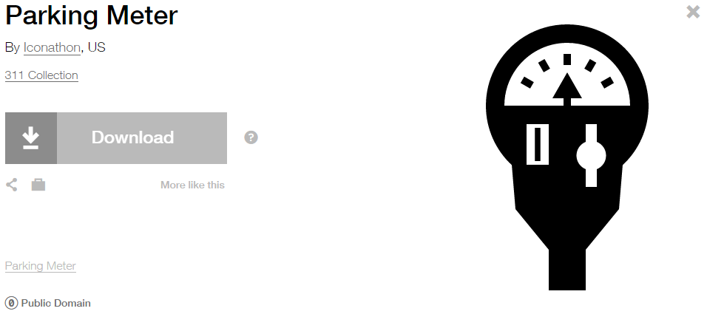
Modified by: Esri Solutions Team
License: Public Domain
Acknowledgement: None required
Notes: None

Personal Property
Symbol Name: Community
Symbol Picture: 
Symbol Source: The Noun Project
Symbol Date: February 2015
Modified by: Esri Solutions Team
License: Public Domain
Acknowledgement: None required
Notes: None

Pesticide Discharge Permit
Symbol Name: Water Recreation
Symbol Picture: 
Symbol Source: Forestry style file
Symbol Date: September 2014
Modified by: Esri Solutions Team
License: None
Acknowledgement: None required
Notes: None

Pet Collection Area
Symbol Name: Unicode 117
Symbol Picture: 
Symbol Source: ESRI Public 1 font
Symbol Date: July 2015
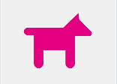
Modified by: Esri Solutions Team
License: None
Acknowledgement: None required
Notes: None

Planning Limits Permit
Symbol Name: City
Symbol Picture: 
Symbol Source: Business style file
Symbol Date: September 2014
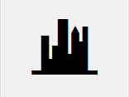
Modified by: Esri Solutions Team
License: None
Acknowledgement: None required
Notes: None

Point Repair
Symbol Name:
Symbol Picture:
Symbol Source:
Symbol Date: May 2015
Created by: Esri Solutions Team
License: None
Acknowledgement: None required
Notes: None

Pole
Symbol Name: P
Symbol Picture: 
Symbol Source: Arial Rounded MT Bold
Symbol Date: July 2015
Modified by: Esri Solutions Team
License: None
Acknowledgement: None required
Notes: None

Police Stations
Symbol Name: Police Badge
Symbol Picture: 
Symbol Source: Crime Analysis style file
Symbol Date: February 2015
Modified by: Esri Solutions Team
License: None
Acknowledgement: None required
Notes: None

Police Vehicle
Symbol Name: Police Badge
Symbol Picture: 
Symbol Source: ESRI Crime Analysis style file
Symbol Date: July 2015
Modified by: Esri Solutions Team
License: None
Acknowledgement: None required
Notes: None

Polling Places
Symbol Name: Polling-Place & Check 1
Symbol Picture: 
Symbol Source: The Noun Project & ESRI style file
Symbol Date: March 2015
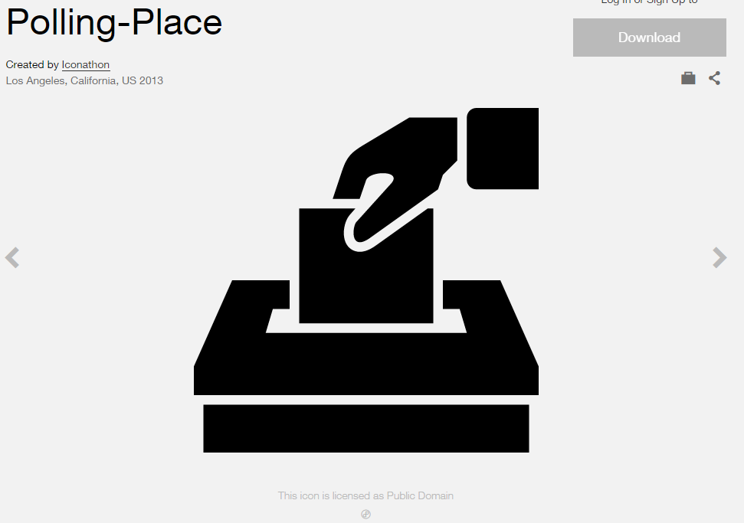
Modified by: Esri Solutions Team
License: Public Domain
Acknowledgement: None required
Notes: None

Porous Pavement
Symbol Name: PP
Symbol Picture: 
Symbol Source: Arial Rounded MT Bold Font
Symbol Date: March 2015
Modified by: Esri Solutions Team
License: None
Acknowledgement: None required
Notes: None

Post Offices
Symbol Name: Post Office
Symbol Picture: 
Symbol Source: Forestry style file
Symbol Date: January 2015

Modified by: Esri Solutions Team
License: None
Acknowledgement: None required
Notes: None

Potential Customer
Symbol Name:
Symbol Picture: 
Symbol Source:
Symbol Date: May 2015
Created by: Esri Solutions Team
License: None
Acknowledgement: None required
Notes: None

Power Distribution
Symbol Name:
Symbol Picture: 
Symbol Source:
Symbol Date: December 2015
Created by: Esri Solutions Team
License: None
Acknowledgement: None required
Notes: None

Power Failure
Symbol Name: Light Bulb
Symbol Picture:
Symbol Source: The Noun Project
Symbol Date: April 2015
Modified by: Esri Solutions Team
License: Public Domain
Acknowledgement: None required
Notes: None

Pressure Reducing Valve
Symbol Name: PRV
Symbol Picture: 
Symbol Source: Arial Rounded MT Bold Font
Symbol Date: March 2015
Modified by: Esri Solutions Team
License: None
Acknowledgement: None required
Notes: None

Primary Entry Point
Symbol Name: P
Symbol Picture: 
Symbol Source: Arial font
Symbol Date: December 2015
Modified by: Esri Solutions Team
License: None
Acknowledgement: None required
Notes: None

Private Security
Symbol Name: Shield
Symbol Picture: 
Symbol Source: The Noun Project
Symbol Date: December 2015
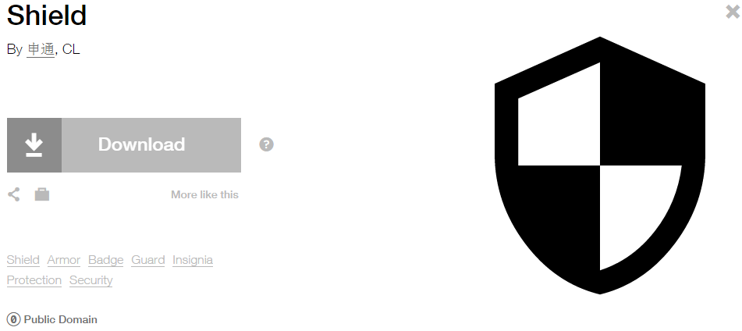
Modified by: Esri Solutions Team
License: Public Domain
Acknowledgement: None required
Notes: None

Project Operations Violation
Symbol Name: PO
Symbol Picture: 
Symbol Source: Arial Rounded MT Bold Font
Symbol Date: March 2015
Modified by: Esri Solutions Team
License: None
Acknowledgement: None required
Notes: None

Public Health Incident
Symbol Name: Men
Symbol Picture: 
Symbol Source: Public Signs style file
Symbol Date: February 2015
Modified by:
License: None
Acknowledgement: None required
Notes:

Radiological Attack
Symbol Name: L1 Radiological Sensor
Symbol Picture: 
Symbol Source: ERS Homeland Security style file
Symbol Date: October 2015
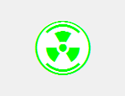
Modified by: Esri Solutions Team
License: None
Acknowledgement: None required
Notes: None

Radiological Release
Symbol Name: L1 Radiological Sensor
Symbol Picture: 
Symbol Source: ERS Homeland Security style file
Symbol Date: October 2015
Modified by: Esri Solutions Team
License: None
Acknowledgement: None required
Notes: None

Rail Incident
Symbol Name: Rail Transportation
Symbol Picture: 
Symbol Source: Public Signs style file
Symbol Date: February 2015
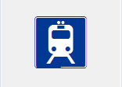
Modified by: Esri Solutions Team
License: None
Acknowledgement: None required
Notes: None

Railroad Crossing
Symbol Name: Railroad Crossing 2
Symbol Picture: 
Symbol Source: Transportation style file
Symbol Date: July 2015

Modified by: Esri Solutions Team
License: None
Acknowledgement: None required
Notes: None

Railroad Stations
Symbol Name: Rail Transportation
Symbol Picture: 
Symbol Source: ESRI Public Signs style file
Symbol Date: January 2015
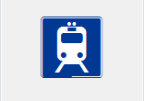
Modified by: Esri Solutions Team
License: None
Acknowledgement: None required
Notes: None

Rain Barrel
Symbol Name: RB
Symbol Picture: 
Symbol Source: Arial Rounded MT Bold Font
Symbol Date: March 2015
Modified by: Esri Solutions Team
License: None
Acknowledgement: None required
Notes: None

Rain Water Catchment
Symbol Name: RWC
Symbol Picture: 
Symbol Source: Arial Rounded MT Bold Font
Symbol Date: March 2015
Modified by: Esri Solutions Team
License: None
Acknowledgement: None required
Notes: None

Ready Mix Concrete Facilities Permit
Symbol Name:
Symbol Picture: 
Symbol Source:
Symbol Date: October 2014
Created by: Esri Solutions Team
License: None
Acknowledgement: None required
Notes: None

Reconnaissance
Symbol Name:
Symbol Picture:
Symbol Source:
Symbol Date: December 2015
Created by: Esri Solutions Team
License: None
Acknowledgement: None required
Notes: None

Recycling Bin
Symbol Name: Unicode 93
Symbol Picture: 
Symbol Source: ESRI ArcPad font
Symbol Date: February 2015
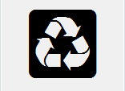
Modified by: Esri Solutions Team
License: None
Acknowledgement: None required
Notes: None

Recycling Facility
Symbol Name: Unicode 93
Symbol Picture: 
Symbol Source: ESRI ArcPad font
Symbol Date: February 2015
Modified by: Esri Solutions Team
License: None
Acknowledgement: None required
Notes: None

Repeat
Symbol Name:
Symbol Picture:
Symbol Source:
Symbol Date: June 2015
Modified by: Esri Solutions Team
License: None
Acknowledgement: None required

Reptiles
Symbol Name: Turtle
Symbol Picture: 
Symbol Source: The Noun Project
Symbol Date: March 2015
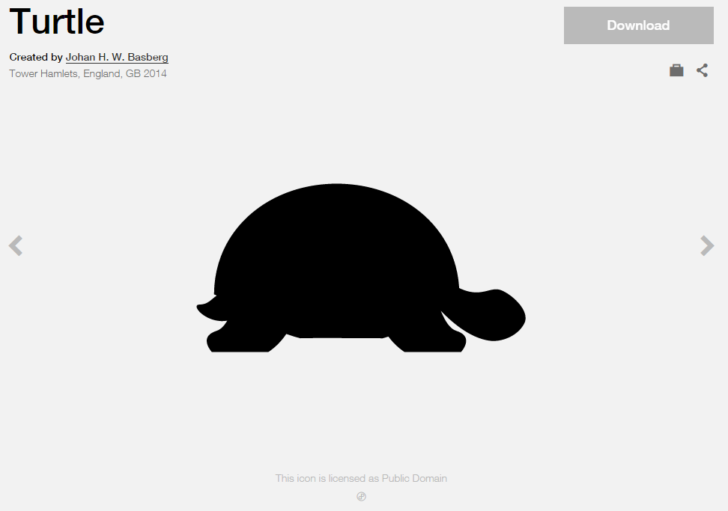
Modified by: Esri Solutions Team
License: Public Domain
Acknowledgement: None required
Notes: None

Research Parks
Symbol Name: Microscope
Symbol Picture: 
Symbol Source: The Noun Project
Symbol Date: March 2015
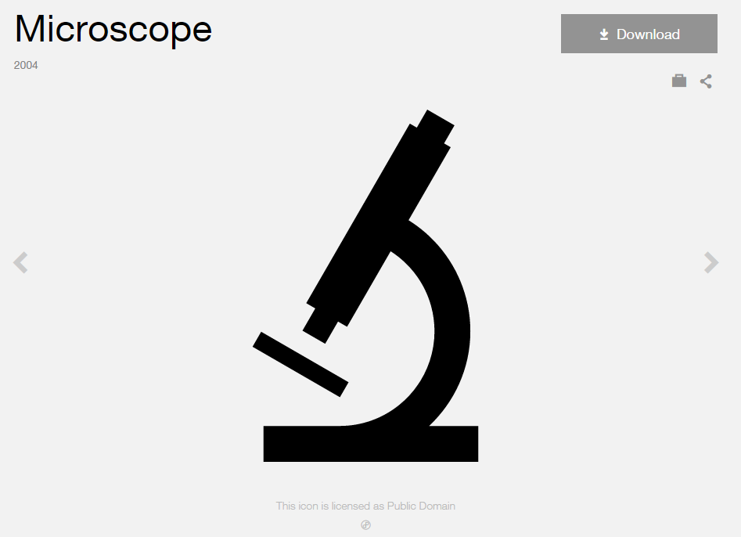
Modified by: Esri Solutions Team
License: Public Domain
Acknowledgement: None required
Notes: None

Responding Company - Command
Symbol Name:
Symbol Picture:
Symbol Source:
Symbol Date: December 2015
Created by: Esri Solutions Team
License: None
Acknowledgement: None required
Notes: None

Responding Company - Engine
Symbol Name:
Symbol Picture:
Symbol Source:
Symbol Date: December 2015
Created by: Esri Solutions Team
License: None
Acknowledgement: None required
Notes: None

Responding Company - Medical
Symbol Name:
Symbol Picture:
Symbol Source:
Symbol Date: December 2015
Created by: Esri Solutions Team
License: None
Acknowledgement: None required
Notes: None

Responding Company - Squad
Symbol Name:
Symbol Picture:
Symbol Source:
Symbol Date: December 2015
Created by: Esri Solutions Team
License: None
Acknowledgement: None required
Notes: None

Responding Company - Truck
Symbol Name:
Symbol Picture:
Symbol Source:
Symbol Date: December 2015
Created by: Esri Solutions Team
License: None
Acknowledgement: None required
Notes: None

Responding Company - Utility
Symbol Name:
Symbol Picture:
Symbol Source:
Symbol Date: December 2015
Created by: Esri Solutions Team
License: None
Acknowledgement: None required
Notes: None

Rest Area
Symbol Name: L1 Rest Stop
Symbol Picture: 
Symbol Source: ERS Homeland Security style file
Symbol Date: February 2016
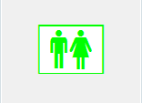
Modified by: Esri Solutions Team
License: None
Acknowledgement: None required
Notes: None

Restaurant Inspections
Symbol Name: Restaurant
Symbol Picture: 
Symbol Source: Public Signs style file
Symbol Date: December 2016

Modified by: Esri Solutions Team
License: None
Acknowledgement: None required
Notes: None

Restaurant Grade - A
Symbol Name: A
Symbol Picture: 
Symbol Source: Arial Rounded MT Bold font
Symbol Date: December 2016
Modified by: Esri Solutions Team
License: None
Acknowledgement: None required
Notes: None

Restaurant Grade - B
Symbol Name: B
Symbol Picture: 
Symbol Source: Arial Rounded MT Bold font
Symbol Date: December 2016
Modified by: Esri Solutions Team
License: None
Acknowledgement: None required
Notes: None

Restaurant Grade - C
Symbol Name: C
Symbol Picture: 
Symbol Source: Arial Rounded MT Bold font
Symbol Date: December 2016
Modified by: Esri Solutions Team
License: None
Acknowledgement: None required
Notes: None

Restroom
Symbol Name: Restrooms
Symbol Picture: 
Symbol Source: Forestry style file
Symbol Date: December 2015

Modified by: Esri Solutions Team
License: None
Acknowledgement: None required
Notes: None

Retail Centers
Symbol Name: Vagrancy, Shopping Cart
Symbol Picture: 
Symbol Source: Crime Analysis style file
Symbol Date: January 2015

Modified by: Esri Solutions Team
License: None
Acknowledgement: None required
Notes: None

Riser Valve
Symbol Name: Riser, General
Symbol Picture: 
Symbol Source: NAPSG (National Alliance for Public Safety GIS Foundation)
Symbol Date: March 2017

Modified by: Esri Solutions Team
License: None
Acknowledgement: None required
Notes: None

Road Blocks
Symbol Name:
Symbol Picture: 
Symbol Source:
Symbol Date: July 2015
Created by: Esri Solutions Team
License: None
Acknowledgement: None required
Notes: None

Road Closed/Blocked
Symbol Name:
Symbol Picture:
Symbol Source:
Symbol Date: June 2015
Created by: Esri Solutions Team
License: None
Acknowledgement: None required
Notes: None

Road Not Passable
Symbol Name:
Symbol Picture:
Symbol Source:
Symbol Date: June 2015
Created by: Esri Solutions Team
License: None
Acknowledgement: None required
Notes: None

Road Problem – Completed, In – Progress, Received, and Submitted
Symbol Name: Pothole
Symbol Picture: 
Symbol Source: The Noun Project
Symbol Date: March 2016
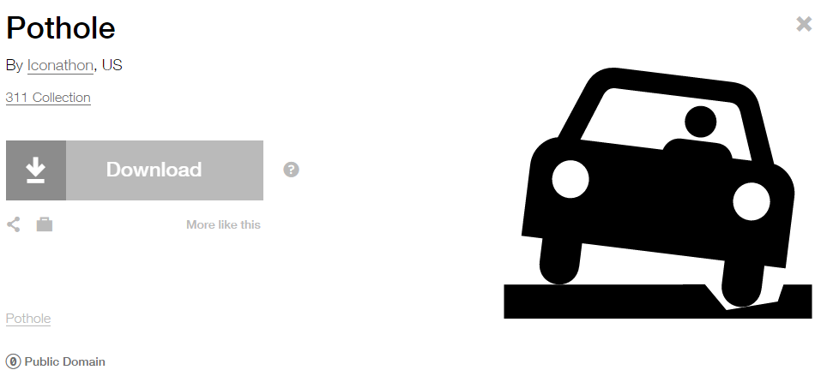
Modified by: Esri Solutions Team
License: Public Domain
Acknowledgement: None required
Notes: None

Roof Access
Symbol Name: Roof Access
Symbol Picture: 
Symbol Source: NAPSG (National Alliance for Public Safety GIS Foundation)
Symbol Date: March 2017
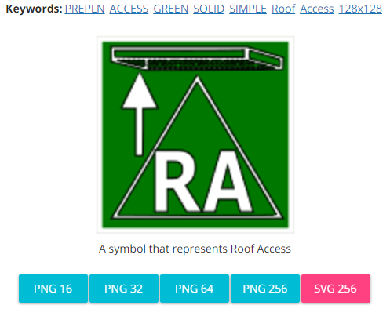
Created by: Esri Solutions Team
License: None
Acknowledgement: None required
Notes: None

Roots
Symbol Name:
Symbol Picture:
Symbol Source:
Symbol Date: May 2015
Created by: Esri Solutions Team
License: None
Acknowledgement: None required
Notes: None

Route End
Symbol Name: F
Symbol Picture:
Symbol Source: Arial Rounded MT Bold
Symbol Date: December 2015
Modified by: Esri Solutions Team
License: None
Acknowledgement: None required
Notes: None

Route Start
Symbol Name: S
Symbol Picture: 
Symbol Source:
Symbol Date: April 2016
Modified by: Esri Solutions Team
License: None
Acknowledgement: None required
Notes: None

Sabotage
Symbol Name: Robbery
Symbol Picture: 
Symbol Source: The Noun Project
Symbol Date: October 2015
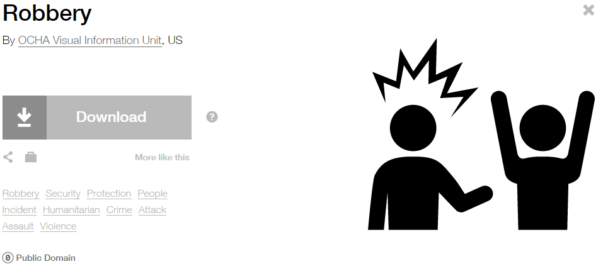
Modified by: Esri Solutions Team
License: Public Domain
Acknowledgement: None required
Notes: None
Safety Problem – Completed, In – Progress, Received, and Submitted
Symbol Name: !
Symbol Picture: 
Symbol Source: Arial Rounded MT Bold
Symbol Date: July 2015
Modified by: Esri Solutions Team
License: None
Acknowledgement: None required
Notes: None

Schools
Symbol Name: School 1
Symbol Picture: 
Symbol Source: Civic style file
Symbol Date: January 2015
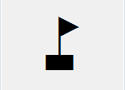
Modified by: Esri Solutions Team
License: None
Acknowledgement: None required
Notes: None

School and workplace violence
Symbol Name: Assault, Solid Fist
Symbol Picture: 
Symbol Source: Crime Analysis style file
Symbol Date: June 2015

Modified by: Esri Solutions Team
License: None
Acknowledgement: None required
Notes: None

Sea Ports
Symbol Name: Marina
Symbol Picture: 
Symbol Source: Forestry style file
Symbol Date: March 2015

Modified by: Esri Solutions Team
License: None
Acknowledgement: None Required
Notes: None

Search and Rescue
Symbol Name: Walk 1
Symbol Picture: 
Symbol Source: Transportation style file
Symbol Date: July 2015
Modified by: Esri Solutions Team
License: None
Acknowledgement: None required
Notes: None

Security Checkpoint
Symbol Name: Safety and Security
Symbol Picture:
Symbol Source: The Noun Project
Symbol Date: December 2015
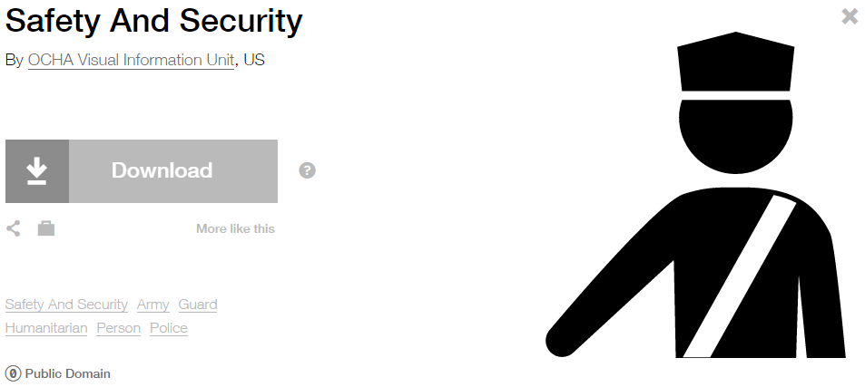
Modified by: Esri Solutions Team
License: Public Domain
Acknowledgement: None required
Notes: None

Sediment
Symbol Name:
Symbol Picture: 
Symbol Source: ESRI Enviro Hazard Sites Unicode 50
Symbol Date: September 2014
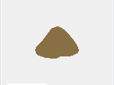
Modified by: Esri Solutions Team
License: None
Acknowledgement: None required
Notes: None

Sediment Barriers Violation
Symbol Name: SB
Symbol Picture: 
Symbol Source: Arial Rounded MT Bold Font
Symbol Date: March 2015
Modified by: Esri Solutions Team
License: None
Acknowledgement: None required
Notes: None

Sediment Traps and Basins Violation
Symbol Name: STB
Symbol Picture: 
Symbol Source: Arial Rounded MT Bold Font
Symbol Date: March 2015
Modified by: Esri Solutions Team
License: None
Acknowledgement: None required
Notes: None

Service Call Incident
Symbol Name: Phone 1
Symbol Picture:
Symbol Source: Civic style file
Symbol Date: November 2015
Modified by: Esri Solutions Team
License: None
Acknowledgement: None required
Notes: None

Severe Thunderstorm
Symbol Name: Thunderstorm
Symbol Picture: 
Symbol Source: The Noun Project
Symbol Date: January 2016
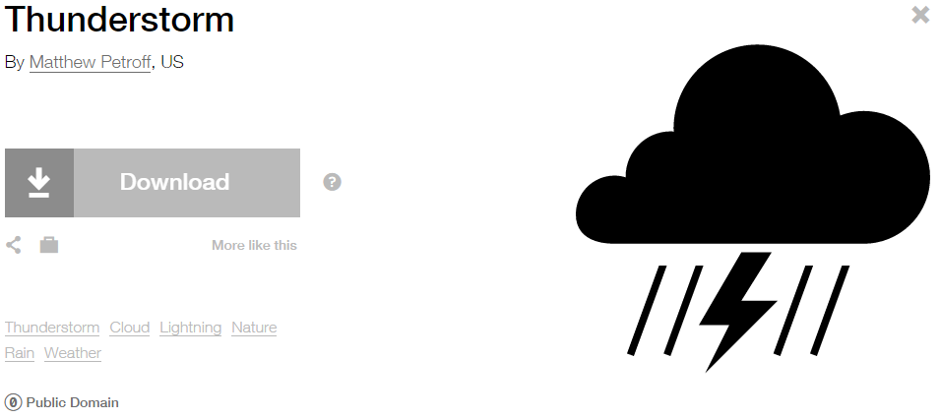
Modified by: Esri Solutions Team
License: Public Domain
Acknowledgement: None required
Notes: None

Service Request
Symbol Name: Tools
Symbol Picture: 
Symbol Source: The Noun Project
Symbol Date: May 2015
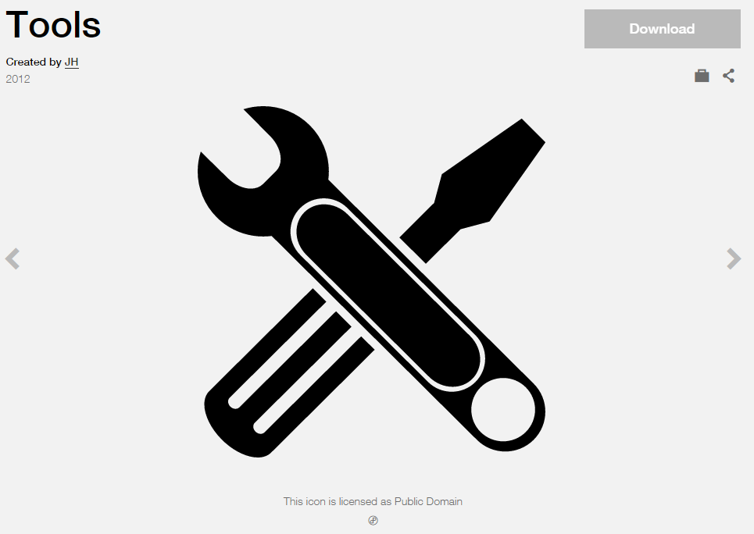
Modified by: Esri Solutions Team
License: Public Domain
Acknowledgement: None required
Notes: None

Sewer Map Change Request
Symbol Name: Map
Symbol Picture:
Symbol Source: The Noun Project
Symbol Date: May 2015
Modified by: Esri Solutions Team
License: Public Domain
Acknowledgement: None required
Notes: None

Sewer Map Change Request Critical
Symbol Name: S
Symbol Picture: 
Symbol Source: Arial Rounded MT Bold Font
Symbol Date: March 2015
Modified by: Esri Solutions Team
License: None
Acknowledgement: None required
Notes: None

Sewer Map Change Request Not Critical
Symbol Name: S
Symbol Picture: 
Symbol Source: Arial Rounded MT Bold Font
Symbol Date: March 2015
Modified by: Esri Solutions Team
License: None
Acknowledgement: None required
Notes: None

Shelter - Alert
Symbol Name: Sleeping Shelter
Symbol Picture: 
Symbol Source: Forestry style file
Symbol Date: December 2015

Modified by: Esri Solutions Team
License: None
Acknowledgement: None required
Notes: None

Shelter - Closed
Symbol Name: Sleeping Shelter
Symbol Picture: 
Symbol Source: Forestry style file
Symbol Date: December 2015
Modified by: Esri Solutions Team
License: None
Acknowledgement: None required
Notes: None

Shelter - Open
Symbol Name: Sleeping Shelter
Symbol Picture: w
Symbol Source: Forestry style file
Symbol Date: December 2015
Modified by: Esri Solutions Team
License: None
Acknowledgement: None required
Notes: None

Shelter - Standby
Symbol Name: Sleeping Shelter
Symbol Picture: 
Symbol Source: Forestry style file
Symbol Date: December 2015
Modified by: Esri Solutions Team
License: None
Acknowledgement: None required
Notes: None

Shelter - Unknown
Symbol Name: Sleeping Shelter
Symbol Picture: 
Symbol Source: Forestry style file
Symbol Date: December 2015
Modified by: Esri Solutions Team
License: None
Acknowledgement: None required
Notes: None

Sniper
Symbol Name: SWAT Sniper Location
Symbol Picture: 
Symbol Source: NAPSG (National Alliance for Public Safety GIS Foundation)
Symbol Date: February 2017
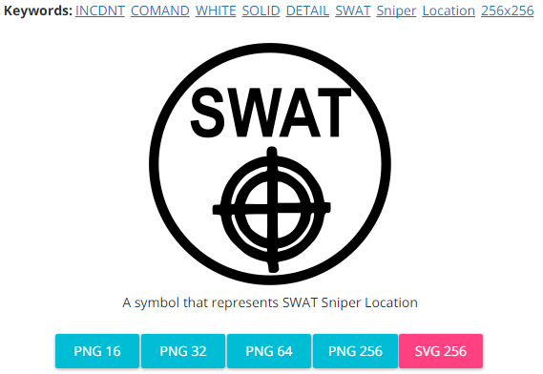
Modified by: Esri Solutions Team
License: None
Acknowledgement: None required
Notes: None

Snow
Symbol Name: Snow
Symbol Picture: 
Symbol Source: The Noun Project
Symbol Date: January 2016
Modified by: Esri Solutions Team
License: Public Domain
Acknowledgement: None required
Notes: None

Sound Stage
Symbol Name:
Symbol Picture:
Symbol Source:
Symbol Date: December 2015
Created by: Esri Solutions Team
License: None
Acknowledgement: None required
Notes: None

Signal
Symbol Name:
Symbol Picture: 
Symbol Source: None
Symbol Date: July 2015
Created by: Esri Solutions Team
License: None
Acknowledgement: None required
Notes: None

Signal Cabinet
Symbol Name:
Symbol Picture: 
Symbol Source:
Symbol Date: July 2015
Created by: Esri Solutions Team
License: None
Acknowledgement: None required
Notes: None

Slope Protection Violation
Symbol Name: SP
Symbol Picture: 
Symbol Source: Arial Rounded MT Bold Font
Symbol Date: March 2015
Modified by: Esri Solutions Team
License: None
Acknowledgement: None required
Notes: None

Sprinkler Control Valve
Symbol Name: Sprinkler Control Valves, General
Symbol Picture: 
Symbol Source: NAPSG (National Alliance for Public Safety GIS Foundation)
Symbol Date: March 2015

Modified by: Esri Solutions Team
License: None
Acknowledgement: None required
Notes: None

Stairs
Symbol Name: Stairs
Symbol Picture: 
Symbol Source: Public Signs style file
Symbol Date: March 2017
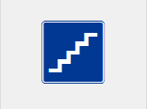
Modified by: Esri Solutions Team
License: None
Acknowledgement: None required
Notes: None

Stairway
Symbol Name: Stairs
Symbol Picture: 
Symbol Source: Public Signs style file
Symbol Date: February 2017
Modified by: Esri Solutions Team
License: None
Acknowledgement: None required
Notes: None

Special Incident
Symbol Name: !
Symbol Picture:
Symbol Source:
Symbol Date: December 2015
Modified by: Esri Solutions Team
License: None
Acknowledgement: None required
Notes: None

Sprinkler Control Valve
Symbol Name: Sprinkler Control Valves, General
Symbol Picture:
Symbol Source: NAPSG (National Alliance for Public Safety GIS Foundation)
Symbol Date: March 2017
Created by: Esri Solutions Team
License: None
Acknowledgement: None required
Notes: None

Staging Area
Symbol Name: S
Symbol Picture: 
Symbol Source: Arial font
Symbol Date: July 2015
Modified by: Esri Solutions Team
License: None
Acknowledgement: None required
Notes: None

State Operating Permit
Symbol Name:
Symbol Picture: 
Symbol Source:
Symbol Date: October 2014
Modified by: Esri Solutions Team
License: None
Acknowledgement: None required
Notes: None

Stormwater Map Change Request
Symbol Name: Map
Symbol Picture: 
Symbol Source: The Noun Project
Symbol Date: May 2015
Modified by: Esri Solutions Team
License: Public Domain
Acknowledgement: None required
Notes: None

Stormwater Map Change Request Critical
Symbol Name: SW
Symbol Picture: 
Symbol Source: Arial Rounded MT Bold Font
Symbol Date: March 2015
Modified by: Esri Solutions Team
License: None
Acknowledgement: None required
Notes: None

Stormwater Map Change Request Not Critical
Symbol Name: SW
Symbol Picture: 
Symbol Source: Arial Rounded MT Bold Font
Symbol Date: March 2015
Modified by: Esri Solutions Team
License: None
Acknowledgement: None required
Notes: None

Stormwater Multisector Permit
Symbol Name: Overboard Discharge (right)
Symbol Picture: 
Symbol Source: Environmental style file
Symbol Date: September 2014
Modified by: Esri Solutions Team
License: None
Acknowledgement: None required
Notes: None

Street Furniture
Symbol Name: Park
Symbol Picture: 
Symbol Source: The Noun Project
Symbol Date: June 2015
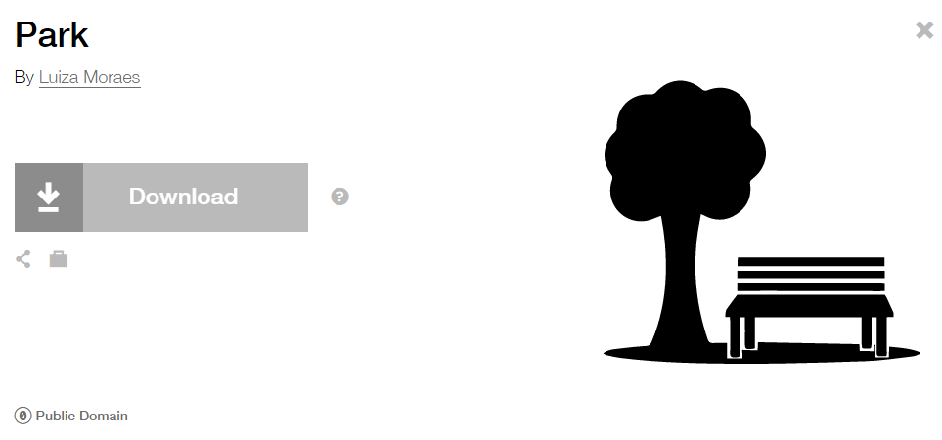
Modified by: Esri Solutions Team
License: Public Domain
Acknowledgement: None required
Notes: None

Streetlight
Symbol Name: Light Bulb
Symbol Picture:
Symbol Source: The Noun Project
Symbol Date: April 2015
Modified by: Esri Solutions Team
License: Public Domain
Acknowledgement: None required
Notes: None

Street Sign
Symbol Name:
Symbol Picture: 
Symbol Source: None
Symbol Date: July 2015
Created by: Esri Solutions Team
License: None
Acknowledgement: None required
Notes: None

Strobe Light
Symbol Name:
Symbol Picture:
Symbol Source:
Symbol Date: December 2015
Created by: Esri Solutions Team
License: None
Acknowledgement: None required
Notes: None

Substance Abuse
Symbol Name: Substance-Abuse-Service
Symbol Picture: 
Symbol Source: The Noun Project
Symbol Date: March 2015
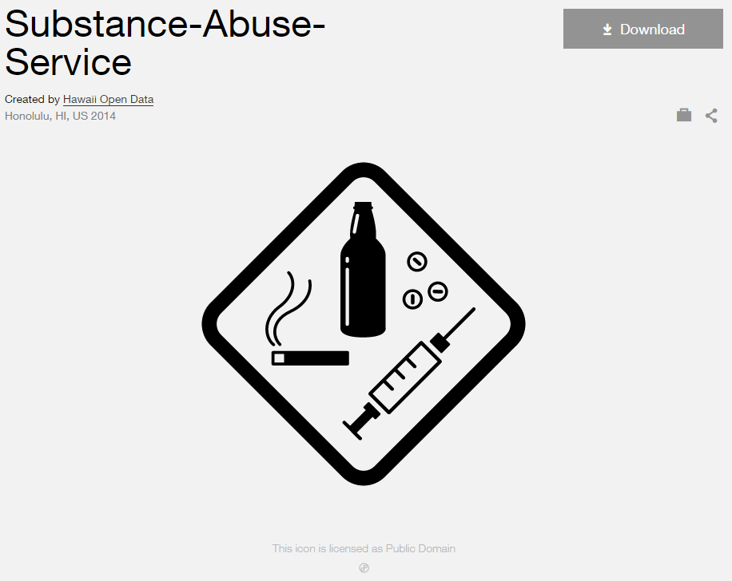
Modified by: Esri Solutions Team
License: Public Domain
Acknowledgement: None Required
Notes: None

Suppression Control Valve
Symbol Name: Fire Supp. Control Panel, General
Symbol Picture: 
Symbol Source: NAPSG (National Alliance for Public Safety GIS Foundation)
Symbol Date: March 2017

Created by: Esri Solutions Team
License: None
Acknowledgement: None required
Notes: None

Surface
Symbol Name:
Symbol Picture:
Symbol Source:
Symbol Date: May 2015
Created by: Esri Solutions Team
License: None
Acknowledgement: None required
Notes: None

Suspect
Symbol Name: Magnifying Glass
Symbol Picture: 
Symbol Source: The Noun Project
Symbol Date: December 2015
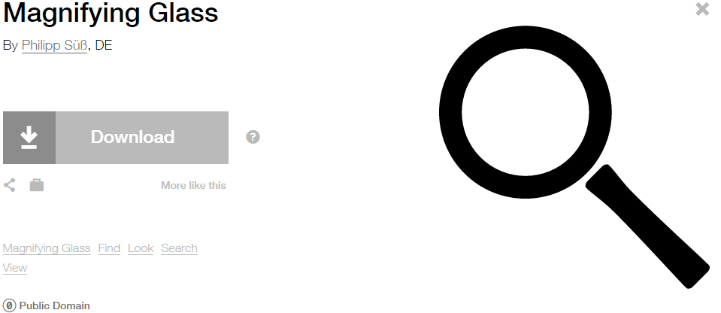
Modified by: Esri Solutions Team
License: Public Domain
Acknowledgement: None required
Notes: None

SWAT Vehicle
Symbol Name: SWAT
Symbol Picture: 
Symbol Source: Arial font
Symbol Date: February 2017
Modified by: Esri Solutions Team
License: None
Acknowledgement: None required
Notes: None

Tap
Symbol Name:
Symbol Picture:
Symbol Source:
Symbol Date: May 2015
Created by: Esri Solutions Team
License: None
Acknowledgement: None required
Notes: None

Target
Symbol Name:
Symbol Picture: 
Symbol Source:
Symbol Date: February 2017
Modified by: Esri Solutions Team
License: None
Acknowledgement: None required
Notes: None

Team 1
Symbol Name: 1
Symbol Picture: 
Symbol Source: Arial font
Symbol Date: December 2015
Modified by: Esri Solutions Team
License: None
Acknowledgement: None required
Notes: None

Team 2
Symbol Name: 2
Symbol Picture: 
Symbol Source: Arial font
Symbol Date: December 2015
Modified by: Esri Solutions Team
License: None
Acknowledgement: None required
Notes: None

Team 3
Symbol Name: 3
Symbol Picture: 
Symbol Source: Arial font
Symbol Date: December 2015
Modified by: Esri Solutions Team
License: None
Acknowledgement: None required
Notes: None

Team 4
Symbol Name: 4
Symbol Picture: 
Symbol Source: Arial font
Symbol Date: December 2015
Modified by: Esri Solutions Team
License: None
Acknowledgement: None required
Notes: None

Telecommunications Shut Off
Symbol Name: Refrigeration_With Line
Symbol Picture: 
Symbol Source: NAPSG (National Alliance for Public Safety GIS Foundation
Symbol Date: March 2017
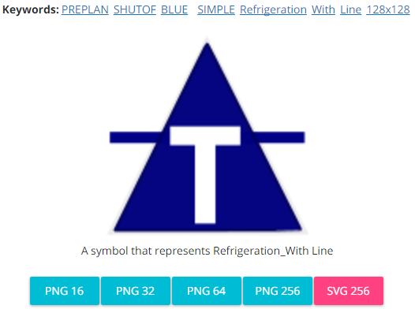
Modified by: Esri Solutions Team
License: None
Acknowledgement: None required
Notes: None

Tent
Symbol Name: Tent
Symbol Picture: 
Symbol Source: Forestry style file
Symbol Date: December 2015

Modified by: Esri Solutions Team
License: None
Acknowledgement: None required
Notes: None

Threat
Symbol Name: !
Symbol Picture: 
Symbol Source: Arial font
Symbol Date: February 2017
Modified by: Esri Solutions Team
License: None
Acknowledgement: None required
Notes: None

Ticket Purchase
Symbol Name: Ticket Purchase
Symbol Picture:
Symbol Source: Public Signs style file
Symbol Date: December 2015
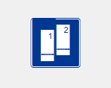
Modified by: Esri Solutions Team
License: None
Acknowledgement: None required
Notes: None

Tornado
Symbol Name: Tornado
Symbol Picture: 
Symbol Source: ERS Homeland Security style file
Symbol Date: October 2015
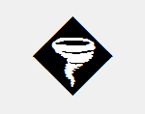
Modified by: Esri Solutions Team
License: None
Acknowledgement: None required
Notes: None

Traffic Checkpoint
Symbol Name:
Symbol Picture:
Symbol Source:
Symbol Date: December 2015
Created by: Esri Solutions Team
License: None
Acknowledgement: None required
Notes: None

Traffic Safety Problem – Completed, In – Progress, Received, and Submitted
Symbol Name: Car & Men
Symbol Picture: 
Symbol Source: The Noun Project & Public Signs style file
Symbol Date: March 2016
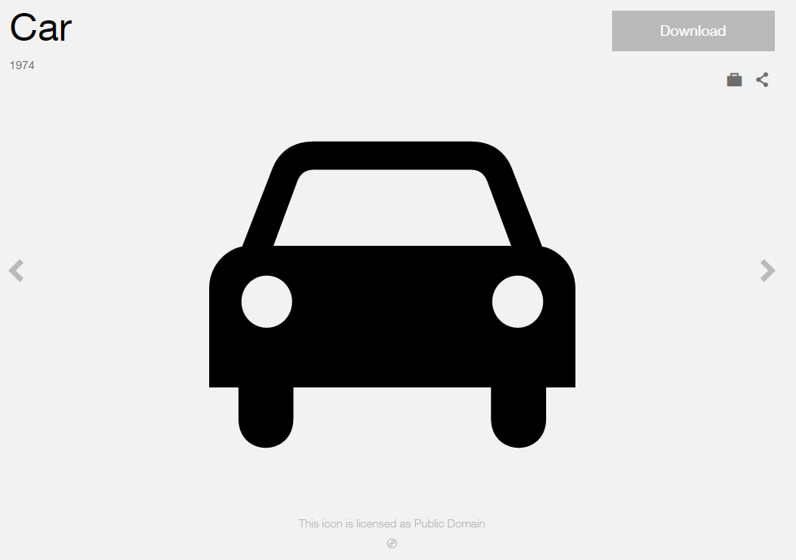
Modified by: Esri Solutions Team
License: Public Domain
Acknowledgement: None required
Notes: None

Train Derailment
Symbol Name: Rail Transportation
Symbol Picture: 
Symbol Source: Public Signs style file
Symbol Date: February 2015
Modified by: Esri Solutions Team
License: None
Acknowledgement: None required
Notes: None

Trash Dumpster
Symbol Name: Dumpster Diving
Symbol Picture:
Symbol Source: The Noun Project
Symbol Date: December 2015
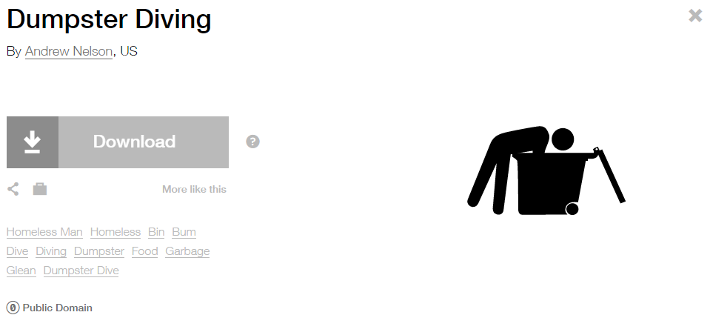
Modified by: Esri Solutions Team
License: Public Domain
Acknowledgement: None required
Notes: None

Trash Problem – Completed, In – Progress, Received, and Submitted
Symbol Name: Solid Waste
Symbol Picture: 
Symbol Source: The Noun Project
Symbol Date: March 2016
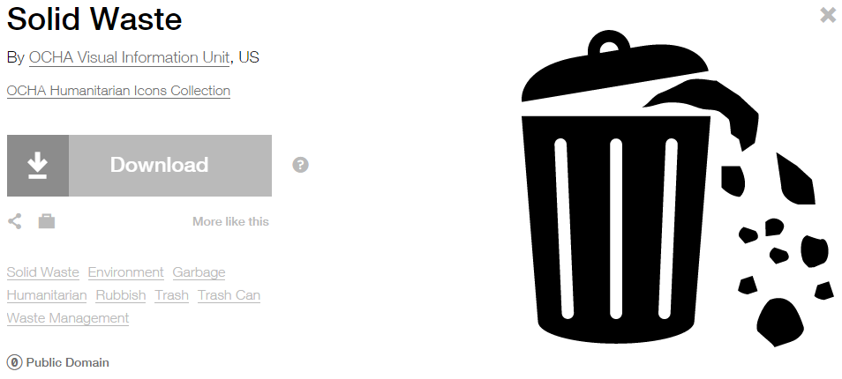
Modified by: Esri Solutions Team
License: Public Domain
Acknowledgement: None required
Notes: None

Trash Receptacle
Symbol Name: Unicode 123
Symbol Picture:
Symbol Source: ESRI Public 1 Font
Symbol Date: December 2015

Modified by: Esri Solutions Team
License: None
Acknowledgement: None required
Notes: None

Treatment Exception
Symbol Name: No Spray
Symbol Picture:
Symbol Source: The Noun Project
Symbol Date: March 2016
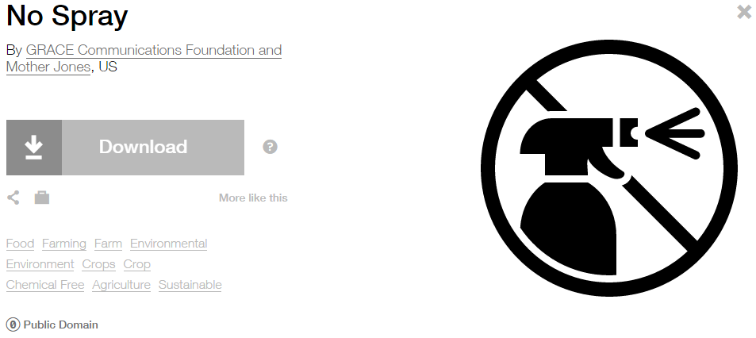
Modified by: Esri Solutions Team
License: Public Domain
Acknowledgement: None required
Notes: None

Tsunami
Symbol Name: Tsunami
Symbol Picture: 
Symbol Source: ERS Homeland Security style file
Symbol Date: October 2015

Modified by: Esri Solutions Team
License: None
Acknowledgement: None required
Notes: None

Typha
Symbol Name: Wetland
Symbol Picture: 
Symbol Source: The Noun Project
Symbol Date: May 2016
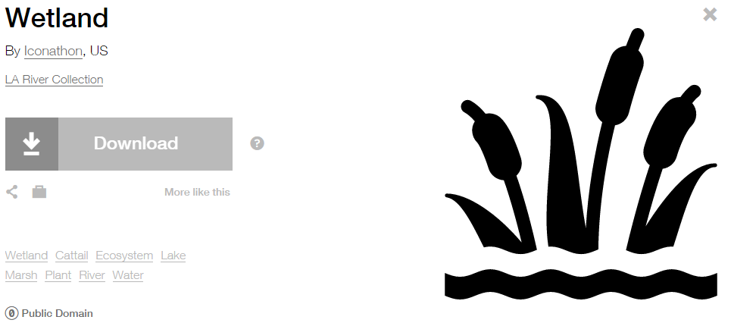
Modified by: Esri Solutions Team
License: Public Domain
Acknowledgement: None required
Notes: None

Trees
Symbol Name: Tree, Deciduous, Top
Symbol Picture: 
Symbol Source: Environmental style file
Symbol Date: July 2015

Modified by: Esri Solutions Team
License: None
Acknowledgement: None required
Notes: None

Unauthorized Attachment - Cable
Symbol Name: C
Symbol Picture: 
Symbol Source: Arial Rounded MT Bold
Symbol Date: April 2015
Modified by: Esri Solutions Team
License: None
Acknowledgement: None required
Notes: None

Unauthorized Attachment - Fiber
Symbol Name: Fb
Symbol Picture: 
Symbol Source: Arial Rounded MT Bold
Symbol Date: April 2015
Modified by: Esri Solutions Team
License: None
Acknowledgement: None required
Notes: None

Unauthorized Attachment - Fire
Symbol Name: Fr
Symbol Picture: 
Symbol Source: Arial Rounded MT Bold
Symbol Date: April 2015
Modified by: Esri Solutions Team
License: None
Acknowledgement: None required
Notes: None

Unauthorized Attachment - Other
Symbol Name: O
Symbol Picture: 
Symbol Source: Arial Rounded MT Bold
Symbol Date: April 2015
Modified by: Esri Solutions Team
License: None
Acknowledgement: None required
Notes: None

Unauthorized Attachment - Sign
Symbol Name: S
Symbol Picture: 
Symbol Source: Arial Rounded MT Bold
Symbol Date: April 2015
Modified by: Esri Solutions Team
License: None
Acknowledgement: None required
Notes: None

Unauthorized Attachment - Telecommunications
Symbol Name: T
Symbol Picture: 
Symbol Source: Arial Rounded MT Bold
Symbol Date: April 2015
Modified by: Esri Solutions Team
License: None
Acknowledgement: None required
Notes: None

Underground Storage Tank Permit
Symbol Name: Underground Storage Tank
Symbol Picture: 
Symbol Source: Environmental style file
Symbol Date: September 2014
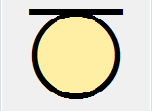
Modified by: Esri Solutions Team
License: None
Acknowledgement: None required
Notes: None

Under Investigation
Symbol Name: Magnifying Glass
Symbol Picture:
Symbol Source: The Noun Project
Symbol Date: December 2015
Modified by: Esri Solutions Team
License: Public Domain
Acknowledgement: None required
Notes: None

Undetermined after Investigation
Symbol Name: ?
Symbol Picture:
Symbol Source: Arial Rounded MT Bold
Symbol Date: December 2015
Modified by: Esri Solutions Team
License: None
Acknowledgement: None required
Notes: None

Unintentional
Symbol Name: Fire Incident
Symbol Picture:
Symbol Source: ERS Homeland Security style file
Symbol Date: July 2015
Modified by: Esri Solutions Team
License: None
Acknowledgement: None required
Notes: None

Urban Conflagration
Symbol Name: City
Symbol Picture: 
Symbol Source: Business style file
Symbol Date: September 2014
Modified by: Esri Solutions Team
License: None
Acknowledgement: None required
Notes: None

Utility Problem – Completed, In – Progress, Received, and Submitted
Symbol Name: Water Recreation & Droplet, Water
Symbol Picture: 
Symbol Source: Forestry & Environmental style file
Symbol Date: December 2015
Modified by: Esri Solutions Team
License: None
Acknowledgement: None required
Notes: None

Vector Control Problem – Completed, In – Progress, Received, and Submitted
Symbol Name: Mosquito
Symbol Picture: 
Symbol Source: bi Project
Symbol Date: March 2016
Modified by: Esri Solutions Team
License: Public Domain
Acknowledgement: None required
Notes: None

Vegetation
Symbol Name: Leaf
Symbol Picture: 
Symbol Source: The Noun Project
Symbol Date: March 2015
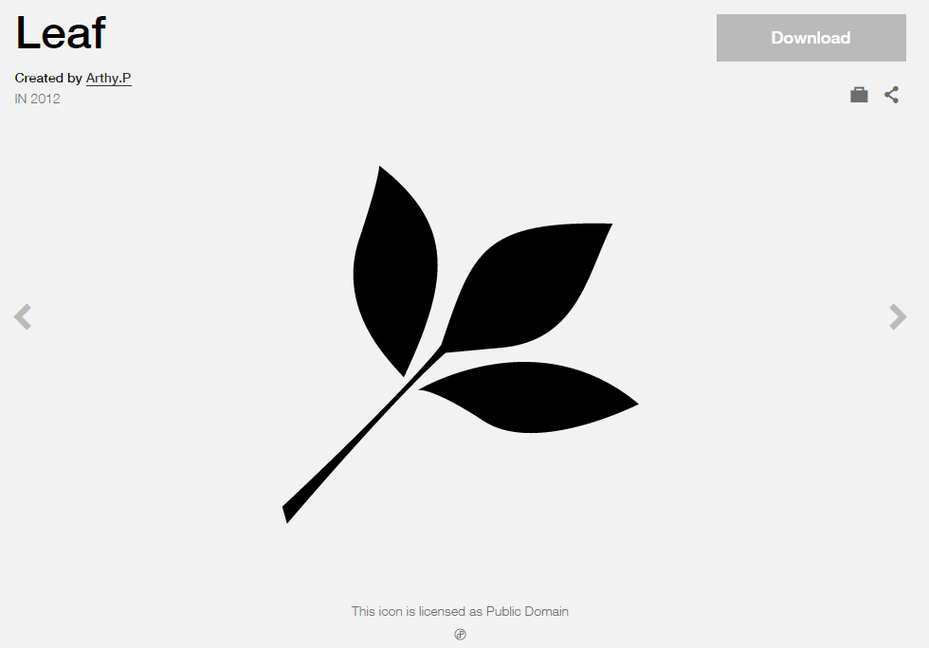
Modified by: Esri Solutions Team
License: Public Domain
Acknowledgement: None required
Notes: None

Vehicle Incident
Symbol Name: Car
Symbol Picture: 
Symbol Source: The Noun Project
Symbol Date: March 2015
Modified by: Esri Solutions Team
License: Public Domain
Acknowledgement: None required
Notes: None

Vermin
Symbol Name:
Symbol Picture:
Symbol Source:
Symbol Date: May 2015
Created by: Esri Solutions Team
License: None
Acknowledgement: None required
Notes: None

Vehicles and Vessels
Symbol Name: Ship
Symbol Picture:
Symbol Source: The Noun Project
Symbol Date: March 2015
Modified by: Esri Solutions Team
License: Public Domain
Acknowledgement: None Required
Notes: None

Victim
Symbol Name: Homicide Location
Symbol Picture: 
Symbol Source: Crime Analysis style file
Symbol Date: February 2017
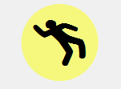
Modified by: Esri Solutions Team
License: None
Acknowledgement: None required
Notes: None

Video
Symbol Name:
Symbol Picture: 
Symbol Source:
Symbol Date: December 2015
Created by: Esri Solutions Team
License: None
Acknowledgement: None required
Notes: None

Violations - Severe
Symbol Name: !
Symbol Picture: 
Symbol Source: Arial Rounded MT Bold
Symbol Date: April 2015
Modified by: Esri Solutions Team
License: None
Acknowledgement: None required
Notes: None

Violations - Medium
Symbol Name: !
Symbol Picture: 
Symbol Source: Arial Rounded MT Bold
Symbol Date: April 2015
Modified by: Esri Solutions Team
License: None
Acknowledgement: None required
Notes: None

Violations - Low
Symbol Name: !
Symbol Picture: 
Symbol Source: Arial Rounded MT Bold
Symbol Date: April 2015
Modified by: Esri Solutions Team
License: None
Acknowledgement: None required
Notes: None

Violent Person
Symbol Name: Assault, Solid Fist
Symbol Picture: 
Symbol Source: Crime Analysis style file
Symbol Date: June 2015
Modified by: Esri Solutions Team
License: None
Acknowledgement: None required
Notes: None

Volcano Eruption
Symbol Name: Volcano
Symbol Picture: 
Symbol Source: The Noun Project
Symbol Date: September 2015
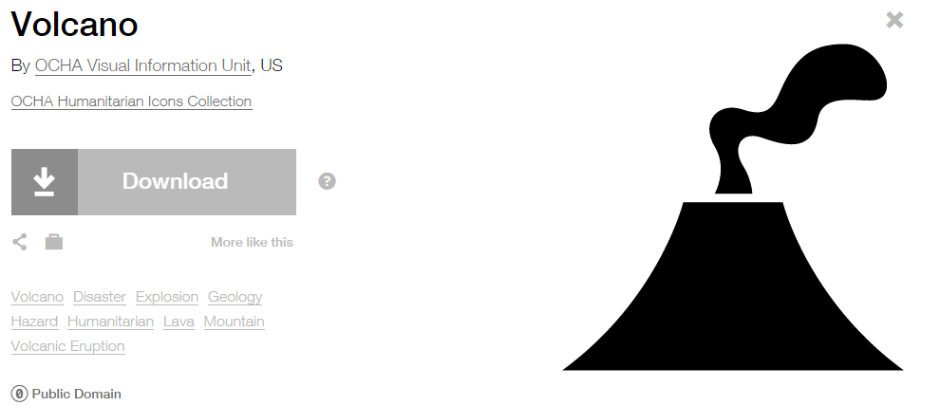
Modified by: Esri Solutions Team
License: Public Domain
Acknowledgement: None required
Notes: None

Volunteer Services
Symbol Name: Men
Symbol Picture:
Symbol Source: Public Signs style file
Symbol Date: December 2015
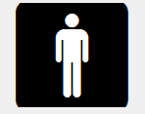
Modified by: Esri Solutions Team
License: None
Acknowledgement: None required
Notes: None

Warming Center
Symbol Name: Unicode 113
Symbol Picture: 
Symbol Source: ESRI Enviro Hazard Analysis
Symbol Date: February 2015
Modified by: Esri Solutions Team
License: None
Acknowledgement: None required
Notes: None

Warning
Symbol Name: !
Symbol Picture: 
Symbol Source: Arial Rounded MT Bold
Symbol Date: May 2015
Modified by: Esri Solutions Team
License: None
Acknowledgement: None required
Notes: None

Warning – on/near road
Symbol Name: !
Symbol Picture: 
Symbol Source: Arial Rounded MT Bold
Symbol Date: May 2015
Modified by: Esri Solutions Team
License: None
Acknowledgement: None required
Notes: None

Water Distribution Center
Symbol Name: Faucet
Symbol Picture: 
Symbol Source: Civic style file
Symbol Date: July 2015
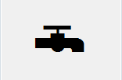
Modified by: Esri Solutions Team
License: None
Acknowledgement: None required
Notes: None

Waste Disposal Violation
Symbol Name: WD
Symbol Picture: 
Symbol Source: Arial Rounded MT Bold Font
Symbol Date: March 2015
Modified by: Esri Solutions Team
License: None
Acknowledgement: None required
Notes: None

Water Map Change Request
Symbol Name: Map
Symbol Picture: 
Symbol Source: The Noun Project
Symbol Date: May 2015
Modified by: Esri Solutions Team
License: Public Domain
Acknowledgement: None required
Notes: None

Water Map Change Request Critical
Symbol Name: W
Symbol Picture: 
Symbol Source: Arial Rounded MT Bold Font
Symbol Date: March 2015
Modified by: Esri Solutions Team
License: None
Acknowledgement: None required
Notes: None

Water Map Change Request Not Critical
Symbol Name: W
Symbol Picture: 
Symbol Source: Arial Rounded MT Bold Font
Symbol Date: March 2015
Modified by: Esri Solutions Team
License: None
Acknowledgement: None required
Notes: None

Water Quality Advisory - No
Symbol Name: Water Recreation & Droplet, Water
Symbol Picture: 
Symbol Source: Forestry & Environmental style file
Symbol Date: December 2015
Modified by: Esri Solutions Team
License: None
Acknowledgement: None required
Notes: None

Water Quality – Not Applicable
Symbol Name: Water Recreation & Droplet, Water
Symbol Picture: 
Symbol Source: Forestry & Environmental style file
Symbol Date: December 2015
Modified by: Esri Solutions Team
License: None
Acknowledgement: None required
Notes: None

Water Quality - Yes
Symbol Name: Water Recreation & Droplet, Water
Symbol Picture: 
Symbol Source: Forestry & Environmental style file
Symbol Date: December 2015
Modified by: Esri Solutions Team
License: None
Acknowledgement: None required
Notes: None

Water Shut Off
Symbol Name: Water Shutoff_With Line
Symbol Picture: 
Symbol Source: NAPSG (National Alliance for Public Safety GIS Foundation)
Symbol Date: March 2017
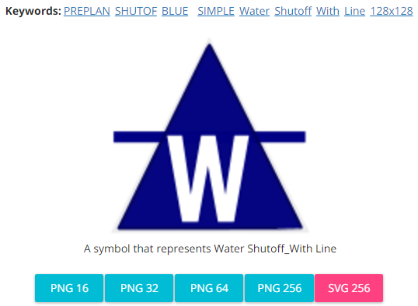
Modified by: Esri Solutions Team
License: None
Acknowledgement: None required
Notes: None

Water Treatment Plant Permit
Symbol Name: Tank Farm
Symbol Picture: 
Symbol Source: Environmental style file
Symbol Date: September 2014
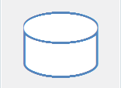
Modified by: Esri Solutions Team
License: None
Acknowledgement: None required
Notes: None

Watering Violations - Commercial
Symbol Name: !
Symbol Picture:
Symbol Source: Arial Rounded MT Bold
Symbol Date: May 2015
Modified by: Esri Solutions Team
License: None
Acknowledgement: None required
Notes: None

Watering Violations - Industrial
Symbol Name: !
Symbol Picture: 
Symbol Source: Arial Rounded MT Bold
Symbol Date: May 2015
Modified by: Esri Solutions Team
License: None
Acknowledgement: None required
Notes: None

Watering Violations - Parks
Symbol Name: !
Symbol Picture: 
Symbol Source: Arial Rounded MT Bold
Symbol Date: May 2015
Modified by: Esri Solutions Team
License: None
Acknowledgement: None required
Notes: None

Watering Violations - Residential
Symbol Name: !
Symbol Picture: 
Symbol Source: Arial Rounded MT Bold
Symbol Date: May 2015
Modified by: Esri Solutions Team
License: None
Acknowledgement: None required
Notes: None

Weeds
Symbol Name: Dandelion
Symbol Picture: 
Symbol Source: The Noun Project
Symbol Date: March 2015
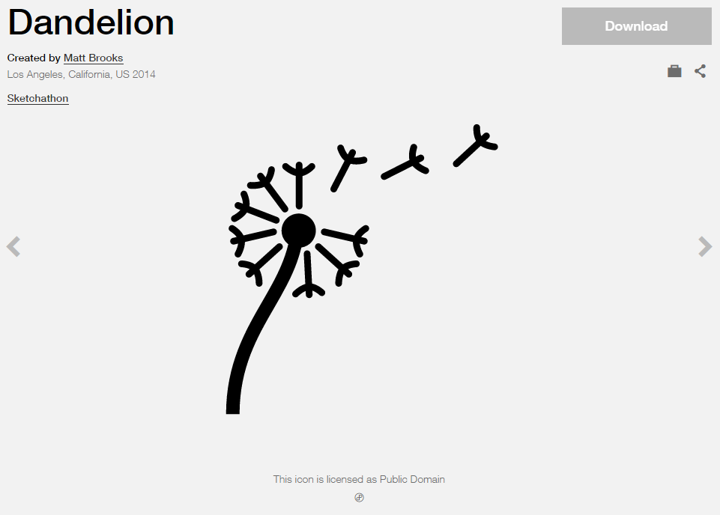
Modified by: Esri Solutions Team
License: Public Domain
Acknowledgement: None required
Notes: None

Weld
Symbol Name:
Symbol Picture:
Symbol Source:
Symbol Date: May 2015
Created by: Esri Solutions Team
License: None
Acknowledgement: None required
Notes: None

West Nile Virus
Symbol Name: !
Symbol Picture: 
Symbol Source: Arial Rounded MT Bold
Symbol Date: December 2016
Modified by: Esri Solutions Team
License: None
Acknowledgement: None required
Notes: None

Width and Height Restriction
Symbol Name:
Symbol Picture: 
Symbol Source:
Symbol Date: February 2016
Created by: Esri Solutions Team
License: None
Acknowledgement: None Required
Notes: None

Width and Height Restriction - Alert
Symbol Name:
Symbol Picture: 
Symbol Source:
Symbol Date: February 2016
Created by: Esri Solutions Team
License: None
Acknowledgement: None Required
Notes: None

Width and Height Restriction – Work Zones
Symbol Name:
Symbol Picture: 
Symbol Source:
Symbol Date: February 2016
Created by: Esri Solutions Team
License: None
Acknowledgement: None Required
Notes: None

Wildfire
Symbol Name: Wildfire
Symbol Picture: 
Symbol Source: ERS Homeland Security style file
Symbol Date: October 2015

Modified by: Esri Solutions Team
License: None
Acknowledgement: None required
Notes: None

Wildlife Management Areas
Symbol Name: Wildlife 2
Symbol Picture: 
Symbol Source: Conservation style file
Symbol Date: May 2014
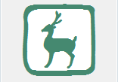
Modified by: Esri Solutions Team
License: None
Acknowledgement: None required
Notes: None

Wind
Symbol Name: Wind
Symbol Picture: 
Symbol Source: The Noun Project
Symbol Date: January 2016
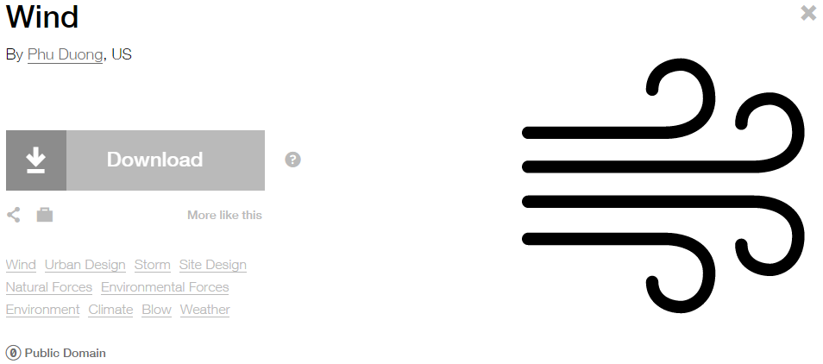
Modified by: Esri Solutions Team
License: Public Domain
Acknowledgement: None required
Notes: None

Window
Symbol Name:
Symbol Picture: 
Symbol Source:
Symbol Date: February 2017
Modified by: Esri Solutions Team
License: None
Acknowledgement: None required
Notes: None

Wineries
Symbol Name:
Symbol Picture: 
Symbol Source:
Symbol Date: March 2015
Created by: Esri Solutions Team
License: None
Acknowledgement: None required
Notes: None

Winter Storm
Symbol Name: Snow
Symbol Picture: 
Symbol Source: The Noun Project
Symbol Date: January 2016
Modified by: Esri Solutions Team
License: Public Domain
Acknowledgement: None required
Notes: None

Wire Down
Symbol Name: Power Lines
Symbol Picture: 
Symbol Source: The Noun Project
Symbol Date: June 2015
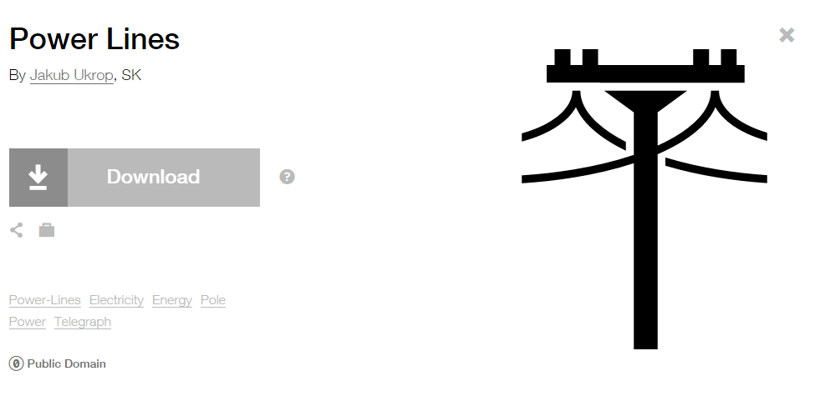
Modified by: Esri Solutions Team
License: Public Domain
Acknowledgement: None required
Notes: None

Work Zone - Inactive
Symbol Name: Worker
Symbol Picture: 
Symbol Source: Transportation style file
Symbol Date: April 2014
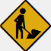
Modified by: Esri Solutions Team
License: None
Acknowledgement: None Required
Notes: None

Work Zone Line
Symbol Name: Worker
Symbol Picture: 
Symbol Source: Transportation style file
Symbol Date: April 2014
Modified by: Esri Solutions Team
License: None
Acknowledgement: None Required

Work Zones
Symbol Name: Worker
Symbol Picture: 
Symbol Source: Transportation style file
Symbol Date: April 2014
Modified by: Esri Solutions Team
License: None
Acknowledgement: None Required
Notes: None

Yellow Fever
Symbol Name: !
Symbol Picture: 
Symbol Source: Arial Rounded MT Bold
Symbol Date: December 2016
Modified by: Esri Solutions Team
License: None
Acknowledgement: None required
Notes: None

Zebra Mussel
Symbol Name:
Symbol Picture: 
Symbol Source:
Symbol Date: May 2016
Created by: Esri Solutions Team
License: None
Acknowledgement: None required
Notes: None

Zika Fever
Symbol Name: !
Symbol Picture: 
Symbol Source: Arial Rounded MT Bold
Symbol Date: December 2016
Modified by: Esri Solutions Team
License: None
Acknowledgement: None required
Notes: None

